

PQS (PAPERLESS QUEUING SYSTEM)

**___________________**

An IT Capstone Project

Presented to

The Faculty of the Computer Studies

ACLC COLLEGE

Mandaue City

**___________________**

In Partial Fulfillment

of the Requirements for the Degree

Bachelor of Science in Information Technology

**___________________**

By

Jhuven Dejito

Ireneo Arcenal Jr.

Lovely Jean Monsanto

Rejhel Sinangote

July 2020

**APPROVAL SHEET**

In partial fulfillment of the requirements for the degree, Bachelor of Science in Information Technology, this Capstone Project entitled “***PQS (PAPERLESS QUEUING SYSTEM***”, has been prepared by ***Jhuven Dejito, Ireneo Arcenal Jr., Lovely Jean Monsanto, Rejhel Sinangote* .**

**DONALD M. FRANCISCO, MSIT**

IT Adviser

Approved by the Committee on Oral Examination with a grade of _____________.

**DONALD FRANCISCO,MSIT**

Panelist 1

**ROY IMPERIAL, MSIT**

College DEAN / School Director

Accepted in partial Fulfillment of the requirements for the degree, BACHELOR OF SCIENCE IN INFORMATION TECHNOLOGY (BSIT).

**ROY IMPERIAL, MSIT**

College Dean / School Director  
ACLC College  
Maguikay, Mandaue City

Date of Oral Examination  
July 03, 2020

**Dedication**

This study is whole heartedly dedicated to our beloved parents, who have been our source of inspiration and gave us strength when we thought of giving up, who continually provide their moral, spiritual, emotional, and financial support.

To our brothers, sisters, relatives, mentors, friends, and classmates who shared their words of advice and encouragement to finish this study. And lastly, we dedicated this book to the almighty God, thank you for the guidance, strength, power of mind, protection and skills and for giving us a healthy. All of these, we offer to you.

***Acknowledgements***

To Jesus Christ, our Lord and Savior, for giving the wisdom strength and knowledge in exploring things, for the guidance in helping all the trials that we encountered and for giving determination to pursue our study, and make this study possible.

We would like to indicate our earnest gratitude to our I.T Capstone adviser Mr. Donald M. Francisco for continuous support in our study, patience, enthusiasm and for sharing his knowledge of what he has learned.

Our sincere thanks also to our School Director Mr. Roy L. Imperial for given us approval for our project proposal and for given us the opportunity to show our skills and capabilities. Without his utmost ideas we would be able to develop this project.

Our tremendous appreciation for our classmates who has been part for sleepless nights, for all the arguments, misunderstanding and extreme fun that we’ve been through in order to pass this subject. Above ground, to our beloved family that given us trust, undying motivation and most important for providing the financial income in conducting this study despite of the pandemic crisis. Thank you.

**Abstract**

**Title : Paperless Queuing System**

**Proponents : Jhuven Dejito, Ireneo Arcenal Jr., Rejhel C. Sinangote, Lovely Jean T. Monsanto**

**Degree : Bachelor of Science in Information Technology**

**School : AMA Computer Learning Center**

**Adviser : Mr. Donald M. Francisco**

This Paperless queuing machine innovates a better queuing system for transactions. It provides valuable data that consist of highly develop virtual data centers that provide software, hardware and The Paperless Queuing System is designed in organizing queues at service sector like accounting department, which expected to have a large number of customers daily. Common ways of managing queues like issuing paper tickets printed with queue nu mbers lead to several problems such as paper tickets littering and also time mismanagement. The purpose of this system consist a Graphical User Interface (GUI) and uses raspberry pi to generate IP Address to the user to select the type of queue into the cashier. This platform integrates the data from many devices and applies analytic to share the most valuable data into the applications that will be sent into the server and will make information synchronize information resources for use when needed in an organization.

This project purpose is to support the development of sustainable green technology, and the expected increase of system efficiency may contribute to improving customers' satisfaction. The main features of this product is a newly high originated Paperless queuing machine Arduino based and with connectivity into the Web & Mobile App. It will also analyzed the components to be used in this project.

In making this project, researchers set an objectives into some points that should be enhanced or should be added. The goal is to develop something that will let the owner of the business increase profit margin, provide a better customer service, monitor and manage their own accounts that is connected to paperless queuing machine.

**Table of Contents**

Pages

Title Page i

Approval Sheet ii

Dedication iii

Acknowledgements iv

Abstract vi

Table of Contents viii

List of Figures xix

List of table’s xii

**CHAPTER I – INTRODUCTION 1**

Statement of the Problem 5

Purpose/Objective of the Study 10

Significance of the Study 12

Scope and Limitation 14

Conceptual Framework 19

Review of Related Literature 20

**CHAPTER II – METHODS 25**

Research Design 45

Description of the Respondents 47

Research Instruments 49

Data Collection or Data Gathering Procedure 58

**CHAPTER III – RESULTS 60**

Data Presentation 60

Data Interpretation 62

Data Analysis 63

**CHAPTER IV – DISCUSSION 65**

Summary 66

Conclusion 70

Recommendations 73

References 74

Appendices 76

Biographical Sketch 157

**List of Figures**

Figure 1:  *Show the concept of queuing 19*

*Figure 2. Long queue Process 26*

*Figure 3. Long queue can be pissed-off 27*

*Figure 4. Paperless queuing doesn’t exist 27*

*Figure 5. Implementing queues 28*

*Figure 6. . Shows both payment and inquiry is applied 28*

*Figure 7. Paper is used in queuing 29*

*Figure 8. Agree to use smartphone 29*

*Figure 9. Shows that mobile application is*

*not used in queuing 30*

*Figure 10. Improvement of queue process 30*

*Figure 11. Utilizing paperless queuing 31*

*Figure 12. The Process Flow of the system 34*

*Figure 13. The Functionality of the system 35*

*Figure 14. The Features of the system 35*

*Figure 15. The Originality of the system 36*

*Figure 16. The users Interface of the system 36*

*Figure 17. The students reaction about the system 37*

*Figure 18. Comment and suggestion of the system 38*

*Figure 19. Show the 25 respondent answer the survey 47*

*Figure 20. Show the 25 respondent answer the survey 48*

*Figure 21. Process flow of the system 57*

*Figure 22. Generate IP Address to the user 134*

*Figure 23. Select Queue transactions 134*

*Figure 24. Users select continue to queue if not a PWD, Senior Citizen or Pregnant Women 135*

*Figure 25. Users dashboard to know the*

*The queuing transactions 135*

*Figure 26. Orange button that represents if the user is on waiting call 136*

*Figure 27. Green button represents if the user is on queue 136*

*Figure 28. Red button represent if the user is on the recall 137*

*Figure 29. Click yellow sign button for PWD, Senior Citizen or Pregnant Women 137*

*Figure 30. Dashboard for PWD, Senior Citizen or Pregnant Women, Uppercase P represent for Priority Lane 138*

*Figure 31. Orange button represent if the user is on waiting call for PWD, Senior Citizen or Pregnant Women 138*

*Figure 32. Green button represent if the user is on queue call for PWD, Senior Citizen or Pregnant Women 139*

*Figure 33. Red button represent if the user is on recall for PWD, Senior Citizen or Pregnant Women 139*

*Figure 34. Click to Log-in 140*

*Figure 35. Cashier Log-in 140*

*Figure 36. Cashier Homepage 141*

*Figure 37. Cashier Button Call 141*

*Figure 38. Cashier Queue transaction Call 142*

*Figure 39. User call on wait 142*

*Figure 40. Cashier is calling a queue to a user 143*

*Figure 41. User is on queue to cashier 143*

*Figure 42. Cashier queues on transaction to the users 144*

*Figure 43. Cashier queue a user’s on the monitor 144*

*Figure 44. Cashier Add limit to the queue 145*

*Figure 45. Limit queue is display 145*

*Figure 46. Limit is display to the monitor 146*

*Figure 47. Queue limit exceed 146*

*Figure 48. Add Announcement 147*

*Figure 49. Add Announcement table is display 147*

*Figure 50. Display announcement to the monitor 148*

*Figure 51. Recall the queue 148*

*Figure 52. User queue is recall 149*

*Figure 53. Cashier sign-out 149*

*Figure 54. Click to Log-in 150*

*Figure 55. Admin Log-in 150*

*Figure 56. Admin Homepage 151*

*Figure 57. Announcement Button 151*

*Figure 58. Add Announcement display 152*

*Figure 59. Add Announcement display on the monitor 152*

*Figure 60. Reset display button 153*

*Figure 61. Add Limit display button 153*

*Figure 62. Add limit is display 154*

*Figure 63. Add limit is display in the monitor 154*

*Figure 64. Add Cashier button 155*

*Figure 65. Add Cashier Log-in is display 155*

*Figure 66. Admin Sign-out 156*

**List of Tables**

Table 1. Pre-Survey Result (Q1) 32

Table 2. Pre-Survey Result (Q2) 32

Table 3. Pre-Survey Result (Q3) 32

Table 4. Pre-Survey Result (Q4) 32

Table 5. Pre-Survey Result (Q5) 32

Table 6. Pre-Survey Result (Q6) 33

Table 7. Pre-Survey Result (Q7) 33

Table 8. Pre-Survey Result (Q8) 33

Table 9. Pre-Survey Result (Q9) 33

Table 10. Pre-Survey Result (Q10) 33

Table 11. Post- Survey Result (Q1 39

Table 12. Post- Survey Result (Q2) 39

Table 13. Post- Survey Result (Q3) 39

Table 14. Post- Survey Result (Q4) 40

Table 15. Post- Survey Result (Q5) 40

Table 16. Hardware Specification for Web & Mobile

Application Development 51

Table 17. Software Specification for Web & Mobile

Application Development 52

Table 18. Hardware Specification for Arduino

Development 52

Table 19. Software Specification for Arduino

Development 53

Table 20. Hardware Specification for PQS

Paperless Queuing System 53

Table 21. Software Specification for PQS

Paperless Queuing System 54

Table 22. Hardware Specification for Admin

Development 54

Table 23. Software Specification for Admin

Development 54

**CHAPTER I – INTRODUCTION**

Queuing system is used to control queues. It is a process of FIFO which means (Firs-In-First-Out). Queues of people form in a various situations and locations in a queue area. The queue areas are places in which people queue (first come first served.) Such us a group of people is known as a queue or line, and the people are said to be waiting or standing in a queue or in a line, respectively.

Queues are happen when the people will try get something like business permits, ticketing, payments or bill and etc. in short it is called priority number, a priority number is a number given by a person to queue a line and wait their turn to be called to transact the said appointment they want.

Today there are many queue system that is implemented by the society or even the government issuance. However there are some problem occurs in queuing like compromised queue integrity, customer complains about wait times, Unusually long lines, queue jumping and reneging, disperse waiting crowd, directional signage. These problem usually occurs when queue line starts. In fact there are possibility to solve this kind of matters like proper assigning of queues, proper alignment of the queues, and organized way of queues. In our world of high-technology many universities, students and developers would want to discovered queue system who dignify this kind of matter and making queue system innovative and useful to avoid mental emotions. The students of ACLC College of Mandaue came up with concepts on queues which is not implied to the school and there are issues happen about the problems on queue. The researcher’s proposing a system to the school to support these matter.

The proposed project is entitled “Paperless Queuing System” is an IT Capstone project. Paperless Queuing System (PQS) is a system that the arrivals of a new user are the Input and served the users are the Output. In this system the user have to wait for their turns to be served since usually the numbers of servers are outnumbered by the number of waiting users. The system is a web based and will use raspberry pi to generate an IP Address and connect to dedicated router and the user will connect to the router and ask the raspberry Pi IP Address to generate the process and select the type of queue into the cashier and they no longer wait and stand for too long. It will help a lot for the student to use this kind of queuing process since they are in a high-technology era.

This project presents the development of a system to manage queues more efficiently and eco-friendly. The user can have their IP address to manage the status of their queuing transactions. They can also view the details of a system through user interface on the ACLC Cashier Queuing System. The project’s target is to removes long and crowded customer queues, at the same time provide excellent service to customer. Upon making this proposed project we also considered the benefits we can get through this project and we believe that this “Paperless Queuing System” can decreased stress on staff from facing happier customers rather than people tired from standing in line seems to have a dramatic improvement on productivity.

Since, technology has a great part of our daily lives in today’s generation, thus we made this system in connected with smart phones as we all know even mostly of the population right now especially the generation are living with the luxury of technology. One of an example is our project the “Paperless Queuing System” while waiting for his turn, the same customer may tend to go outside doing other things. In the case where the first customer with queue number 0001 is being called to the counter, the system detects that the next queue number 0002 exists in the system. Therefore, in the user interface if the customer will see color green their queuing number it is on queued in order to remind that particular customer to be prepared, since his turn to be served is about to come.

**Statement of the Problem**

During the peak hours in usual business days, a long waiting line can be so much troublesome to the consumers. Waiting is not only irritating, but can be very tiring to both public consumers and staffs in charged behind the counters. Lately, the problem with waiting lines took center stage when the consumers complained about the service delivered by the staffs were unpleasant and annoying, especially at the last moment of business hour.

Sometimes, due to the long queue, there will be a modifiable sign at the start of the queue or halfway point in the queue informing people approximately how long their wait will be.

**GENERAL PROBLEM**

ACLC College of Mandaue is a school that needs an improvement regarding on the crowded line of the cashier area and make it hassle for the student if they are on the quick time.

**SPECIFIC PROBLEM**

**Time**

* What is the significant of time in queues?
* To shorten the process of queue and to managed the time in appropriate situation.
* How important is queues when it comes to time?
* Saving such time is very important to settle your appointment in school or any other places you want to go.
* What makes queue process faster?
* System like paperless queuing will be implemented to the school.
* Direct to the point assessment must be involved in the process to save time.

**Line**

* Is queue alignment implemented in school? How?
* No, proper alignment is not needed in this line the only thing is when the local network is generated, where ever you are in the school you can queue a line as long as you have received the generated IP Address given by the cashier and the local network is set as dynamic.
* How to support queues in school or even outside of the school?
* By deployment of the paperless queuing system to generate the process because the school doesn’t have queue system
* How important queue lines in the society?
* Queues are important because it will recognized the proper alignment of scheduling, proper manners of the person and to support the first come first served process.

**Queuing process**

* How queue process is done to other business transactions?
* Queue process is done when the person is given a priority number and wait for them to be called. These is the process where people are using paper now a day. That’s why the researchers prosed a system called paperless queuing system for environment purposes and faster transaction and to expand the high-technology era.
* What are the problem occurs when it comes to queue process?
* Queue problem occurs when the users or customer waited too long to called, ambushing of the lines of the others, irritating, and compromised queue. These are the problem happened when people queue, so part of the system is to resolved this issues like no need to fall in line because the given IP Address is being generated in the school area. Paper is over when people can used smartphone and long wait is over.

**FIFO**

* + How to support the FIFO statement to this matter?
* Too support the FIFO IP Address given by the users is a source of dynamic local network to be set by the technical to queue the same IP Address and whoever the first users received the IP Address the rest will follow. Which means that setting the same network is easier for the technical to do the IP Address

**OBJECTIVES**

**GENERAL OBJECTIVES**

The objective of this project is to provide a system, which will manage the queuing transaction without paper needed. The process of queuing only happens inside the campus and is connected at the same network. To develop this project and fast computer-based system, the users can have a much more organized process compared to the crowded line. In this system it is user-friendly and can make a better time to wait.

**SPECIFIC OBJECTIVES**

* The ACLC Cashier Department will handle the customer’s transaction accommodatingly.
* To help a lot of students in processing their credentials/ payments without waylaying.
* To provide an innovative system to help the administrative, staff, and company manage the relationship between the institution and the students.

* To help the school for the awareness of virus by maintaining social distancing. Students are not allowed to fall a line as long as you are in the school to queue the process.

**Purpose/Objective of the Study**

The purpose of this Software Requirement Specification (SRS) provides an overview of the proposed system. This document contain precise information of the Input and Output. It provides the introduction that will give them an idea about our proposed system, the project scope, the projects functionalities & capabilities, the limitation, in which it is stated the boundaries of the system, providing the readers to understand the system. The SRS is intended for the users and administrator of any related queuing machines documentation.

The project “Paperless Queuing System” is a system that the arrivals of a new user are the input and served the users are the output. The system is a web based and will use raspberry pi to generate an IP so that the user will select the type of queue into the cashier and they no longer wait and stand for too long, it will help a lot for the student to use this kind of queuing process since we are in a high-technology era.

The purpose of this project is to implement queuing management system for the flexibility and faster transactions for the users. For hassle free and time may be sufficient. It is a process of system that sustain an organize way of queue management and encourage the student to use their smartphone to develop an ease of use devices such as queue. Thus, to avoid a disorganize way of queuing by ambushing and manipulate the lines of the others.

**Significance of the Study**

“Paperless Queuing System” a study that will recognized the process of paperless queuing to support the environment and to pertain the innovative way of queuing and to upgrade the current queuing system in a business transaction like school and to have a queue system with the used of generated IP Address. In which the school doesn’t exist in this kind of system. Not only for the school but every person involved in the premises can benefit this project or system.

This study will benefit the following:

* **Administrator**
* Managed and monitor the school transactions in easy way. They can lessen their work and less paper to handle.
* **Staff**
* The staffs like cashiers, technical and registrar will transact the process hassle free, relief the pain of stress, easier transactions.
* **Users/costumers**
* Faster way to queue the transactions, no ambushing of the lines and no manipulating of lines. No need to fall a line to queue the process as long as the users are in the range of a network provided by the technical. To avoid the physical distancing and uncrowded.
* **Guardians**
* They can access easily for their transaction and long wait is over and manage time efficiency.
* **School**
* The school can benefit the system like avoid the crowded people, more students will enroll to the school if they hear about the queue system and they can gain money by utilizing it.
* **Researchers**
* The researcher can benefit in a way of gaining money if the system will be utilized and also knowledge in dealing this matter and recognized in the school.
* **Future Researcher**
* The future researchers can also gain money if they want to upgrade the system and less cost of the system in terms of materials needed.

**Scope and Limitation**

**General Scope**

The scope of the study is to design a Paperless Queuing System for the ACLC cashier department. The UI of this system is a web based and will use raspberry pi to act as a server to generate an IP Address which is connected to the dedicated router and can transfer data wirelessly.

* All users will ask and type the IP Address of the server which is the raspberry Pi that is connected to the router and go to the IP address and select the type of queue.
* When users (students or guardians) selected their queue, the modal will display and will select a button. Continue if they are not PWD and will be given a priority number, however if there will be a PWD there will be separate button for them for their priority number. Then click continue
* The users (students or guardians) will be ask to go to the dashboard to see their queuing number
* In the dashboard the user queuing number color is orange and will be changed to green if their number has been queued by the cashier and will change the color to red when their number has been called again.

**Specific Scope**

**Web Platform**

**Staff**

* Can add announcement
* It is a function that the staff uses if he/she has an announcement to make. It will automatically display on the TV.
* Can control the queuing transactions
* It is a function where they can control the queuing numbers. They can select or insert first the priority numbers.
* Can operate in mobile platform
* It is a function where they can also operate in mobile platform as long as they are connected on the raspberry pi network.
* Can set a limit of queuing
* It is a function where they can set a limit so that they can manage on how many students they can serve per day.

**Admin**

* Add Cashier
* It is function where the admin can add another cashier to accommodate the queuing transactions.
* Can add queuing transactions
* It is a function where they can control the queuing numbers. They can select or insert first the priority numbers.
* Reset queuing numbers
* It is a function where the admin can reset queuing numbers. This functions will reset the query. Upon resetting it will erase all the records in database.
* Add announcement
* It is a function that the staff uses if he/she has an announcement to make. It will automatically display on the TV.
* Can set a limit of queuing
* It is a function where they can set a limit so that they can manage on how many students they can serve per day.
* Can control the queuing transactions
* It is a function where they can control the queuing numbers. They can select or insert first the priority numbers.

**Mobile Platform**

**User/Students**

* Can select a transaction
* It is a function where the user will select what kind of transactions they want.
* Able to see their queuing number
* It is a function where the user will be able to see their queuing numbers. After selecting the transactions, they want, the user will be redirected to the page where they can see their queuing numbers.

**Limitation**

* Cannot operate when the device is not connected on the Local Network.
* Cannot support for non-smartphone user.
* Does not generate billing statement.
* Other information which are not related to the system.

**Conceptual Framework**

The process of this project will represents how the transactions has been conceptualized, plan and visualized. The concept of the system is about the first come first served process and uses mobile phone or any other related devices that can generate an IP Address. The conceptual design is the process which presented in form of diagram. For the development of Paperless Queuing System

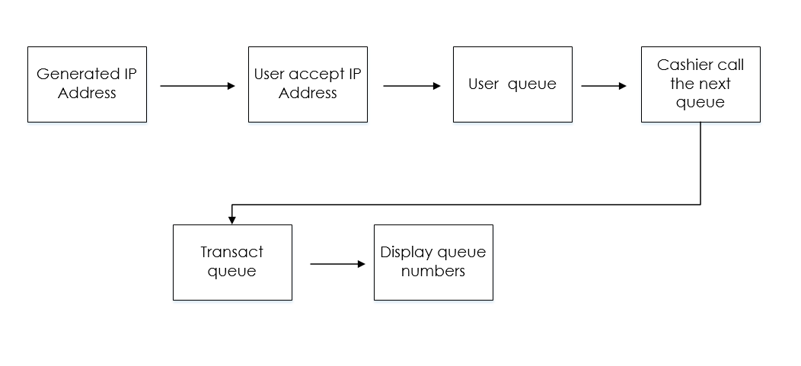

*Figure 1. Show the concept of queuing*

**Review of Related Literature**

**Theoretical Background**

In order to develop further and understand the study, the researchers made use of different reading materials and other references such as books, past thesis, web articles both foreign and local related to ordering system. It also serves as a guide to the researchers to achieve their target objectives.

Technology, understood as material culture, is a fundamental dimension of social structure and social change. It usually defined as the use of scientific knowledge to set procedures in a reproducible manner.

Through technology, Paperless Queuing System is even accessible to consumers through business gateways and it allows the user to connect fast and can feel free even its waiting.

**Related Literature**

**“FIFO”**

A queue can be defined in different ways. One definition of a queue is, “A particular data type or collection in which the entities in the collection are kept in order and the principal (or only) operations on the collection are the addition of entities to the rear

Terminal position, known as enqueue, and removal of entities from the front terminal position, known as DE queue. This makes the queue a First-IN-First-Out (FIFO) data structure.” This type of queue is an example of a linear data structure, or more abstractly a sequential collection. Another definition of queue is, “A line of people or vehicles waiting for something.” Both definitions are relevant to this project and will be elaborated in this review.

According to FIFO data structure, the first element added to the queue will be the first one to be withdrawn. This is parallel to the requirement that whenever an element is added, all elements that were added before have to be withdrawn before the new element can be withdrawn.

**“Study in Traffic Control and Queuing”**

“A queue is a waiting line of customers requiring service from one server to another and it is mathematical study of waiting lines or queue. It is extremely useful in predicting and evaluating the system performance. There are some applications of queuing like Traffic control, Health service and Ticket sales.”

* **(Shiwangi Yadav)**

**QLess Mobile Wait Management**

QLess is one of the virtual applications that provide queue management service to the users. The concept is easy – users are not necessary to be physically waiting in the line at the queue area, they can have their queue turn at the tips of their fingers instead. QLess provides a simple solution by alerting the users of real-time wait times at the store or office queue area, increasing demand for lower wait store or office while reducing demand for higher wait ones, thereby smoothing demand across supply. QLess is dedicated to letting people live more and wait less. QLess Mobile Wait Management dramatically reduces waiting in line or on hold by letting people join a mobile queue from their phones, roam freely and get notified as their turn approaches

**Web-based Queue Machine Development using Raspberry and ESP8266**

The queue system used previously uses a computer as a server and as a client. This system still has many disadvantages like the number of computer needed, that are same as the lockets. Moreover, the configuration is rather complicated. The expected queue system that uses Arduino Uno, NodeMCU ESP8266 (Wifi module) and Raspberry Pi 3(Raspberry). Raspberry itself (which runs the Raspbian operating system) functions as a server that can receive data request from NodeMCU ESP8266 that are available on the console or display via a wifi network. To display the queue at the P10 LED display counter, Arduino Uno as a miscontroller receives data from NodeMCU ESP8266.

**An Empirical Analysis of Queuing Model and Queuing Behaviour in Relation to Customer Satisfaction at Jkuat Students Finance Office**

The unpleasant experience of waiting in lines can often have a negative effect on the rest of a client’s experience with a particular organization. The way in which managers of organization address the waiting time issues is critical to the long term success of their organizations.

* **(Daves et al,2003)**

**CHAPTER II – METHODS**

Paperless Queuing system undergo such method like costing, hardware specification, pre-survey result, post survey result, schematic diagram and flowchart. These are the methods used to determine the process of queuing to develop the system and proper deployment to the School of ACLC College of Mandaue to determine the system is workable and to utilize. These helps the progress of the system for more specific and realistic function. The researcher’s conduct quantitative surveys in which the respondent (students) fill up forms using google form surveys and qualitative surveys asking the respondent (cashier, technical, and administrator) in verbal questions. The researcher’s compare these system to the current queuing system of the school universities, ticketing and banking. There are queue systems that uses papers to queue the process.

**Pre-Survey Questions and Result**

The survey used google form for quantitative respond of the respondent which is the students.

1. This part of the survey state that many students had been in a long queue. It shows that students experience long queues in schools.

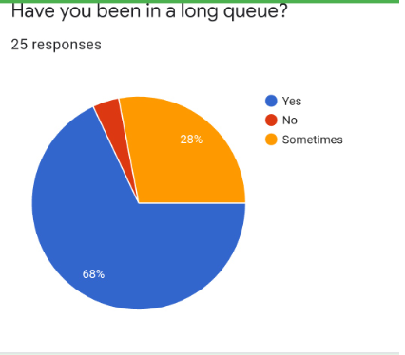

*Figure 2. Long Queue Process*

1. Student’s pissed-off while long queue ahead. This states that many students had been pissed with the issue of having a long queues in terms of payments or inquiry.

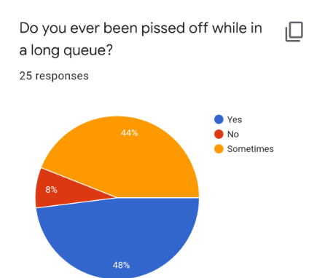

*Figure 3. Long Queue can be pissed-off*

1. The students and guardians does not know about the system called paperless queuing. They usually used paper when queuing.

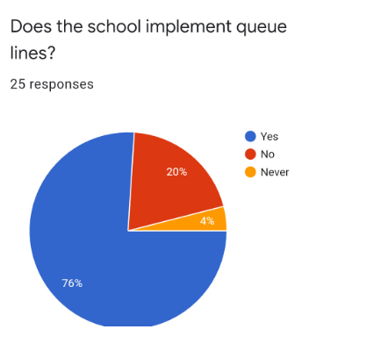

*Figure 4. Paperless queuing doesn’t exist.*

1. This part of the survey shows that schools has implement queue lines. Better way to implement queue lines to avoid manipulating the lines of the others.

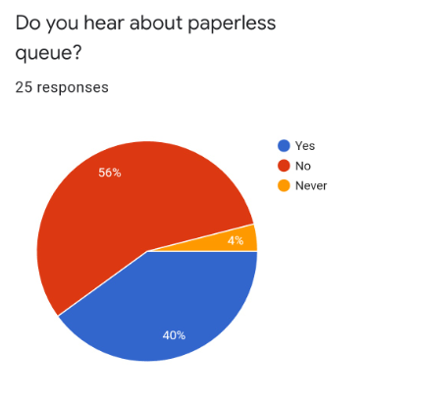

*Figure 5. Implement queues.*

1. 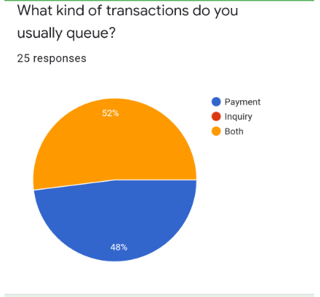This part of the survey explain that students has both inquiry and payment when they queue to cashier.

*Figure 6. Shows both payment and inquiry at the same time.*

1. 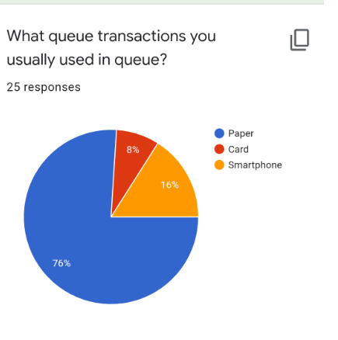This explains that many students queue their transactions through paper and not by the mobile platform. Details shown that student’s queues using paper and mobile platform does not apply.

*Figure 7. Paper is used in queuing.*

1. 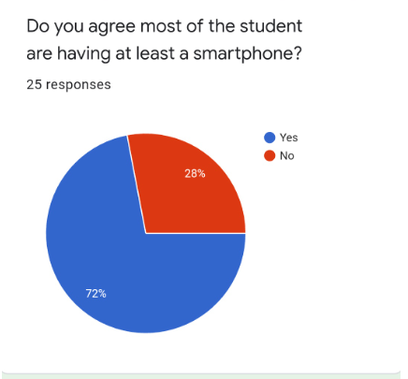This part of the survey explains the demand of smartphone. Even current system uses smartphone but not literally in schools, there are some system like inventory system, management systems and rental system are the highlight of the schools.

*Figure 8. Agree to use smartphone.*

1. 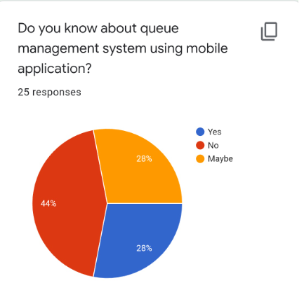This part of the survey explain on queue system does not apply to mobile application.

*Figure 9. Shows that mobile application is not used in queuing.*

1. 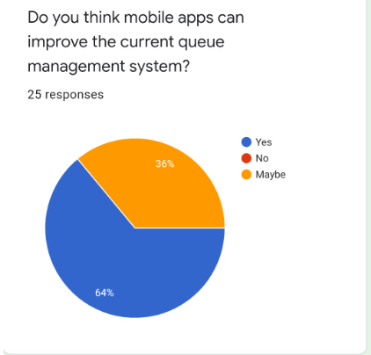This part of the survey explain that current queue system be improved with the used of smartphone.

*Figure 10. Improvements of queue process.*

1. It explain that paperless queuing system will be utilize with the used of smartphone and no doesn’t support paper transactions. Utilizing the paperless queuing system is a huge help for the school in which they can benefit the process in an easy way and convenient to the users.

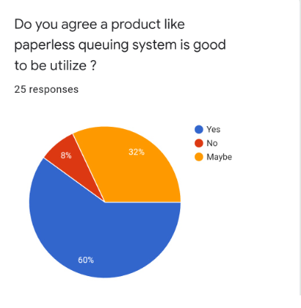

*Figure 11. Utilizing paperless queuing.*

**Pre-Survey Result**

|  |  |  |  |  |
| --- | --- | --- | --- | --- |
| **Questions** | **No. of respondent** | **Percentage** | | |
| 1. When a salon is closed, do you prefer to book online? | 10 | Yes | No | Sometimes |
| 68% | 4% | 28% |

*Table 1. Pre-Survey Result (Q1)*

|  |  |  |  |  |
| --- | --- | --- | --- | --- |
| **Questions** | **No. of respondent** | **Percentage** | | |
| 2. Before making a booking, Do you like to check the services offered directly on the website? | 10 | Yes | No | Maybe |
| 70% | 10% | 20% |

*Table 2. Pre-Survey Result (Q2)*

|  |  |  |  |  |
| --- | --- | --- | --- | --- |
| **Questions** | **No. of respondent** | **Percentage** | | |
| 3.Do you want to see first the upcoming deals and promotions before choosing a booking date? | 10 | Yes | No | Maybe |
| 90% | 10% | N/A |

*Table 3. Pre-Survey Result (Q3)*

|  |  |  |  |  |
| --- | --- | --- | --- | --- |
| **Questions** | **No. of respondent** | **Percentage** | | |
| 4. Is it helpful for you to display on the website, the reviews & testimonials, before and after pictures of past work before choosing a salon? | 10 | Yes | No | Maybe |
| 90% | N/A | 10% |

*Table 4. Pre-Survey Result (Q4)*

|  |  |  |  |  |
| --- | --- | --- | --- | --- |
| **Questions** | **No. of respondent** | **Percentage** | | |
| 5. Is it helpful for you to include a detailed description of treatments & services displayed on the website? | 10 | Yes | No | Maybe |
| 100% | N/A | N/A |

*Table 5. Pre-Survey Result (Q5)*

|  |  |  |  |  |
| --- | --- | --- | --- | --- |
| **Questions** | **No. of respondent** | **Percentage** | | |
| 6. Do you also want to know the information on products used or for sale at the salon? | 10 | Yes | No | Maybe |
| 90% | N/A | 10% |

*Table 6. Pre-Survey Result (Q6)*

|  |  |  |  |
| --- | --- | --- | --- |
| **Questions** | **No. of respondent** | **Percentage** | |
| 7. Do you like to check other salons on the same website after checking one salon you visited online? | 10 | Yes | No |
| 90% | 10% |

*Table 7. Pre-Survey Result (Q7)*

|  |  |  |  |
| --- | --- | --- | --- |
| **Questions** | **No. of respondent** | **Percentage** | |
| 8. Which of these two features are most important to you on the salon/barber/spa website? | 10 | Products for sale online | Blog and news on the latesttrends |
| 60% | 60% |

*Table 8. Pre-Survey Result (Q8)*

|  |  |  |  |  |
| --- | --- | --- | --- | --- |
| **Questions** | **No. of respondent** | **Percentage** | | |
| 9. This software can help to search available Salons and get directions via Google Map. Do you like the concept of the Software? | 10 | Yes | No | Maybe |
| 100% | N/A | N/A |

*Table 9. Pre-Survey Result (Q9)*

|  |  |  |  |  |
| --- | --- | --- | --- | --- |
| **Questions** | **No. of respondent** | **Percentage** | | |
| 10. Is it helpful for you to use a website that can find the nearest salon and display the location and prominently displayed the salon opening hours? | 10 | Yes | No | Maybe |
| 100% | N/A | N/A |

*Table 10. Pre-Survey Result (Q10)*

**Post Survey**

The survey used google form for quantitative respond of the respondent which is the students.

1. This part of the system state that the process flow of the Paperless Queuing System is considered good out of excellent.

*Figure 12. The Process Flow of the System.*

1. These survey state that the functionality of the system is good out of excellent because the students see how the functionality works.

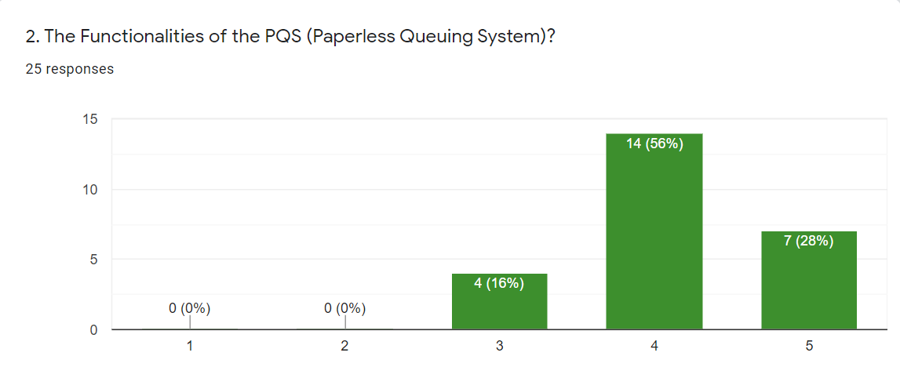

*Figure 13. The Functionality of the System.*

1. The survey states that the features of the system is more likely good as students observe the given demonstration.

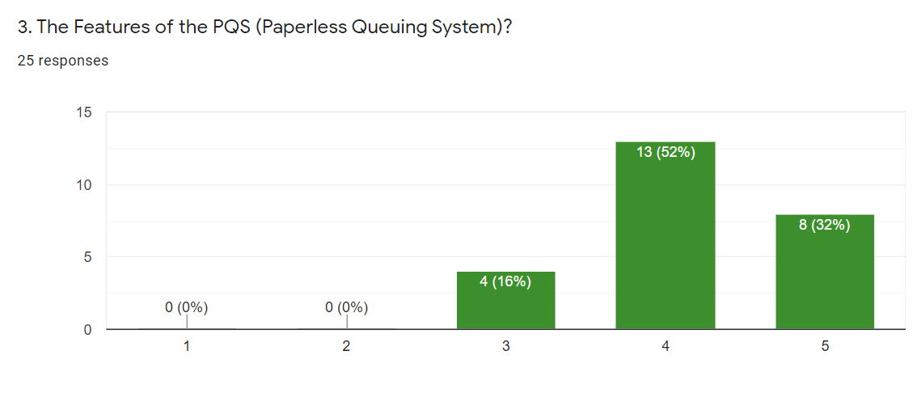

*Figure 14. The features of the System.*

1. 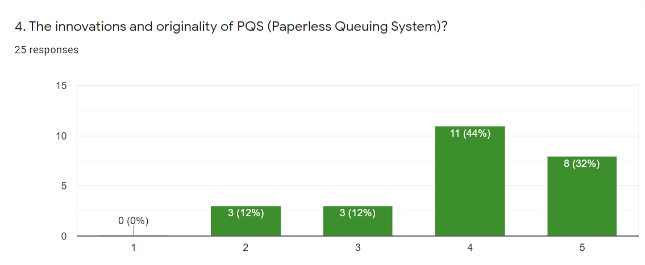These explain that the originality of the system is good than any other queue system.

*Figure 15. The Originality of the System.*

1. 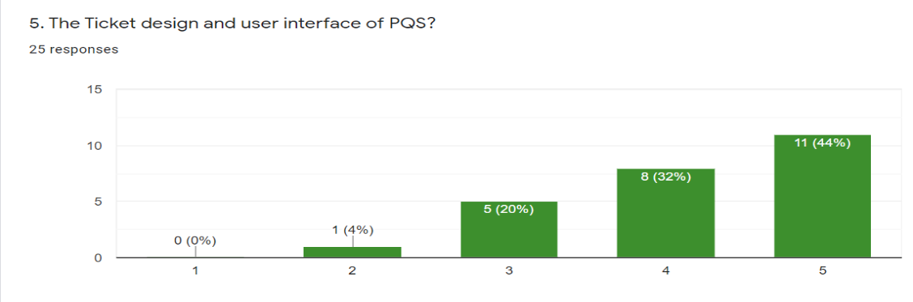The survey states that the user interface is more likely excellent as students observed in the demonstration. Ticket is use with paper but compare to the Paperless queuing there’s no need to use paper for this system.

*Figure 16. The User Interface of the System.*

1. These explain the overall reactions of the students which means they can say a lot of things based on the observation about the Paperless Queuing Systems indeed most of the users/ students are agreed the functionality and the better way to queue a process.

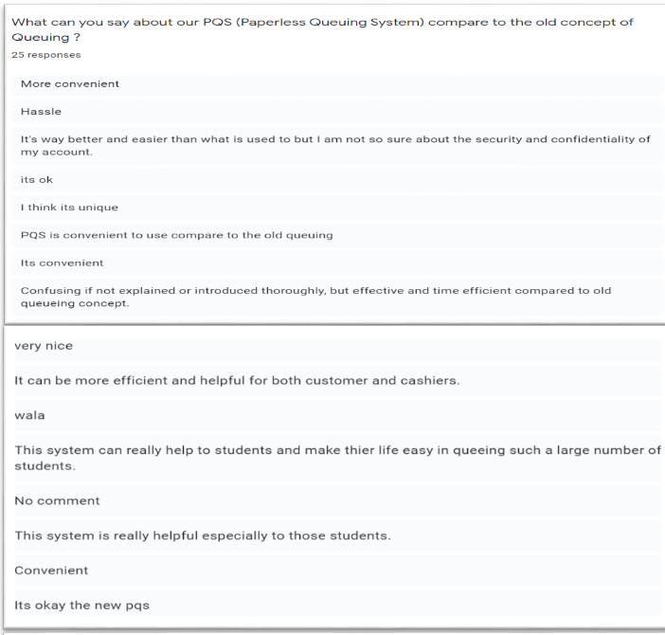

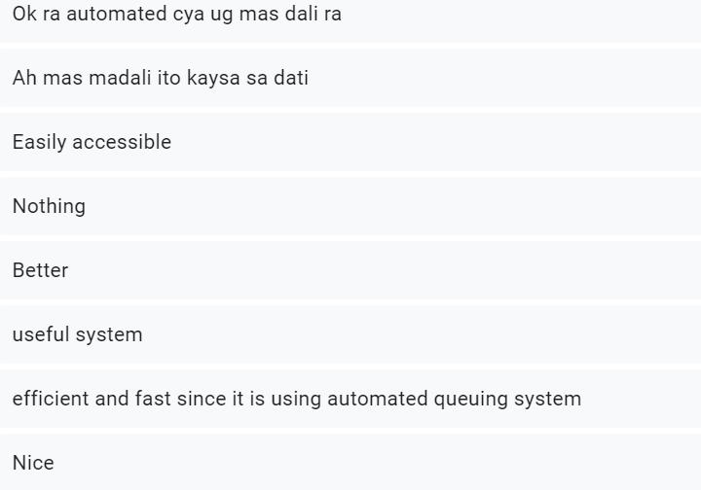

*Figure 17. The Students reaction about the system.*

1. These explain that most of the users/ students are agreed that paperless queuing system are more convenient, hassle free and useful for the school.And also the school can benefit this kind of queue.

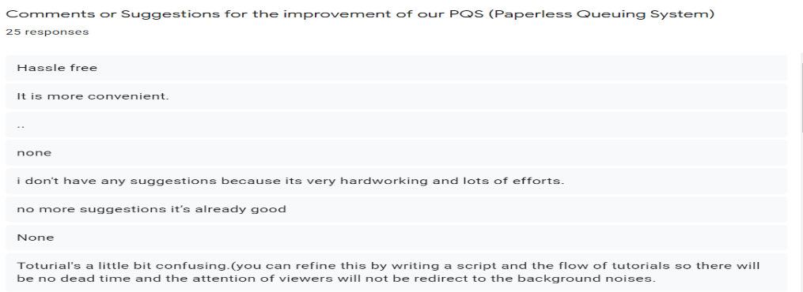

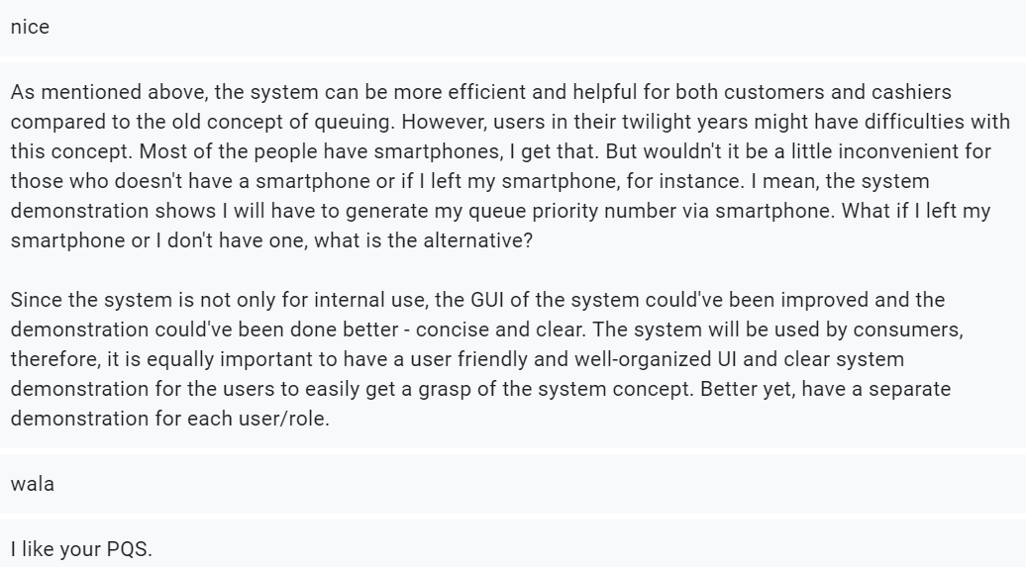

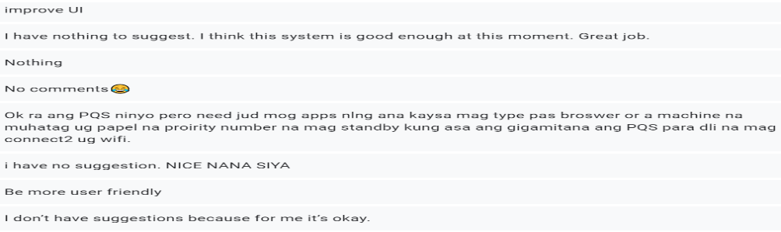

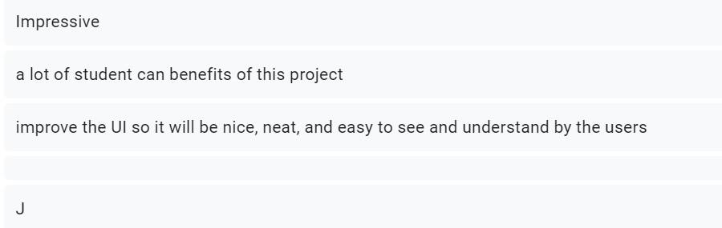

*Figure 18. Comment and suggestion of the system.*

**Result**

|  |  |  |  |  |  |  |
| --- | --- | --- | --- | --- | --- | --- |
| **Questions** | **No. of respondent** | **Percentage** | | | | |
| 1. The process flow of the PQS (Paperless Queuing System)? | 25 | 1 Extremely Bad | 2  Bad | 3  Fair | 4  Good | 5  Excellent |
| 0(0%) | 0(0%) | 5(20%) | 12(48%) | 8(32%) |

*Table 11. Post- Survey Result (Q1)*

|  |  |  |  |  |  |  |
| --- | --- | --- | --- | --- | --- | --- |
| **Questions** | **No. of respondent** | **Percentage** | | | | |
| 2. The Functionality of the PQS (Paperless Queuing System)? | 25 | 1 Extremely Bad | 2  Bad | 3  Fair | 4  Good | 5  Excellent |
| 0(0%) | 0(0%) | 4(16%) | 14(56%) | 7(28%) |

*Table 12. Post- Survey Result (Q2)*

|  |  |  |  |  |  |  |
| --- | --- | --- | --- | --- | --- | --- |
| **Questions** | **No. of respondent** | **Percentage** | | | | |
| 3. The Features of the PQS  (Paperless Queuing System)? | 25 | 1 Extremely Bad | 2  Bad | 3  Fair | 4  Good | 5  Excellent |
| 0(0%) | 0(0%) | 4(16%) | 13(52%) | 8(32%) |

*Table 13. Post- Survey Result (Q3)*

|  |  |  |  |  |  |  |
| --- | --- | --- | --- | --- | --- | --- |
| **Questions** | **No. of respondent** | **Percentage** | | | | |
| 4. The Innovations and Originality of PQS  (Paperless Queuing System)? | 25 | 1 Extremely Bad | 2  Bad | 3  Fair | 4  Good | 5  Excellent |
| 0(0%) | 3(12%) | 3(12%) | 11(44%) | 8(32%) |

*Table 14. Post- Survey Result (Q4)*

|  |  |  |  |  |  |  |
| --- | --- | --- | --- | --- | --- | --- |
| **Questions** | **No. of respondent** | **Percentage** | | | | |
| 5. The ticketing design and user interface of PQS  (Paperless Queuing System)? | 25 | 1 Extremely Bad | 2  Bad | 3  Fair | 4  Good | 5  Excellent |
| 0(0%) | 1(4%) | 5(20%) | 8(32%) | 11(44%) |

*Table 15. Post- Survey Result (Q5)*

**Cashier Survey**

Cashier area has assign two person to transact the student’s credentials. The researchers ask them verbal question for the alignment of the system.

1. How many students in a normal days come to transact in cashier area?

**Answer:**

Both cashiers said that 500+

1. In what mode of transaction does the students do?

**Answer:**

Payment for tuition fee, documents, school uniform & etc.

1. Does the school implement queue lines?

**Answers:**

Both of them say YES

1. What do you feel if the cashier area is crowded?

**Answer:**

Stressful, haggard, very annoying

1. What do you think the best thing you can do in cashier area to avoid crowded people?

**Answer:**

Inform them to form a line.

1. Do you think system like paperless queuing help the cashier area avoid crowded students?

**Answer:**

Both of them say YES.

1. If the school will implement paperless queuing system, do you think it can help you as a cashier?

**Answer:**

Both of them say YES.

1. What benefit will you get if there is paperless queuing system in the school?

**Answer:**

Easy work and less work

More convenient for us.

Faster transaction.

**Technical Survey**

Two technical personnel assign to manage the network addressing to support queue process. The researchers ask them verbal question for the alignment of the system.

1. As technical staff, do you think that Local Network can dominate the same IP Address like 100 students share IP Address? How?

**Answer:**

Yes, The School will add dedicated network to avoid logging of the process.

1. Do you think this can help you as technical staff this kind of network addressing? Why?

**Answer:**

Yes, More convenient.

1. What can you say about the Paperless queuing system as technical?

**Answer:**

Nice

1. Does the project can help a lot to solve the issue of crowded students?

**Answer:**

Yes, actually it will.

1. What benefit will you get if there is paperless queuing system in the school?

**Answer:**

Help mother earth and save the trees.

**Research Design**

Gathering the data on how the survey was done and how the question was answered. Google forms help the researcher’s to undergo the study on paperless queuing system. Data that gather for the researchers are both quantitative and qualitative surveys. To explain and improve the proposed systems of the researchers.

Queue process are widely enhance by other business transactions such us banking, school credentials, business permit, and etc. This project is develop to maintain the said alignment of queue, the proper procedures and to monitor the queue in organized way. These system shows feasibility: however a queue process must be design to meet the proper integration and faster way of queue without any hesitations to the users.

The system usability must runs on both hardware and software, the software have any operating systems that supports Windows 7 & up-to-date windows because it deals with IP Address connectivity or above in desktop platform and mobile platform. This systems may comply with windows operating system as long as the connectivity of an IP Address suits for Ethernet connections, Wi-Fi or hotspot. The hardware main board is design to program the system function to indicate the connection of the link or IP Address given, its constraints lacks a full operating system but can run written code that is interpreted by its firmware.

**Description of the Respondents**

The researchers aim to develop a device that is unique, useful and ease of use for this project. To integrate and innovate a project there must be a respondents, in which the respondent has knowledge to answer the question thrown to them and give them questionnaire. They must be legible to finish the question giving to them and answer honestly, for the researcher’s intellect and to support the information needed.

These survey was created through the use of google form. These are the respondents (student and guardians) for Pre-Survey.

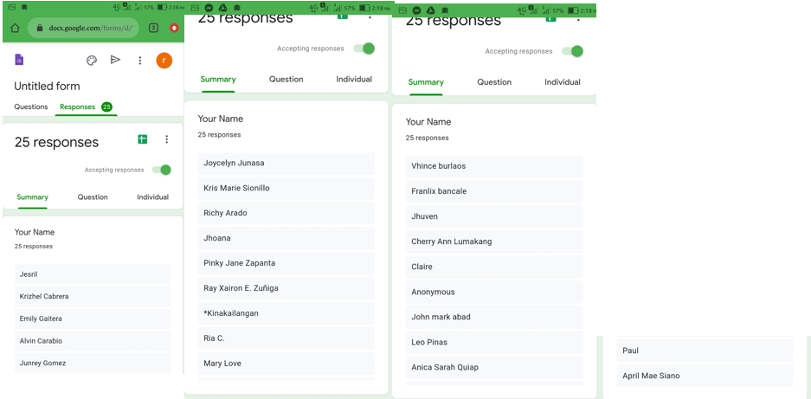

*Figure 19. Shows the 25 respondents answer the survey*

These survey was created through the use of google form. These are the respondents (student and guardians) for Post-Survey.

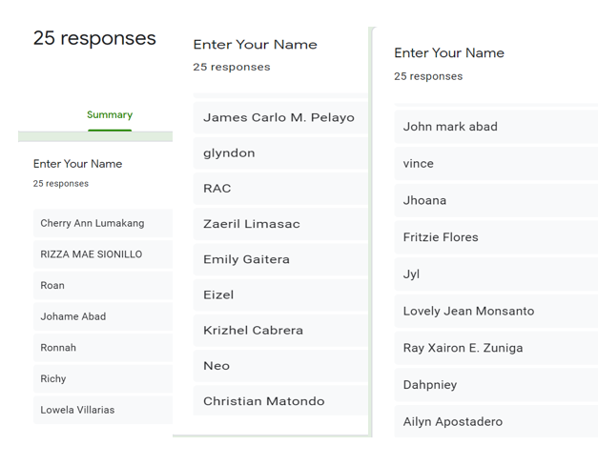

*Figure 20. Shows the 25 respondents answer the survey*

**Research Instruments**

**“**PSQ (Paperless Queuing System)” main functionality is to generate a software that allows the users to queue by organized way, select a transaction, and give priority number to PWD through an IP address. It will also requires an internet connection to receive the given IP Address. The mobile application allows the user to manage their queuing and the web page will monitor the process.

These are the instrument of the PSQ (Paperless Queuing System):

**COMPONENT**

* **Raspberry PI Board**

It is a component that will generate the process of queue to the user in which the IP Address is supported or created.

* **Monitor**

It allows the users to know the next transaction prior to them where view point of transaction is described.

* **Pi Power Supply**

It is a component where the connector of the Raspberry PI Board as a battery.

* **LED Screen Power**

This will be the blink of the monitor when the queue transaction was done,

**USER INTERFACE APPLICATION**

* **Mobile Application**

It is an application where the user look for the process of queuing, received an IP address and managed there queue.

* **Web page Application**

It is an application where the process of queuing was given and managed through IP address and used by the user as there queue number. It will also monitor and set the limit of transaction.

* **IP Address**

It is the main queue process happen and received by the user and monitor by the administration.

**Hardware Specification**

**Development**

|  |  |
| --- | --- |
| **Hardware Specification for Web/Desktop/Mobile App Development** | |
| **PC** | |
| Processor | Intel Core i5-6500 (2.4 GHz, 3MB L3 Cache) |
| Memory | 4 GB DDR4 Memory |
| Storage | 240 GB M.2 2280 Solid State Drive |
| Display | 14" LCD w/ 1366x768 px resolution |
| Battery | Lithium Ion (Li-Ion) 2800 mAh |
| Communication | WLAN: IEEE 802.11ac / LAN: Gigabit Ethernet |
| **Wi-Fi Router** | |
| Type | Wi-Fi access point, Local Network, Mobile Wifi |
| Wireless Standard | 802.11n, frequency 2.4 / 5 GHz |
| Protection Information | WEP, WPA, WPA2, 802.1x |
| **Mobile Phone** | |
| Processor | MediaTek MT6750 Octa Core |
| Memory | 16GB ROM, 2 GB RAM |
| Display | Touch screen1080x2160 Resolution(5.70) |
| Battery | Non-removable Li-Ion 4130 mAh battery |
| Communication | WLAN: Wi-Fi 802.11 b/g/n, Wi-Fi Direct, hotspot |

*Table 16. Hardware Specification for Web & Mobile App Development*

|  |  |
| --- | --- |
| **Software Specification for Web/Desktop/Mobile App Development** | |
| **PC** | |
| Operating System | Windows 8.1 |
| Languages | Php 7, Mariadb , Apache 2 |
| Frameworks, & Libraries | Node.js, Vue-Router, Apache Cordova, IP Address, WebSocket |
| IDE's & Tools | Php 7, Rasppian OS, Notepad |
| Web Browsers | Google Chrome |
|  |  |

*Table 17. Software Specification for Web & Mobile App Development*

|  |  |
| --- | --- |
| **Hardware Specification for Arduino Development** | |
| **PC** | |
| Processor | Intel Core i5-6500 (2.4 GHz, 3MB L3 Cache) |
| Memory | 4 GB DDR4 Memory |
| Storage | 240 GB M.2 2280 Solid State Drive |
| Display | 14" LCD w/ 1366x768 px resolution |
| Battery | Lithium Ion (Li-Ion) 2800 mAh |
| Communication | WLAN: IEEE 802.11ac / LAN: Gigabit Ethernet |
| **Arduino Components** | |
| Microcontrollers | Raspberry Pi 3 model B + |
| Tv / Monitor | Full HD (FHD) aka 1080p aka HD resolution |
| LED Screen HDMICable | support 8k@60Hz and 4k@120Hz,Bandwidth capacity up to 48Gbps |
| Pi Power Supply (Micro USB) | Raspberry pi power supply, LED Screen Power |
| LED Screen Power (Micro USB) | The maximal power consumption of a pitch16mm LED display is 15624 x 0.1 W = 1.56 pero square meter |
| 1 TX Port | ATmega 328p – 8 bit AVR family microcontroller, Operating Voltage 5V |

*Table 18. Hardware Specification for Arduino Deployment*

|  |  |
| --- | --- |
| **Software Specification for Arduino Development** | |
| **PC** | |
| Operating System | Windows 8.1 |
| Languages | Php 7, Mariadb , Apache 2 |
| IDE's & Tools | Visual Studio Code, Android SDK, GitHub, Devtools |
| Libraries | IP Address, SoftwareSerial |

*Table 19: Software Specification for Arduino Development*

**Deployment**

|  |  |  |
| --- | --- | --- |
| **Hardware Specification for Paperless Queuing System** | | |
| **Arduino Components** | | |
| Microcontrollers | Raspberry Pi 3 Model B+, Raspian OS | |
| TV / Monitor | Full HD (FHD) aka 1080p aka HD resolution | |
| LED Screen HDMI Cable | support 8k@60Hz and 4k@120Hz, Bandwidth capacity up to 48Gbps | |
| Pi Power Supply (Micro USB) | Soulbay 5V 3A Micro USB AC Adaptor with 6 feet Long, Cord for Raspberry Pi 3 2 Model B | |
| LED Screen Power (Micro USB) | The maximal power consumption of a pitch16mm LED display is 15624 x 0.1 W = 1.56 pero square meter | |
| 1 TX Port | ATmega 328p – 8 bit AVR family microcontroller, Operating Voltage 5V | |
| **Mobile Phone** | | |
| Processor | | MediaTek MT6750 Octa Core |
| Memory | | 16GB ROM, 2 GB RAM |
| Display | | Touch screen1080x2160 Resolution(5.70) |
| Battery | | Non-removable Li-Ion 4130 mAh battery |
| Communication | | WLAN: Wi-Fi 802.11 b/g/n, Wi-Fi Direct, hotspot |
| **Wi-Fi Router** | | |
| Type | | Wi-Fi access point |
| Wireless Standard | | 802.11n, frequency 2.4 / 5 GHz |
| Protection Information | | WEP, WPA, WPA2, 802.1x |

*Table 20. Hardware Specification for Paperless Queuing System*

|  |  |
| --- | --- |
| **Software Specification for Paperless Queuing System Development** | |
| **Tablet** | |
| Operating System | Android (5.0) Lollipop |
| Software | IP Address Link |

*Table 21. Software Specification for Paperless Queuing System Development*

|  |  |
| --- | --- |
| **Hardware Specification for Admin Development** | |
| **PC** | |
| Processor | Intel Core i5-6500 (2.4 GHz, 3MB L3 Cache) |
| Memory | 4 GB DDR4 Memory |
| Storage | 240 GB M.2 2280 Solid State Drive |
| Display | 14" LCD w/ 1366x768 px resolution |
| Battery | Lithium Ion (Li-Ion) 2800 mAh |
| Communication | WLAN: IEEE 802.11ac / LAN: Gigabit Ethernet |
| **Mobile Phone** | |
| Processor | MediaTek MT6750 Octa Core |
| Memory | 16GB ROM, 2 GB RAM |
| Display | Touch screen1080x2160 Resolution(5.70) |
| Battery | Non-removable Li-Ion 4130 mAh battery |
| Communication | WLAN: Wi-Fi 802.11 b/g/n, Wi-Fi Direct, hotspot |

*Table 22. Hardware Specification for Admin Development*

|  |  |
| --- | --- |
| **Software Specification for Admin Development** | |
| **Android Platform** | |
| Operating System | Android 8.0 (Oreo) |
| Software | IP Address Link |
| **Desktop Platform** | |
| Operating System | Windows 8.1 |
| Software | IP Address Link |
| **Web Platform** | |
| Operating System | Windows 8.1 |
| Browser | Google Chrome |

*Table 23. Software Specification for Admin Development*

**Costing**

|  |  |  |  |
| --- | --- | --- | --- |
| **Development: Hardware** | | | |
| **Functional Hardware** | **Qty** | **Price** | **Total Cost** |
| Raspberry Pi 3 Model B+ | 1 | ₱ 2945.00 | ₱ 2945.00 |
| Sd Card 16Gb w/ OS | 1 | 750.00 | 750.00 |
| HDMI Cable 1.3 meter | 1 | 250.00 | 250.00 |
| Keyboard | 1 | 450.00 | 450.00 |
|  |  |  |  |
| **Total Functional Hardware Cost** | | | **₱ 3945.00** |
|  | | |  |
| **Non-Functional Hardware** |  | | **Total Cost** |
| Devant LED Monitor | ₱ 10,000.00 |
| Lenovo Laptop Series i5 | 24,000.00 |
| Asus Phone version 8.0 | 12.000.00 |
| Ethernet | 0.00 |
|  |  |
| **Total Non-Functional Hardware Cost** | | | **₱ 46,000.00** |
| **Total Hardware Cost** | | | **₱ 49.000.00** |
| **Development: Software** | | |  |
| **Software** |  | | **Total Cost** |
| Google Chrome | ₱ 0.00 |
| Visual Studio Code | 0.00 |
| IP Address Link | 0.00 |
| Raspian OS | 0.00 |
| Php 7 | 0.00 |
| Mariadb |  | | 0.00 |
| Apache2 |  | | 0.00 |
| Notepad |  | |  |
| **Total Software Cost** | | | **₱0.00** |
|  | | |  |
|  | | |  |
| **Deployment: Hardware** | | |  |
| **Functional Hardware** | **Qty** | **Price** | **Total Cost** |
| Raspberry Pi 3 Model B+ | 1 | ₱ 2945.00 | ₱ 2945.00 |
| Sd Card 16Gb | 1 | 650.00 | 650.00 |
| HDMI Cable 1.3 meter | 1 | 250.00 | 250.00 |
|  |  |  |  |
|  |  |  |  |
| **Total Functional Hardware Cost** | | | **₱ 3,845.00** |
|  | | |  |
| **Non-Functional Hardware** |  | | **Total Cost** |
| Samsung Tablet | ₱ 5,000.00 |
| Ethernet | 0.00 |
|  |  |
|  |  |
|  |  |
| **Total Non-Functional Hardware Cost** | | | **₱ 5,000.00** |
| **Total Hardware Cost** | | | **₱ 8,845.00** |

|  |  |  |
| --- | --- | --- |
| **Deployment: Software** | | |
| **Software** |  | **Total Cost** |
| Google Chrome | ₱ 0.00 |
| IP Address Link | 0.00 |
| Raspian OS | 0.00 |
| Php 7 | 0.00 |
| Mariadb | 0.00 |
| Apache2 |  | 0.00 |
| Notepad |  | 0.00 |
|  |  |  |
| **Total Software Cost** | | **₱ 0.00** |  |
|  | |  |

**Flowchart**

*Figure 21. Process Flow of the System*

**Data Collection or Data Gathering Procedure**

The survey was conducted on 25 respondents of targeted users which is the students of ACLC College of Mandaue. For Post survey, the researcher’s was conducted 25 respondent through the use of google form which means the feasibility and goodness of the system if ever it will deploy. The staff which 2 cashiers involved and 2 personnel for technical department to support the proper connection of the network.

The data given by the staff, technical personnel and the students are fact. In fact this system is new to them, even if they hear about the queue system. That’s why the researcher’s plan and analysis the data to prove that the paperless queuing system will exist.

The reason of choosing the School is because the school doesn’t have queue management system. The survey was conducted through google form which the researcher send links to the students and send it back to know there interaction.

In developing the project the researchers has 25 respondents to support the concrete information on this study. Base on the respondents the school doesn’t have a proper queuing for inquiring their credentials on the cashier. The researchers also found out that the queue takes longer due to manipulating the lines and personal assessment. There’s a possibility that this project will be implement in schools, business transactions like banking, business permit and etc. due to the respondent response to the survey.

**CHAPTER III – RESULTS**

**Data Presentation**

Data Presentation is essential for supporting the previously identified hypothesis. It validates the purpose of the project and helps in the holistic development of the Paperless Queuing. For gathering data, a questionnaire survey was conducted. The survey comprises of 10 sets of question. The survey was then distributed to 25 respondents who are the students on ACLC College of Mandaue. The survey shows the aspects of question’s such as implementing the process of queuing, the long wait of queuing, paperless queuing and how would be done in school. Student is the target of the survey who bound to support the project.

In Post survey, there 25 respondents who answers the question through the use of google form. The survey comprises of 7 sets of question. The surveys explain that the result of the systems usability, functionality and feasibility are innovative.

For the cashiers, the researchers use verbal questions to interrogate the 2 cashiers. Based on the cashier the paperless queuing system is very useful and helpful for them, they says that this queue system avoid them from stress, crowded people and mental emotions.

For the Administration, the researcher’s uses also verbal question to interrogate them. Based on them paperless queuing system help them to lessen the paper transactions. This is a new way of queuing to avoid crowded people and to implement physical distancing.

For the Technical Personnel, the researcher’s uses also verbal question to interrogate them. Based on them paperless queuing system is more convenient and give them easy access for the dedicated device.

The data presented in the project is through google form and verbal questions which the researcher’s aim to give the respondent a questionnaire that need to answer basing on the process of the school queue.

**Data Interpretation**

These area refers to the implementation of process through which data is reviewed for the purpose of arriving at an informed conclusion. In this, the researcher given a data in a form of google form to answer a set of questions. And a verbal questions to support the study.

The respondents of this studies are students whose questions are related to queue process and how it is done in school or outside in the school and answer the questions in a positive response.

The cashiers are also the respondent of the study whose questions are related to the process of queue alignment, the usability of the system and the functionality of the system. Based on the result the system is more likely usable and good to be utilized.

The administrators are part of the respondent to the study whose questions are related to the process of queue alignment, the significant of the system and usability. Based on the result queue system is good to implement in the school.

The technical are also part of the respondent to the study because they are the alignment of the network for setting up the server of the system.

**Data Analysis**

The purpose of the survey/questionnaire is to analyze demographical preference of the target audience towards using the PQS (Paperless Queuing System) and familiarization with the use of smartphone or any types of gadget that will generate the process. The researchers gather the data that will complement the device and the survey shows that it is better to utilize the paperless queuing system to the school in ACLC College of Mandaue. The researchers also found out that using a generated IP Address through the use of smartphone is innovative and useful for the respondent and so the device as well. User manual also guided in making this project.

Paperless Queuing” process will be using an IP address to generate the intended users (student) and the Administrator. The process is to give an IP address to each user and let the user received the IP address given and select the type of queue, if there are some PWD they will be given priority number prior to the user. The user will be ask to go to the dashboard to see their queuing number. And let the user choose what type of transaction they want to queue.

The project work is to designed and implement by raspberry pi 3 model B+ which is an upgraded Arduino board, HDMI cable, Pi power supply, raspberry OS and local server or internet to dominate the IP Address to the users using there smartphones or any types of devices that will can access the IP Address.

Queuing consist of web page application wherein it will dominate and monitor the transaction of queue, the selection of the process and the data of each transaction. It will also features the color coding process in which (orange) dashboard (green) has been queued (red) called again.

Next is the mobile-based application it will serve us the end-user’s application where the user queue the process and select the queue. It will also serve as the controller of the queue or the user interface.

PSQ (Paperless Queuing System) was designed to develop paperless transaction and it is built by robotic Arduino. Arduino is a device that makes embedded programming much easier and it is good at single core function and cost less because it’s capable of combine a component to work together.

**CHAPTER IV – DISCUSSION**

The data that the researchers gather is more valuable for helping the projects visible and the surveys will implies the uses of the queue system to prove that the study exist. The primary goal of the PSQ (Paperless Queuing System) or queue process is to generate a transmission of data through link/ IP address to queue, and too innovate the paperless transaction of any types of queuing. The devices is design to be simple so that the user will used as soon it may done. However users/clients may still require some supplementary information about the component of the devices and support the detail requirements needed. Since the documentation is ongoing the support system of the project may still run as long the prototype is done. After the completion of the design and will be implemented the user manual can be provided to support the said project or device.

**Summary**

PQS (Paperless Queuing System) is an innovate way of queuing which generate an IP Address send to the user using any types of gadgets like smartphone, tablet, Personal Computer etc. and click the given IP Address received to queue a transaction for the flexibility and faster transactions of the users paperless. This will also provide hassle free transaction for business inquiry, payments and other business credentials to avoid the user to be doubtful to queue in the cashier. It definitely helps the organizations to increase the customer satisfaction thus enhance the image of the organizations.

In chapter 1, it explains the process on how the paperless queuing system is gather and implied to support the feasibility of the system. How queue system from the current queue process is done. The queue process from the current process is different now because the paperless queuing doesn’t support paper and it is easily to transact with the use of any gadget that will generate the process using IP Address. How useful is the queuing system from other universities or government issuance was made. It is useful because the staff will no longer feel the stress of being in the crowded people. How important if the system is being deployed to the school and how to use this paperless queuing and how the users, the school, the guardians, the staff, the technical and the administration benefits the system. The objective of this system is to develop the innovative way of queuing with no paper needed and hassle free for the staff to queue the transactions.

In chapter 2, the researchers needed a method to support and analyze the data. These are the pre-survey, post survey, personal questions to the staff about the queuing system that the school doesn’t have. The costing of the system, the hardware and software specification, the respondent survey and result. The researchers needed this method to gather specific data and alignment to the system. The integration and functionality of the system is a must, these are combine quantitative and qualitative materials to develop the system. The method help the researchers to surpass the misconception of the system. These will prove that methods are the way to provide the main purpose of the study due to the respondent who are being true by answering the questions given by the researchers. The respondent and the staff says that the system is better that the current queuing system of the other universities, the functionality and uses of the system is very admirable and useful.

In chapter 3, which is the result of the chapter 2 methods in which the progress of the chapter 2 answers the result in chapter 3. The graph will show how useful and innovative the paperless queuing system is. The results gather from the chapter 3 is fact and justified by the chapter 2.

In a way that the result will prove how the system is develop slowly and mold by the respondent response. And also the staff of the school helps a lot to cooperate the said matter. These are the evidence that the researchers will hold and apply these sooner.

In chapter 4, the summary of all the chapters from 1 to 4 is applied. The recommendations and conclude for the users, staffs, administrator, researcher’s and future researchers that will deploy the system is the way of data gathering to support the project. The researcher’s data is fact even the small data count to make this project successful. The focus of this study is the data gathering from any person who are involved in the project and testing the project is a must to believe the respondent that the prototype is working.

The project will be developed using mobile and web platform. There is over millions of smartphones and devices throughout the world which using Android operating systems to run their devices. It is the largest mobile platform and the number is still growing every day.

**Conclusion**

The researcher conclude that this type of queuing provides a better and faster way to queue a transaction in organized process which is also an environment friendly that doesn’t support paper transaction. This is helpful for any kind of queue transaction for a better solution. The main goal of the researcher is to innovate an ease of use queue process that leads the users unhesitant to queue. And to avoid a disorganize way of queuing by ambushing and manipulate the lines of the others. The development of system will be using the INTRODUCTION METHOD RESULT AND DISCUSSION (IMRAD) method. The researchers also conclude that the system is valuable to the users and the staffs like avoiding the crowded people, social distancing issues, hassle free transactions, easy queuing process and can save time.

By evaluating the process of Paperless Transaction, this system could help promote the “Eco-friendly” solution by creating an awareness to improve paper waste management thus preventing greenhouse effect which can harm the environment. In align with government encouragement in using smartphones, this application has a better future in the market as it helps society to manage time for daily activities.

The GUI of this system is simple that the researchers is basing the concept color and logo of the school. The AMA logo has a three button to get the priority and number, the log-in of the cashier and admin, lastly the status of the queue transaction. The researcher conclude to use this concept since the school doesn’t have a queuing system.

**Recommendation**

For improvement purposes, several suggestions can be imposed on Paperless Queuing System based on the conducted test. We recommend this project simply because the Philippines experiencing the pandemic it is the because of the virus called COVID-19. In a way that the researchers help to avoid crowded people as long as you are in the same ground like school. The users will no longer fall in line to queue the process let the network help you to generate the IP Address given and proceed to queuing. Another thing is the staff will no longer feel the pain of stress in which crowded people is too much to transact the process. They don’t able to see many people in front them. Another thing from the user’s side you can do the same things like studying from the library while you’re in queue, if the queue is not called no need to worry about that because you are in a list of queuing after you receive the given IP Address.

For future researchers, we encourage you to upgrade any possible feasibility that the devices has to be. The researcher’s is applying only the queue process, the history of the cashier and the database does not apply on the process, we challenge you to do this and also give message alert wants the student is done for this queue.

Projects on using eco-friendly devices is much better than any other obsolete devices. It’s our honor and privilege to look forward of your project. There are millions of mobile and web applications that we our using every day and even single code can derived to develop a project that is more reliable and resourceful using recyclable hardware.

**References**

**Web Resources**

**Docs, Guides, and Codes**

* https://forms.gle/j6RMEzBJyYjrRnSaA
* https://www.raspberrypi.org/downloads/raspberry-pi-os/
* https://www.raspberrypi.org/documentation/raspbian/applications/omxplayer.md
* https://www.php.net/manual/en/book.ds.php
* https://www.php.net/manual/en/function.msg-set-queue.php
* https://q4m.github.io/
* https://www.npmjs.com/package/student-queue-mariadb-plugin
* https://whstatic.1and1.com/help/CloudServer/EN-US/d849943.html
* https://onlinerandomtools.com/generate-random-ip
* https://generate.plus/en/address/ip
* https://www.slideshare.net/mobile/Nab287/queue-38646798
* https://www.slideshare.net/mobile/RojanPariyar/presentation-on-queue
* https://learn.jquery.com/effects/queue-and-dequeue-explained/
* https://stackoverflow.com/questions/1058158/what-are-queues-in-jquery

**Appendices**

**Pre-Implementation Survey**

Name:

“PSQ” is a proposed IT Capstone project that will develop an innovate Paperless Queuing System. It is design in organizing queues at every department in school which expected to have a large number of students daily. It is a process of system that encourage the students to use their smartphone to develop an ease of use devices such a queue.

1. Have you been in a long queue?

* Yes
* No
* Sometimes

1. Do you ever been pissed off while in a long queue?

* Yes
* No
* Sometimes

1. Do you hear about the paperless queue?

* Yes
* No
* Sometimes

1. Does the school implement queue lines?

* Yes
* No
* Sometimes

1. What kind of transactions you usually queue?

* Paper
* Card
* Smartphone

1. Do you agree most of the student are having at least smartphone?

* Yes
* No

1. Do you know about the queue management system using mobile application?

* Yes
* No
* Maybe

1. Do you think mobile apps can improve the current queue management system?

* Yes
* No
* Maybe

1. Do you think mobile apps can improved the current queue management system?

* Yes
* No
* Maybe

1. Do you agree a product like paperless queuing system is good to be utilize?

* Yes
* No
* Maybe

**Post-Implementation Survey**

"PQS" is a proposed IT Capstone project that will develop an innovative Paperless Queuing System. It is designed in organizing queues at every department in school which expected to have a large number of students daily. It is a process of system that encourage the student to use their smartphone to develop an ease of use devices such as queue.

Name:

Video Demonstration

Instruction:

Please check the box on each survey questions. Rate on Scale (1-5):

1. Extreme badly 3 – Fair 5. Excellent
2. Bad 4 – Good
3. The process flow of the PQS (Paperless Queuing System)?
4. 2 3 4 5
5. The Functionalities of the PQS (Paperless Queuing System)?

1 2 3 4 5

1. The Features of the PQS (Paperless Queuing System)?

1 2 3 4 5

1. The innovations and originality of PQS (Paperless Queuing System)?

1 2 3 4 5

1. The Ticket design and user interface of PQS?

1 2 3 4 5

1. What can you say about our PQS (Paperless Queuing System) compare to the old concept of Queuing?
2. Comments or Suggestions for the improvement of our PQS (Paperless Queuing System)

**Cashiers Questionnaire**

**Interrogation**

1. How many students in a normal days come to transact in cashier area?
2. In what mode of transaction does the students do?
3. Does the school implement queue lines?
4. What do you feel if the cashier area is crowded?
5. What do you think the best thing you can do in cashier area to avoid crowded people?
6. Do you think system like paperless queuing help the cashier area avoid crowded students?
7. If the school will implement paperless queuing system, do you think it can help you as a cashier?
8. What benefit will you get if there is paperless queuing system in the school?

**Technical Questionnaire**

**Interrogation**

1. As technical staff, do you think that Local Network can dominate the same IP Address like 100 students share IP Address? How?
2. Do you think this can help you as technical staff this kind of network addressing? Why?
3. What can you say about the Paperless queuing system as technical?
4. Does the project can help a lot to solve the issue of crowded students?
5. What benefit will you get if there is paperless queuing system in the school?

**Main Page Codes**

**Index.php**

<!DOCTYPE html>

<html lang="en">

<head>

<meta charset="utf-8">

<link href="CSS/index.css" rel="stylesheet">

<meta name="viewport" content="width=device-width, initial-scale=1.0">

<script src="JS/mainjs.js"></script>

</head>

<title>aclc queuing system</title>

<body>

<script src="JS/indexjs.js"></script>

<div class="container">

<div class="button_containers">

<button id="gpn">Get Priority Number</button>

<button id="cl">CASHIER AND ADMIN Log-In</button>

<button id="cne">PRIORITY Number Entertained </button>

</div>

</div>

</body>

</html>

**cashiersys.php**

<?php

//THIS IS THE MAIN FILE OF THE CASHIER SYSTEM AND THE PAGE OF CASHIER SYSTEM

//THIS FUNC IS TO REPLACE THE STRING CONTENT

function replace_string_in_file($filename, $string_to_replace, $replace_with){

$content=file_get_contents($filename);

$content_chunks=explode($string_to_replace, $content);

$content=implode($replace_with, $content_chunks);

file_put_contents($filename, $content);

}

session_start();

if(isset($_SESSION['user'])){

//TO INITIALIZE THE USER OF THE CASHIER SYSTEM

$user=$_SESSION['user'];

$name=$_SESSION['name'];

$content=$_SESSION['name']."\n";

$file=fopen("INC/count/userav.txt", "a");

fwrite($file,$content);

fclose($file);

if($_SESSION['gender']=="male"){

$gender="IMG/male.png";

}

else{

$gender="IMG/female.png";

}

}

//IF THERE IS NO LOGIN CASHIER THEN IT WILL REDIRECT TO LOGIN PAGE

else{

header(("location:login.php"));

}

//THIS CONDITION IS THAT IF THE CASHIER IS ADMIN IT HAVE RESET AND ADD CASHIER BUTTON

if($_SESSION['user']=="admin"){

$add="<li><a href='#' id='add'>ADD CASHIER</a></li>";

$reset="<li><a href='#' id='res'>RESSET</a></li>";

}

//IF NOT THE THERE'S NO RESET AND ADD CASHIER BUTTON

else if($_SESSION['name']!="admin"){

$add="";

$reset="";

}

//THIS CONDITION IS TO CHECK IF THE CASHIER IS NOT SIGNOUT

if($_GET['name']=="signout"){

$blank="";

replace_string_in_file("INC/count/userav.txt", $content, $blank);

session_unset();

session_destroy();

header("location:index.php");

}

?>

<!DOCTYPE html>

<html lang="en">

<head>

<meta charset="utf-8" />

<link rel="stylesheet" type="text/css" href="CSS/CS1.css">

<meta name="viewport" content="width=device-width, initial-scale=0.75">

<script src='JS/mainjs.js'></script>

</head>

<body>

</div>

<script src='JS/dataloader.js'></script>

<div class="container">

<header>

<img id="img_log" src="IMG/amalogo.PNG"/>

<h1>ACLC CASHIER QUEUING SYSTEM</h1>

</header>

<nav id='navigation'>

<div id='d'></div>

<div class="info">

<img src=<?php echo $gender;?> class="avatar">

<p>NAME OF CASHIER</p>

<p id="user"><?php echo $user;?></p>

<p>COUNTER NUMBER</p>

<p id="name"><?php echo $name;?></p>

</div>

<ul>

<li ><a href='#' id='addan'>ADD ANNOUNCEMENT</a></li>

<?php echo $reset;?>

<li><a href='#' id='addlimit'>ADD LIMIT</a></li>

<?php echo $add;?>

<li ><a href='?name=signout'>SIGN OUT</a></li>

</ul>

</nav>

<div class='lane'>

<ul>

<li style="float:left;"><input type="radio" name="sel" value="all" checked>all</li>

<li><input type="radio" name="sel" value="pl">priority lane</li>

<li style="float:right;"><input type="radio" name="sel" value="pn">priority number</li>

</ul>

</div>

<div id="head2"><p>priority number</p></div>

<div id="maincont">

<table id="t" >

</table>

</div>

<div class="func_container">

<div class="but_cont">

<button id="call" ><div>call</div></button>

<button id="recall"><div>recall</div></button>

<button id="done" ><div>done</div></button>

<button id="cancel"><div>cancel</div></button>

</div>

</div>

<div class="modal">

<div class="Ann">

<h2>ADD ANOUNCEMENT</h2>

<input type="text" name="add" placeholder="Add Anouncement"/>

<button class="ok">Done</button>

<button class="close">Close</button>

</div>

</div>

<div class="limitmod">

<div class="limit">

<h2>ADD Limit</h2>

<input type="text" name="limit" placeholder="Add Limit"/>

<button class="ok">Done</button>

<button class="close">Close</button>

</div>

</div>

</div>

</body>

</html>

**getpriority.php**

<!-- //THIS IS THE PAGE OF THE TRANSACTION SELECTION OF THE USER -->

<!DOCTYPE html>

<html>

<head>

<meta charset="UTF-8">

<link href="CSS/QS.css" rel="stylesheet">

<meta name="viewport" content="width=device-width, initial-scale=.75">

<body>

<center>

<h>Welcome to ACLC Cashier <br>Queuing System</br></h>

<h1><img src="IMG/aclclogo.png" /></h1>

<h>

Select Trasactions</br>

</h>

<button id="PBtn" class="btn bac">Payment</button></br>

<button id="IBtn" class="btn bac">Inquiry</button>

<div id="myModal" class="modal">

<div class="modal-content">

<svg height="7" width="480"><line x1="30" x2="460" y1="3" y2="3" style="stroke:#B83847" stroke-width="10" stroke-linecap="round"/></svg>

<img src="IMG/aclclogo.png"style="height:15%;width:auto;max-width:100%;float:left;padding: 10px;"/>

<img src="IMG/aclclogo.png"style="height:15%;width:auto;max-width:100%;float:right;padding: 10px;"/>

<div style="font-size:24px;color:white;font-weight: bold;padding:10px">PAYMENT</div>

<svg height="7" width="480"><line x1="30" x2="460" y1="3" y2="3" style="stroke:#B83847" stroke-width="10" stroke-linecap="round"/></svg>

<form action='INC/querynumber.php' method='POST'>

<button type="submit" class="btn2 bac2" name="name" value="PPPS">PWDs|Pregnant Woman|SENIOR CITIZEN</button></br>

<button type="submit" class="btn3 bac" style="float:left" name="name" value="pcont">CONTINUE >>></button>

</form>

<button id="cancel" class="btn3 bac"style="float:right">CANCEL</button>

</div>

</div>

<div id="myModal2" class="modal">

<div class="modal-content">

<svg height="7" width="480"><line x1="30" x2="460" y1="3" y2="3" style="stroke:#B83847" stroke-width="10" stroke-linecap="round"/></svg>

<img src="IMG/aclclogo.png"style="height:15%;width:auto;max-width:100%;float:left;padding: 10px;"/>

<img src="IMG/aclclogo.png"style="height:15%;width:auto;max-width:100%;float:right;padding: 10px;"/>

<div style="font-size:24px;color:white;font-weight: bold;padding:10px">INQUIRY</div>

<svg height="7" width="480"><line x1="30" x2="460" y1="3" y2="3" style="stroke:#B83847" stroke-width="10" stroke-linecap="round"/></svg>

<form action='INC/querynumber.php' method='POST'>

<button type="submit" class="btn2 bac2" name="name" value="IPPS">PWDs|Pregnant Woman|SENIOR CITIZEN</button></br>

<button type="submit" class="btn3 bac" style="float:left" name="name" value="icont">CONTINUE >>></button>

</form>

<button id="cancel2" class="btn3 bac"style="float:right">CANCEL</button>

</div>

</div>

<script src="JS/modal_cancel.js"></script>

</body>

</head>

</html>

**Login.php**

<?php

//THIS IS THE PAGE OF LOGIN OF CASHIER SYSTEM

require 'INC/loginconf.php';

?>

<!DOCTYPE html>

<html lang="en">

<head>

<meta charset="UTF-8">

<title>Log-In</title>

<link rel="stylesheet" href="CSS/logstyle.css">

<style type="text/css">

body{ font: 14px sans-serif; }

.wrapper{ width: 350px; padding: 20px; }

</style>

</head>

<body>

<center>

<div class="wrapper">

<h2>Log-In</h2>

<form action="<?php echo htmlspecialchars($_SERVER["PHP_SELF"]); ?>" method="post">

<div class="form-group <?php echo (!empty($username_err)) ? 'has-error' : ''; ?>">

<label>Username</label>

<input type="text" name="username" class="form-control" placeholder="User Name">

<span class="help-block"><?php echo $username_err; ?></span>

</div>

<div class="form-group <?php echo (!empty($password_err)) ? 'has-error' : ''; ?>">

<label>Password</label>

<input type="password" name="password" class="form-control" placeholder="Password" value="<?php echo $password; ?>">

<span class="help-block"><?php echo $password_err; ?></span>

</div>

</div>

<div class="form-group">

<input type="submit" class="btn btn-primary" value="Submit">

<input type="reset" class="btn btn-default" value="Reset">

</div>

</form>

</center>

</body>

</html>

**prioritynum.php**

<?php

session_start();

if(isset( $_SESSION['num'])){

$num= $_SESSION['num'];

} else{

header("location:getpriority.php");

}

if(isset($_POST['RES'])){

session_unset();

session_destroy();

}

?>

<!DOCTYPE html>

<html>

<head>

<link href="CSS/text.css" rel="stylesheet" type="text/css">

<script src='JS/mainjs.js'></script>

<body>

<script>

var status;

var user;

var msg;

$(document).ready(function(){

var num='<?php echo($num); ?>';

setInterval(function(){

$.post("INC/priority.php",{

No:num

},function(data){

data=$.parseJSON(data);

status=data.status;

user=data.caller;

});

if(status=="done" || status=="cancel"){

$.post("INC/priority.php",{RES:"res"});

$.post("prioritynum.php",{RES:"res"});

location.reload();

}

if(status=="onwait"){

$("#status").html("W");

$("#number").css({"background":"#f47610"});

$(".circleC").css({"background":"#f47610"});

}

else if(status=="call"){

$("#status").html("Q");

$("#number").css({"background":"#1c6708"});

$(".circleC").css({"background":"#1c6708"});

}

else if(status=="recall"){

$("#status").html("R");

$("#number").css({"background":"#6d080b"});

$(".circleC").css({"background":"#6d080b"});

}

else{

$("#status").html("W");

$("#number").css({"background":"#f47610"});

$(".circleC").css({"background":"#f47610"});

}

if(!$.isEmptyObject(user)){

$(".counter").html("PROCEED TO"+user);

}

},500);

});

</script>

<div class="center">

<img src="IMG/aclclogo.png" /><br>

<p>ACLC Cashier Department</p></br>

<div class="labelcont">

<div>

<div class="circleO">W

</div>

<p>On Wait</p>

</div>

<div>

<div class="circleG">Q

</div>

<p>On Queued</p>

</div>

<div>

<div class="circleR">R

</div>

<p>Recall</p>

</div>

</div>

<center>

<div class="box">

<div class="circleC"><div id="status">W</div></div>

<div id="number">

<?php echo $num;?>

</div>

<div class="counter">

</div>

</div>

</center>

</div>

</body>

</head>

</html>

**prioritynumtable.php**

<!DOCTYPE html>

<!--THIS IS THE PRIORITY TABLE PAGE -->

<html lang="en">

<head>

<meta charset="utf-8">

<link href="CSS/prioritytable.css" rel="stylesheet">

<meta name="viewport" content="width=device-width, initial-scale=1.0">

<script src="JS/mainjs.js"></script>

<title>ENTERTAINED PRIORITY</title>

</head>

<body>

<script src="JS/priotable.js"></script>

<script src="JS/announ.js"></script>

<script src="JS/queued.js"></script>

<div class="content_container">

<table class="cashier">

<tr>

<th>counter</th>

<th>priority number</th>

<th>counter</th>

<th>priority number</th>

</tr>

<tr>

<td id="conter0"></td>

<td id="content0"></td>

<td id="conter1"></td>

<td id="content1"></td>

</tr>

</tr>

<tr>

<td id="conter2"></td>

<td id="content2"></td>

<td id="conter3"></td>

<td id="content3"></td>

</tr>

</tr>

<tr>

<td id="conter4"></td>

<td id="content4"></td>

<td id="conter5"></td>

<td id="content5"></td>

</tr>

</tr>

<tr>

<td id="conter6"></td>

<td id="content6"></td>

<td id="conter7"></td>

<td id="content7"></td>

</tr>

</tr>

<tr>

<td id="conter8"></td>

<td id="content8"></td>

<td id="conter9"></td>

<td id="content9"></td>

</tr>

</table>

</div>

<div class="anouncement_container">

<div class="Ann">

ANNOUNCEMENT:

<div class="Ann_cont">

</div>

</div>

<div class="Limit_cont">

<div class="limit">

LIMIT:

<div id="limit"></div>

</div>

<div clas="que">Queued:

<div id"num" style="font-size:38px;margin-top:5%;font-weight:bold;color:#000;text-shadow: 2px 2px 5px #9cc3ce;">

<div id="qn">

</div>

</div>

</div>

</div>

</body>

</html>

**register.php**

<?php

//THIS IS THE PAGE OF REGISTER

session_start();

function replace_string_in_file($filename, $string_to_replace, $replace_with){

$content=file_get_contents($filename);

$content_chunks=explode($string_to_replace, $content);

$content=implode($replace_with, $content_chunks);

file_put_contents($filename, $content);

}

if(isset( $_SESSION['name'])){

require 'INC/config.php';

$content="";

replace_string_in_file("INC/count/userav.txt", "counter 1\n", $content);

}

else{

header("location:index.php");

}

?>

<!DOCTYPE html>

<html lang="en">

<head>

<meta charset="UTF-8">

<title>Sign Up</title>

<link rel="stylesheet" href="CSS/logstyle.css">

<style type="text/css">

body{ font: 14px sans-serif; }

.wrapper{ width: 350px; padding: 20px; }

</style>

</head>

<body>

<center>

<div class="wrapper">

<h2>Sign Up</h2>

<p>Please fill this form to create an account.</p>

<form action="<?php echo htmlspecialchars($_SERVER["PHP_SELF"]); ?>" method="post">

<div class="form-group <?php echo (!empty($username_err)) ? 'has-error' : ''; ?>">

<label>Username</label>

<input type="text" name="username" class="form-control" placeholder="User Name">

<span class="help-block"><?php echo $username_err; ?></span>

</div>

<div class="form-group <?php echo (!empty($name_err)) ? 'has-error' : ''; ?>">

<label>COUNTER NUMBER</label>

<input type="text" name="name" class="form-control" placeholder="CONTER NO:">

<span class="help-block"><?php echo $name_err; ?></span>

</div>

<div class="form-group <?php echo (!empty($password_err)) ? 'has-error' : ''; ?>">

<label>Password</label>

<input type="password" name="password" class="form-control" placeholder="Password" value="<?php echo $password; ?>">

<span class="help-block"><?php echo $password_err; ?></span>

</div>

<div class="form-group <?php echo (!empty($confirm_password_err)) ? 'has-error' : ''; ?>">

<label>Confirm Password</label>

<input type="password" name="confirm_password" class="form-control" value="<?php echo $confirm_password; ?>">

<span class="help-block"><?php echo $confirm_password_err; ?></span>

</div>

<div>

<label for="gender">GENDER: </label>

<select id="gender" name="gender">

<option value="male">MALE</option>

<option value="female">FEMALE</option>

</select>

</div>

<br>

<div class="form-group">

<input type="submit" class="btn btn-primary" value="Submit">

<input type="reset" class="btn btn-default" value="Reset">

</div>

</form>

</center>

</body>

</html>

**INCLUDES CODE**

**querynumber.php**

<?php

class Querynum{

//THIS CLASS IS TO CREATE THE CLIENT/USER NUMBER AND SEND IT TO THE DATABASE

public $name;

public $type;

public static $num=0;

public function __construct($name){

$this->name=$name;

}

//THIS FUNCTION IS TO CREATE/OVERWRITE THE FILE CONTAINING THE QUEUE-USER

public function CF(){

$file=fopen("count/".$this->name.".txt", "r");

$pay_num=fread($file,filesize("count/".$this->name.".txt"));

fclose($file);

$pay_num++;

$file=fopen("count/".$this->name.".txt", "w");

fwrite($file,"$pay_num");

fclose($file);

return $pay_num++;

}

//THIS FUNCTION IS TO SEND THE THE NUMBER CREATED BY THE QUEUE-USER AND SEND IT TO DATABASE

public function display(){

$name=$this->name;

if($name=="IPPS" or $name=="PPPS"){

$num=$num."-P";

}

if($num<10){

$num='000' . strval($num);

if($name=="PPPS" or $name=="pcont"){

$num="P-".$num;

return array($num,$name,"pay","onwait");

}

else{

$num="I-".$num;

return array($num,$name,"inq","onwait");

}

if($num>=10 and $num<100){

$num='00' . strval($num) ;

if($name=="PPPS" or $name=="pcont"){

$num="P-".$num;

return array($num,$name,"pay","onwait");

}

else{

$num="I-".$num;

return array($num,$name,"inq","onwait");

}

}

if($num>=100 and $num<1000){

$num='0' . strval($num) ;

if($name=="PPPS" or $name=="pcont"){

$num="P-".$num;

return array($num,$name,"pay","onwait");

}

else{

$num="I-".$num;

return array($num,$name,"inq","onwait");

}

}

if($num>=1000 and $num<10000){

$num=strval($num) ;

if($name=="PPPS" or $name=="pcont"){

$num="P-".$num;

echo $num;

}

else{

$num="I-".$num;

return array($num,$name,"inq","onwait");

}

}

}

}

//ACCESSING DATABASE AND PREPARING FOR SENDING THE QUEUE NUMBER TO DATABASE CREATED BY CLASS Querynum

$obj= new Querynum($_POST['name']);

$mysqli= new mysqli("localhost","root","raspberry","num");

$sql = "INSERT INTO priority (number, date,time,type,lane,status,caller) VALUES (?,?,?,?,?,?,?)";

$data=$obj->display();

list($number,$name,$type,$status)=$data;

$date=date("m/d/Y");

$time=date("h:i:s A");

$file=fopen("count/limit.txt", "r");

$limit=fgets($file);

fclose($file);

$file=fopen("count/limitcounter.txt", "r");

$limitcount=fgets($file);

fclose($file);

$caller="";

//THIS CONDITION IS TO INCREAMENT THE LIMIT-COUNTER FOR EVERY QUEUED-USER WHICH IS LIMITED AND SENT IT TO THE DATABASE

if((int)$limit>$limitcount){

if($stmt = $mysqli->prepare($sql)){

$stmt->bind_param("sssss", $number,$date,$time, $type,$name,$status,$caller);

$stmt->execute();

session_start();

$_SESSION['num']=$number;

(int)$limitcount+=1;

$_SESSION['limit']=$limitcount;

$file=fopen("count/limitcounter.txt", "w");

fwrite($file,$limitcount);

header("location:../prioritynum.php");

}

else{

echo mysqli_connect_error();

}

}

//IF THE LIMIT IS 0 OR NONE IT WILL AUTOMATICALLY SEND IT TO THE DATABASE

if((int)$limit==0 OR $limit=="none"){

if($stmt = $mysqli->prepare($sql)){

$stmt->bind_param("sssssss", $number,$date,$time, $type,$name,$status,$caller);

$stmt->execute();

session_start();

$_SESSION['num']=$number;

$file=fopen("count/limitcounter.txt", "w");

fwrite($file,0);

}

else{

echo mysqli_connect_error();

}

}

//IF THE LIMIT COUNTER IS EQUAL TO THE LIMIT IT WILL NOT SEND TO DATABASE AND ONLY DISPLAY THIS

else{

echo "SORRY YOU EXCEED THE LIMIT OF QUERY ";

}

**anoun.php**

<?php

//THIS FILE IS TO SEND THE ANNOUNCEMENT CONTENT

//IN THE ANNOUN TEXT FILE TO THE PRIORITY TABLE

$file=fopen("count/announ.txt", "r") or die("cannot open file");

while (($line = fgets($file)) !== false) {

$line=trim($line);

$announ[]=$line;

}

echo $announ;

**limit.php**

<?php

//THIS FILE IS TO SEND (LIMIT/LIMIT COUNTER) TO THE PRIORITY TABLE

$file=fopen("count/limit.txt", "r") or die("cannot open file");

$limit=fgets($file);

fclose($file);

if((int)$limit==0 or $limit==="0" or $limit==="none"){

echo "";

}

else{

$file=fopen("count/limitcounter.txt", "r") or die("cannot open file");

$limitcount=fgets($file);

fclose($file);

echo $limitcount."/".$limit;

}

**time.php**

<?php

//THIS FILE IS ONLY TO DISPLAY TIME&DATE REALTIME

echo date("F d Y")."<br>".date("l")."<br>".date( "h:i:s A");

**queued.php**

<?php

//THIS FILE IS TO GET AND DISPLAY 4 QUEUED NUMBERS TO THE TABLE

if(isset($_POST['GET'])){

//ACCESSING THE DATABASE AND SENDING IT TO PRIORITY TABLE

$mysqli= new mysqli("localhost","root","raspberry","num");

mysqli_set_charset($mysqli, 'utf8');

$sql = 'SELECT * FROM priority WHERE status="onwait"LIMIT 4';

$result = $mysqli->query($sql);

if($result->num_rows!=0){

while($row=$result->fetch_assoc()){

$data[] =$row['number'];

}

echo data;

}

else{

echo "";

}

}

**priotable.php**

<?php

//THIS FILE IS FOR THE CALLED QUERY OR CLIENT IN ANY CASHIER

$file=fopen("count/userav.txt", "r") or die("cannot open file");

$mysqli= new mysqli("localhost","root","raspberry","num");

mysqli_set_charset($mysqli, 'utf8');

while (($line = fgets($file)) !== false) {

$line=trim($line,"\n");

$sql = "SELECT * FROM priority where caller=' $line'";

$result = $mysqli->query($sql);

if($result->num_rows!=0){

$row=$result->fetch_assoc();

$activename[]=array("name"=>$line,"number"=>$row['number']);

}

else{

$activename[]=array("name"=>$line);

}

}

echo $activename;

**priority.php**

<?php

//THIS FILE IS TO UPDATE THE STATUS OF THE QUEUED NUMBER/USER IF IT IS CALLED,RECALLED,DONE OR CANCELED

if(isset( $_POST['No'])){

$mysqli= mysqli_connect("localhost","root","raspberry","num");

mysqli_set_charset($mysqli, 'utf8');

$stmt="SELECT * FROM priority WHERE number='".$_POST['No']."'";

$result= mysqli_query($mysqli, $stmt);

$row=mysqli_fetch_assoc($result);

echo $row;

}

//IF IT IS DONE/CANCELED THE QUEUED NUMBER/USER WOULD BE DELETED FROM THE DATABASE

if(isset( $_POST['RES'])){

$mysqli= mysqli_connect("localhost","root","raspberry","num");

mysqli_set_charset($mysqli, 'utf8');

$stmt="DELETE FROM priority WHERE status='done'";

mysqli_query($mysqli, $stmt);

mysql_close($mysqli);

}

**navfunc.php**

<?php

//THIS FILE IS THE FUNCTION OF THE NAVBAR BUTTONS

if( $_POST['value']=='res'){

//IT WILL MAKE ALL TRANSACTION QUERIES RETURN TO ZERO AGAIN AND ALSO

//REMOVE THE LIMIT AND ANOUNCEMENT IN THE TABLE

$file=fopen("count/IPPS.txt", "w");

fwrite($file,0);

fclose($file);

$file=fopen("count/PPPS.txt", "w");

fwrite($file,0);

fclose($file);

$file=fopen("count/icont.txt", "w");

fwrite($file,0);

fclose($file);

$file=fopen("count/pcont.txt", "w");

fwrite($file,0);

fclose($file);

$file=fopen("count/announ.txt", "w");

fwrite($file);

fclose($file);

$file=fopen("count/limit.txt", "w");

fwrite($file);

fclose($file);

echo "done";

}

if( $_POST['value']=='ann'){

//IT WILL APPEND THE CONTENT/DATA OF ANNOUNCEMENT TO THE ANNOUN TEXT FILE

$content=$_POST['content']."\n";

$file=fopen("count/announ.txt", "a");

fwrite($file,$content);

fclose($file);

echo $content;

}

if( $_POST['value']=='limit'){

//IT WILL WRITE THE CONTENT/DATA OF THE LIMIT OT THE LIMIT TEXT FILE

$content=$_POST['content'];

echo $content;

$file=fopen("count/limit.txt", "w");

fwrite($file,$content);

fclose($file);

$file=fopen("count/limitcounter.txt", "w");

fwrite($file,0);

fclose($file);

}

**loader.php**

<?php

//THIS FILE IS FOR THE LANING RADIO BUTTONS

if(isset($_POST['sel'])){

$mysqli= new mysqli("localhost","root","raspberry","num");

mysqli_set_charset($mysqli, 'utf8');

//THIS CONDITION IS FOR ALL LANES

if($_POST['sel']=="all"){

$sql = 'SELECT * FROM priority WHERE status="onwait"';

$result = $mysqli->query($sql);

if($result->num_rows!=0){

while($row=$result->fetch_assoc()){

$data[] = $row;

}

echo $data;

}

}

//THIS CONDITION IS FOR PRIORITY LANES

elseif($_POST['sel']=="pl"){

$sql = 'SELECT * FROM priority WHERE status="onwait" AND (lane = "IPPS" OR lane = "PPPS") ';

$result = $mysqli->query($sql);

if($result->num_rows!=0){

while($row=$result->fetch_assoc()){

$data[] = $row;

}

echo $data;

}

}

//THIS CONDITION IS FOR NORMAL/PRIORITY NUMBER

else{

$sql = 'SELECT * FROM priority WHERE status="onwait" AND (lane = "pcont" OR lane = "icont") ';

$result = $mysqli->query($sql);

if($result->num_rows!=0){

while($row=$result->fetch_assoc()){

$data[] = $row;

}

echo $data;

}

}

}

**updatedata.php**

<?php

/*THIS FILE IS THE FUNCTION OF ALL THE CASHIER-FUNCTION BUTTONS

THIS FILE IS TO UPDATE THE USERS QUERY STATUS IF IT IS CALLED,RECALLED,DONE OR CANCEL

BY ANY CASHIER CALLING ANY FUNCTION*/

function call(){

$mysqli= mysqli_connect("localhost","root","raspberry","num");

mysqli_set_charset($mysqli, 'utf8');

$stmt="UPDATE priority SET status='call',caller=' ".$_POST['user']."'"."WHERE number='" .$_POST['number']."'";

mysqli_query($mysqli, $stmt);

$newstmt="SELECT * FROM priority WHERE number='".$_POST['number']."'";

$result= mysqli_query($mysqli, $newstmt);

$row=mysqli_fetch_assoc($result);

echo $row;

}

function recall(){

$mysqli= mysqli_connect("localhost","root","raspberry","num");

mysqli_set_charset($mysqli, 'utf8');

$stmt="UPDATE priority SET status='recall',caller=' ".$_POST['user']."'"."WHERE number='" .$_POST['number']."'";

mysqli_query($mysqli, $stmt);

$newstmt="SELECT * FROM priority WHERE number='".$_POST['number']."'";

$result= mysqli_query($mysqli, $newstmt);

$row=mysqli_fetch_assoc($result);

echo $row;

}

function done(){

$mysqli= mysqli_connect("localhost","root","raspberry","num");

mysqli_set_charset($mysqli, 'utf8');

$nstmt="UPDATE priority SET status='done',caller=' ".$_POST['user']."'"."WHERE number='" .$_POST['number']."'";

mysqli_query($mysqli, $nstmt);

}

function cancel(){

$mysqli= mysqli_connect("localhost","root","raspberry","num");

mysqli_set_charset($mysqli, 'utf8');

$nstmt="UPDATE priority SET status='done',caller=' ".$_POST['user']."'"."WHERE number='" .$_POST['number']."'";

mysqli_query($mysqli, $nstmt);

}

if(isset($_POST['number']) and isset($_POST['value'])){

$i=$_POST['value'];

switch ($i) {

case "call":

echo call();

break;

case "recall":

echo recall();

break;

case "done":

echo done();

break;

case "cancel":

echo cancel();

break;

}

}

**loginconf.php**

<?php

//THIS FILE IS FOR LOGIN SYSTEM TO CONNECT TO THE DATABASE AND SEE IF THE LOG USERNAME AND PASSWORD IS IN THE DATABASE

$link = mysqli_connect("localhost", "root", "raspberry", "admin");

if($link === false){

die("ERROR: Could not connect. " . mysqli_connect_error());

}

$username = $password = "";

$username_err = $password_err = "";

if($_SERVER["REQUEST_METHOD"] == "POST"){

//THIS CONDITION IS TO VALIDATE USERNAME

if(empty(trim($_POST["username"]))){

$username_err = "Please enter a username.";

} else{

$sql = "SELECT * FROM user WHERE username = ?";

if($stmt = mysqli_prepare($link, $sql)){

mysqli_stmt_bind_param($stmt, "s", $param_username);

$param_username = trim($_POST["username"]);

$username = trim($_POST["username"]);

mysqli_stmt_close($stmt);

}

}

//THIS CONDITION IS TO VALIDATE PASSWORD

if(empty(trim($_POST["password"]))){

$password_err = "Please enter a password.";

} else{

$password = trim($_POST["password"]);

}

if(empty($username_err) && empty($password_err)){

//SENDING THE DATA IN TO THE DATA BASE AND CHECK IF IT IS IN THE DATABASE

mysqli_set_charset($link, 'utf8');

$sql = "SELECT * FROM user WHERE username=?";

$stmt=mysqli_stmt_init($link);

if($stmt = mysqli_prepare($link, $sql)){

mysqli_stmt_bind_param($stmt, "s", $username);

mysqli_stmt_execute($stmt);

$result=mysqli_stmt_get_result($stmt);

if($result->num_rows!=0){

$row=mysqli_fetch_assoc($result);

$pwdcheck=password_verify($password,$row['password']);

if($pwdcheck==false){

$password_err = "Incorect Password";

}

else{

session_start();

$sel=$_SESSION['sel'];

$_SESSION['user']=$username;

$_SESSION['name']=$row['name'];

$_SESSION['gender']=$row['gender'];

header("location:cashiersys.php");

}

}

}

}

}

mysqli_close($link);

**config.php**

<?php

//THIS FILE IS TO SEND THE REGISTERED CASHIER/COUNTER TO THE DATABASE BY THE ADMIN

function function_alert($msg) {

echo "<script type='text/javascript'>alert('$msg');";

echo " document.location.href='index.php'</script>;";

}

$link = mysqli_connect("localhost", "root", "raspberry", "admin");

if($link === false){

die("ERROR: Could not connect. " . mysqli_connect_error());

}

$username = $password = $confirm_password = "";

$username_err = $password_err = $confirm_password_err = "";

if($_SERVER["REQUEST_METHOD"] == "POST"){

//VALIDATE THE USERNAME

if(empty(trim($_POST["username"])) or empty(trim($_POST["name"]))){

if( empty(trim($_POST["name"]))){

$name_err = "Please enter a name.";

}

else if(empty(trim($_POST["username"]))){

$username_err = "Please enter a username.";

} else{

$name_err = "Please enter a name.";

$username_err = "Please enter a username.";

}

} else{

//THIS CONDITION IS TO CHECK EITHER THE USERNAME IS IN USED OR NOT

$sql = "SELECT * FROM user WHERE username = ?";

if($stmt = mysqli_prepare($link, $sql)){

mysqli_stmt_bind_param($stmt, "s", $param_username);

$param_username = trim($_POST["username"]);

if(mysqli_stmt_execute($stmt)){

mysqli_stmt_store_result($stmt);

if(mysqli_stmt_num_rows($stmt) == 1){

$username_err = "This username is already taken.";

} else{

$username = trim($_POST["username"]);

}

} else{

echo "Oops! Something went wrong. Please try again later.";

}

mysqli_stmt_close($stmt);

}

}

//VALIDATE THE PASSWORD

if(empty(trim($_POST["password"]))){

$password_err = "Please enter a password.";

} else{

$password = trim($_POST["password"]);

}

if(empty(trim($_POST["confirm_password"]))){

$confirm_password_err = "Please confirm password.";

} else{

$confirm_password = trim($_POST["confirm_password"]);

if(empty($password_err) && ($password != $confirm_password)){

$confirm_password_err = "Password did not match.";

}

}

//THIS CONDITION IS TO CHECK THE INPUTS IF THERE ARE ERRORS

if(empty($username_err) && empty($password_err) && empty($confirm_password_err)){

$sql = "INSERT INTO user (username, password,name,gender) VALUES (?, ?, ?, ?)";

if($stmt = mysqli_prepare($link, $sql)){

mysqli_stmt_bind_param($stmt, "ssss", $param_username, $param_password,$_POST['name'],$_POST['gender']);

$param_username = $username;

$param_password = password_hash($password, PASSWORD_DEFAULT); // HASH THE PASSWORD BEFORE SENDING TO DATABASE

if(mysqli_stmt_execute($stmt)){

function_alert("SUCCESSFUL REGISTRATION");

header("location:cashiersys.php");

}

else{

echo "Something went wrong. Please try again later.";

}

mysqli_stmt_close($stmt);

}

}

mysqli_close($link);

}

**JavaScript Codes**

**announ.js**

var anoun_count=0;

//THIS FILE IS FOR THE ANOUNCEMENT DISPLAY

$(document).ready(function(){

//THIS FUNC IS TO DISPLAY OR CHANGE THE ANOUNCEMENT EVERY 5 SEC

setInterval(function(){

$(document).load("INC/announ.php",function(data){

var anoun_count=0;

var result= data;

$(".Ann_cont").html(result[anoun_count]);

anoun_count+=1;

if(anoun_count==result.length){

anoun_count=0;

}

});

},5000);

});

**priotable.js**

var count=0;

var j=0;

var k=0;

$(document).ready(function(){

//THIS FUCTION IS TO DISPLAY THE LIMIT IN THE LIMIT SECTION

setInterval(function(){$("limit").load("INC/limit.php")},500);

//THIS FUNCTION IS TO DISPLAY THE AVAILABLE COUNTER AND THEIR CALLED QUEUED NUMBER

setInterval(function(){$(document).load("INC/priotable.php",function(data){

var result= data;

$.each( result, function( i, value ){

$("#conter"+i).html(value['name']);

$("#content"+i).html(value['number']);

k=i;

});

if( j!=k || $.isEmptyObject(result)){

while( count<9){

$("#conter"+count).html("");

$("#content"+count).html("");

count+=1;

}

j=k;

count=0;

}

});},500);

});

**queued.js**

var result;

var S;

$(document).ready(function(){

setInterval(function(){

//FUNCTION TO GET THE 1ST 4 QUERY AND DISPLAY IN THE QUEUED NUMBER SIDE

$.post("INC/queued.php",function(data){

if(!$.isEmptyObject(data)){

result= data;

$.each(result,function(i,value){

S+=value +"<br>";

});

$("#qn").html(S);

S="";

}else{

S="";

$("#qn").html(S);

}

}

);},500);

});

**modal_cancel.js**

//THIS FILE IS FOR THE MODAL IN THE TRANSACTION SELECTION

var modal = document.getElementById("myModal");

var modal2 = document.getElementById("myModal2");

var btn = document.getElementById("PBtn");

var btn2 = document.getElementById("IBtn");

var can = document.getElementById("cancel");

var can2 = document.getElementById("cancel2");

var span = document.getElementsByClassName("close")[0];

btn.onclick = function() {

modal.style.display = "block";

}

btn2.onclick = function() {

modal2.style.display = "block";

}

can.onclick = function() {

modal.style.display = "none";

}

can2.onclick = function() {

modal2.style.display = "none";

}

window.onclick = function(event) {

if (event.target == modal) {

modal.style.display = "none";

}

}

**index.js**

$(document).ready(function(){

//THIS FOR THE DIRECTION WHEN THE BUTTON OF INDEX IS CLICKED

$('#gpn').click(function(){$(location).attr('href', 'getpriority.php');});

$('#cl').click(function(){

$(location).attr('href', 'login.php');

});

$('#cne').click(function(){$(location).attr('href', 'prioritynumtable.php');});

});

**Dataloader.js**

//THIS FILE IS THE THE MAIN JS OF CASHIER SYSTEM

$(document).ready(function(){

//THIS FUNCTION IS TO LOAD THE TIME IN EVERY 0.5 SEC

setInterval(function(){$("#d").load("INC/time.php");},500);

//THIS FUNCTION IS ALL THE CLICKABLE IN THE CASHIER SYSTEM

setInterval(function(){

var selectedOption = $("input:radio[name=sel]:checked").val();

//THIS FUNCTION IS TO LOAD THE SELECTED DATABASE IN THE RADIO-BUTTON SELECTED

//AND DISPLAY IT IN THE TABLE IN CASHIER SYSTEM

$.post("INC/loader.php",{sel:selectedOption},function(data){

result=data;

var dataS = "<tr><th>priority number</th><th>date</th><th>time</th><th>transactions</th><th>status</th><tr>";

if(!$.isEmptyObject(called)){

if(called['type'] =="inq"){

type="inquiry";

}

else{

type = "payment";

}

if(called['status']=='onwait'){

value['status']="";

}

dataS += "<tr><td>"+called['number']

+"</td>"+"<td>"+called['date']

+"</td>"+"<td>"+called['time']

+"</td>"+"<td>"+type

+"</td>"+"<td>"+called['status']

+"</td></tr>";

}

if(!$.isEmptyObject(result)){

result= $.parseJSON(result);

$.each( result, function( i, value ){

if(value['type'] =="inq"){

type="inquiry";

}

else{

type = "payment";

}

if(value['status']=='onwait'){

value['status']="";

}

dataS += "<tr><td>"+value['number']

+"</td>"+"<td>"+value['date']

+"</td>"+"<td>"+value['time']

+"</td>"+"<td>"+type

+"</td>"+"<td>"+value['status']

+"</td></tr>";

});

}

$("#t").html(dataS);

dataS="";

});

},500);

//THIS FUNCTION IS TO SEND AND LOAD THE DATA WHEN IS CALLED

$('#call').click(function(){

var user=$("#name").text();

user=user.toString();

$.post("INC/updatedata.php",{

number:result[0].number,

value:"call",user:user

},function(data){

called =data;

});

});

//THIS FUNCTION IS TO SEND AND LOAD THE DATA WHEN IS RECALLED

$('#recall').click(function(){

var user=$("#name").text();

user=user.toString();

$.post("INC/updatedata.php",{

number:called['number'],

value:"recall",user:user

},function(data){

called = data;

});

});

//THIS FUNCTION IS TO SEND AND LOAD THE DATA WHEN IS DONE

$('#done').click(function(){

$.post("INC/updatedata.php",{

number:called['number'],

value:"done"

}

,function(){

alert("done trasaction of "+called['number']);

called = null;

});

});

//THIS FUNCTION IS TO SEND AND LOAD THE DATA WHEN IS CANCELED

$('#cancel').click(function(){

$.post("INC/updatedata.php",{

number:called['number'],

value:"cancel"

}

,function(){

called = null;

});

});

//THIS FUNCTION IS TO OPEN THE MODAL OF ANNOUNCEMENT AND SEND IT TO CREATE THE ANNOUN TEXT FILE

$('#addan').click(function(){

$(".modal, .Ann").show();

});

$('#addlimit').click(function(){

$(".limitmod, .limit").show();

});

$('.Ann .close').click(function(){

$(".modal, .Ann").hide();

});

$('.Ann .ok').click(function(){

$(".modal, .Ann").hide();

var ann = $("input:text[name=add]").val();

$.post("INC/navfunc.php",{

value:"ann",

content:ann

},function(data){

alert(data);

});

$("input:text[name=add]").val("");

});

//THIS FUNCTION IS TO OPEN THE MODAL OF LIMIT AND SEND IT TO CREATE THE LIMIT TEXT FILE

$('.limit .close').click(function(){

$(".limitmod, .limit").hide();

});

$('.limit .ok').click(function(){

$(".limitmod, .limit").hide();

var lim=$("input:text[name=limit]").val();

$.post("INC/navfunc.php",{

value:"limit",

content:lim

},function(data){

alert("limited for next "+data +" queries");

});

$("input:text[name=limit]").val("");

});

//THIS FUNCTION IS TO RETURN EVERYTHING TO ZERO AND REMOVES LIMIT AND ANNOUNCEMENT

$('#res').click(function(){

$.post("INC/navfunc.php",{

value:"res"

},function(data){

alert(data);}

);});

//THIS FUNCTION IS TO REDIRECT TO REGISTER LOCATION

$('#add').click(function(){$(location).attr('href', 'register.php');});

});

**CSS CODES**

**CS1.css**

.container{

width:100vw;

height:100vh;

margin:0 0 0 0;

padding:0;

position:relative;

}

body{

margin:0;

padding:0;

overflow:none;

}

header{

margin-top:0px;

height:1.5fr;

background:#6B080B;

}

header h1{

font-size:32px;

margin:0;

padding:0 0 20px;

}

#img_log{

height:73px;

width:auto;

position:relative;

float:left;

margin-top:0;

padding:0;

}

#navigation {

padding:0;

height: 95vh;

width:250px;

position: absolute;

background-color: #39393A;

float:left;

text-align:center;

}

#navigation>#d{

color:#818181;

position:relative;

padding-top:50px;

font-weight:bold;

font-size:24px;

}

#navigation>#d:hover{

color: #ffb800;

}

#navigation ul{

position:absolute;

bottom: 50px;

margin:0;

padding:0;

text-transform:uppercase;

}

#navigation li{

z-index:1;

display:block;

font-size:22px;

padding:10px;

}

li a{

color: #818181;

text-decoration:none;

font-weight:bold;

}

li a:hover{

color: #ffb800;

text-decoration:none;

}

.lane{

width:auto;

height:10%;

background-color: #d5d6d8;

margin-left:250px;

text-align: center;

}

.lane ul{

margin:0;

padding:0;

text-transform:uppercase;

}

.lane li{

margin:10px 30px 10px 30px;

display:inline-block;

font-size:22px;

padding: 20px 0 20px 0;

}

#head2{

margin-left:250px;

background: #166812;

text-align: center;

margin-top:0;

padding:0;

font-size:25px;

text-align

}

#head2 p{

margin-top:0;

text-transform:uppercase;

padding:0;

margin-bottom:0;

}

.container #maincont{

overflow-y:auto;

height:50%;

margin-top:0;

margin-left:250px;

padding:0;

text-transform:uppercase;

}

#maincont #t{

width:100%;

height:100%;

margin:0 0 0 0;

padding:0;

text-align:left;

}

th{

font-size: 30px;

}

td{

font-size: 20px;

}

.func_container{

margin-left:250px;

padding:0;

}

.func_container .but_cont{

margin-top:50px;

border-top: 1px solid black;

}

.but_cont> button{

text-transform:uppercase;

margin-left:50px;

margin-right:50px;

display: inline-block;

height:200px;

width:200px;

}

.but_cont> button>div{

margin-top:150px;

font-size:20px;

font-weight:bold;

}

#call{

background: no-repeat center/100% url("../IMG/call-button.png");

}

#recall{

background: no-repeat center/100% url("../IMG/call-button.png");

}

#done{

background: no-repeat center/100% url("../IMG/yes-button.png");

}

#cancel{

background: no-repeat center/100% url("../IMG/no-button.png");

}

.modal {

display: none;

position: fixed;

z-index: 1;

padding-top: 100px;

width: 100%;

height: 100%;

left: 0;

top: 0;

overflow: none;

background-color: rgba(0,0,0,0.5);

}

.Ann{

background-color:rgb(255, 255, 255);

position: absolute;

top: 50%;

left: 50%;

transform: translate(-50%, -50%);

width: 100%;

height: 100%;

max-height:320px;

max-width:480px;

padding: 20px 50px 20px 20px;

}

.limitmod {

display: none;

position: fixed;

z-index: 1;

padding-top: 100px;

width: 100%;

height: 100%;

left: 0;

top: 0;

overflow: none;

background-color: rgba(0,0,0,0.5);

}

.limit{

background-color:rgb(255, 255, 255);

position: absolute;

top: 50%;

left: 50%;

transform: translate(-50%, -50%);

width: 100%;

height: 100%;

max-height:320px;

max-width:480px;

padding: 20px 50px 20px 20px;

}

.avatar {

width: 150px;

height: 150px;

border-radius: 50%;

}

.info{

margin-top:50px;

}

.info p{

color:#818181;

margin-top:15px;

margin-bottom:0;

padding:0;

font-weight:bold;

font-size:20px;

}

.info p:nth-child(odd){

text-transform:uppercase;

margin:0;

font-size:25px;

color:#d40e0e;

text-shadow: 1px 1px 2px black;

border-bottom: 1px solid black;

}

input[type=text] {

width: 100%;

padding: 12px 20px;

margin: 8px 0;

box-sizing: border-box;

}

.ok{

border: none;

color: white;

padding: 14px 28px;

font-size: 24px;

cursor: pointer;

margin-top: 32px;

background-color: #2196F3;

}

.close{

border: none;

color: white;

padding: 14px 28px;

font-size: 24px;

cursor: pointer;

margin-top: 32px;

background-color: #2196F3;

}

.ok:hover{ background-color: #E3CE17;}

.close:hover{ background-color: #E3CE17;}

**index.css**

body{

width:100vw;

height:100vh;

margin:0;

padding:0;

background: no-repeat center/contain url("../IMG/aclclogo.png");

}

.container{

text-align: center;

max-width:250px;

max-height:600px;

top: 50%;

left: 50%;

transform: translate(-50%, -50%);

position: absolute;

}

button_containers{

position:relative;

}

.button_containers > button{

border-radius: 50%;

background-color: rgba(0,0,0,0.5);

color: Black;

padding: 14px 28px;

font-size: 24px;

cursor: pointer;

margin-top: 32px;

text-shadow: 1px 1px 2px black;

}

.button_containers > button:hover{

border-radius: 50%;

background-color: rgba(255,255,255,0.5);

color: Black;

padding: 14px 28px;

font-size: 24px;

cursor: pointer;

margin-top: 32px;

text-shadow: 1px 1px 2px black;

}

**priotable.css**

body{

width:100vw;

height:100vh;

margin:0;

padding:0;

background: no-repeat center/contain url("../IMG/aclclogo.png");

}

.content_container{

margin:0;

padding:0;

width: 99%;

height:70%;

}

.content_container .cashier{

width: 100%;

border: 5px solid black;

}

tr td{

width: 100px;

height:75px;

border: 5px solid black;

font-size:72px;

text-align:center;

font-weight: bold;

background: rgba(0,0,0,0.5);

}

th{

border: 5px solid black;

width: 100px;

height:75px;

text-transform:uppercase;

font-size:32px;

}

.anouncement_container{

width: 99%;

height:25%;

border: 5px solid black;

}

.anouncement_container .Ann{

float:left;

width: 75%;

height:100%;

text-transform:uppercase;

font-size:32px;

}

.anouncement_container .Ann .Ann_cont{

margin-left:20%;

text-shadow: 2px 2px 5px #bbbbbb;

}

.anouncement_container .Limit_cont{

display: grid;

grid-template-columns: auto auto;

grid-gap: 10px;

margin:0;

padding:0;

float:right;

width: 25%;

height:100%;

text-transform:uppercase;

font-size:32px;

text-shadow: 2px 2px 5px #bbbbbb;

}

.anouncement_container .Limit_cont #limit{

margin-left:20%;

font-size:50px;

}

**text.css**

body{

height:100vh;

width:100vw;

overflow:none;

}

img{

width:auto;

height:150px;

margin-top:2%;

}

.center p{

text-align: center;

display: inline;

font-size:32px;

}

#number{

position:relative;

margin-top:75px;

width:350px;

height:auto;

float:left;

text-align: center;

display: block;

font-size:48px;

word-wrap: inherit-word;

}

.center{

width:100%;

height:100%;

text-align: center;

justify-content:center;

align-items:center;

display: block;

position:relative;

}

.circleO {

width: 35px;

height: 35px;

border-radius: 50%;

font-size: 16px;

color: #000;

line-height: 35px;

text-align: center;

background: #f47610;

font-weight:bold;

}

.circleG {

width: 35px;

height: 35px;

border-radius: 50%;

font-size: 16px;

color: #000;

line-height: 35px;

text-align: center;

background: #1c6708;

font-weight:bold;

}

.circleR {

width: 35px;

height: 35px;

border-radius: 50%;

font-size: 16px;

color: #000;

line-height: 35px;

text-align: center;

background: #6d080b;

font-weight:bold;

}

.labelcont>div{

display:inline-block;

padding:16px 16px 16px 16px;

}

.labelcont>div p{

font-size:16px;

word-wrap:normal;

font-weight:bold;

margin-top:16px;

}

.box {

text-align:center;

border-radius: 5%;

width: 480px;

height: 285px;

border: 100%;

font-size: 16px;

color: #000;

line-height: 35px;

text-align: center;

background: #b65151;

font-weight:bold;

}

.box2{

border-radius: 5%;

position: relative;

text-align: center;

}

.box .circleC {

position: relative;

top:40%;

left:75%;

width: 50px;

height: 50px;

border-radius: 50%;

font-size: 32px;

color: #000;

line-height: 50px;

text-align: center;

font-weight:bold;

background:#f47610;

}

.content_con{

margin-top:15%;

width:100%;

}

.box .counter{

display:inline-block;

position:relative;

width:auto;

height:50px;

margin-top:25px;

font-size:25px;

}

@media only screen and (max-width: 968px){

.modal-content {

position: absolute;

top: 50%;

left: 50%;

transform: translate(-50%, -50%);

width: 100%;

height: 100%;

}

}

**Project Charter**



**Project Title:**

**PQS (Paperless Queuing System)**

**PROJECT PROPONENTS:**

Jhuven Dejito

Ireneo Arcenal Jr.

Lovely Jean Monsanto

Rejhel Sinangote

**Mr. Donald M. Francisco**

**Adviser**

**Start-up Checklist**

|  |  |  |  |  |
| --- | --- | --- | --- | --- |
| **TASK #** | **DESCRIPTION** | **EXPECTED DATE OF COMPLETION** | **ACTUAL DATE OF COMPLETION** | **STATUS** |
| 1 | SCHEDULE FOR PLANNING | 12/15/19 | 12/22/19 | Completed |
| 2 | SCHEDULING TASK  FOR THE MEMBERS | 12/23/19 | - | Pending |
| 3 | SCHEDULING TASK FOR THE MEMBERS | 12/25/19 | 01/03/20 | Completed |
| 4 | GATHERING OF DATA | 01/15/20 | - | Pending |
| 5 | CANVASING OF PARTS | 01/09/20 | - | Pending |
| 6 | PROCUREMENT RAW MATERIALS AND PARTS | 02/28/20 | - | Pending |
| 7 | PROTOTYPE DESIGNING (SCHEMATICS) | 03/08/20 | - | Pending |
| 8 | TEST RUN AND ERRORS | 04/13/20 | - | Pending |
| 9 | INTEGRATION AND TESTING | 04/06/20 | - | Pending |
| 10 | CREATING 2ND PROTOTYPE | 05/08/20 | - | Pending |
| 11 | TEST RUN AND ERROR | 05/11/20 | - | Pending |
| 12 | FINISHING TOUCHES | 05/19/20 | - | Pending |

**Hardware Specification**

* **Raspberry Pi board**
* Soc: Broadcom BCM2837BO Cortex-A53 (ARMv8) 64-bit Soc.
* CPU: 1.4Hz 64-bit quad-core ARM Cortex-A53
* RAM: 1GB LPDDR2
* SDRAM: WIFI: Dual-band 802.11ac wireless LAN(2.4Hz and 5GHz) and Bluetooth 4.2.
* Ethernert: Gigabit Ethernet over USB 2.0 (max 300 Mpbs).
* **Tv/Monitor**
* 5k resolution
* 5120 x 2880
* 2k aka 1440p resolution
* 2560 x 1440 (typical monitor resolution)
* 2048 x 1080 ( official cinema resolution)
* WUXGA resolution
* 1920 x 1200
* Full HD (FHD) aka 1080p aka HD resolution
* 1920 x 1080
* HD aka 720p resolution
* 1280 x 720
* **LED Screen HDMI Cable**
* support 8k@60Hz and 4k@120Hz
* Dynamic HDR
* 3meters length
* Bandwidth capacity up to 48Gbps
* **Pi Power Supply (Micro USB)**
* Soulbay 5V 3A Micro USB AC Adaptor with 6 feet Long Cord for Raspberry Pi 3 2 Model B
* B+ Pi A/A+ Zero
* Android Tablet
* Compatible with DC5V 2.5A 2A
* **LED Screen Power (Micro USB)**
* The maximal power consumption of a pitch16mm LED display is 15624 x 0.1 W = 1.56 pero square meter.
* The average power consumption of a pitch 16mm LED display is 1.56Kw / 2 = 780W.
* **TX Port**
* ATmega 328p – 8 bit AVR family microcontroller
* Operating Voltage 5V
* Recommended Input voltage 7-12V
* Input Volatge Limits 6-20V
* Analog Inputs Pins 6(A0-A5)
* Digital I/O Pins 14
* DC Current on I/O Pins 40mA
* DC Current on 3.3V Pin 50 mA
* Flash Memory 32KB
* SRAM 2KB
* EPPROM 1KB
* Frequency 16MHz

**Project Description:**

Paperless Queuing System is a system that the arrivals of a new user are the input and served the users are the output. In this system the user have to wait for their turns to be served since usually the numbers of servers are outnumbered by the number of waiting users. The system is a web based and will use raspberry pi to generate an IP so that the user will select the type of queue into the cashier and they no longer wait and stand for too long It will help a lot for the student to use this kind of queuing process since they are in a high-technology era.

**Reason for the Project:**

The purpose of this project is to implement queuing management system for the flexibility and faster transactions for the users. For not waiting for so long and time may be sufficient. It is a process of system that sustain an organize way of queue management and encourage the student to use their smartphone to develop an ease of use devices such as queue. In addition for the knowledge of the student not using only social media app instead, help them to learn what the purpose of having this kind of devices are. And to avoid a disorganize way of queuing by ambushing and manipulate the lines of the others.

**PROJECT SCOPE / LIMITATIONS**

**General Scope**

The scope of the study is to design a Paperless Queuing System for the ACLC cashier department. The UI of this system is a web based and will use raspberry pi to generate an IP and can transfer data wirelessly.

* The user will go to the IP address and select the type of queue
* When user selected their queue, the modal will display and will select a button. Continue if they are not PWD and will be given a priority number, however if there will be a PWD there will be separate button for them for their priority number. Then click continue
* The user will be ask to go to the dashboard to see their queuing number
* In the dashboard the user queuing number color is orange and will be changed to green if their number has been queued by the cashier and will change the color to red when their number has been called again

**Specific Scope**

**Admin/Cashier**

* Can add announcement
* Can control the queuing transactions
* Can operate in mobile platform
* Can set a limit of queuing

**Super Admin**

* Add Cashier
* Can add queuing transactions
* Reset queuing numbers
* Add announcement
* Can set a limit of queuing
* Can control the queuing transactions

**User/Students**

* Can select a transaction
* Able to see their queuing number

**Limitation**

* Cannot operate when their so no Wi-Fi
* Cannot use for non-smartphone user.
* Does not generate billing statement
* Other information which are not related to the system.

**Specific Scope**

**Admin/Cashier**

* Can add announcement
* Can control the queuing transactions
* Can operate in mobile platform
* Can set a limit of queuing

**Super Admin**

* Add Cashier
* Can add queuing transactions
* Reset queuing numbers
* Add announcement
* Can set a limit of queuing
* Can control the queuing transactions

**User/Students**

* Can select a transaction
* Able to see their queuing number

**Limitation**

* Cannot operate when their so no Wi-Fi
* Cannot use for non-smartphone user.
* Does not generate billing statement
* Other information which are not related to the system.

**User/Students User Interface**

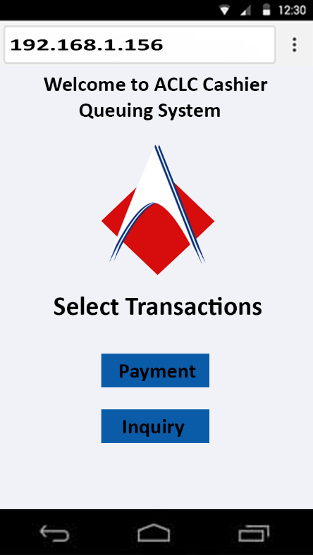

The User is required to enter to the generated IP by the raspberry pi in order for them to queue.

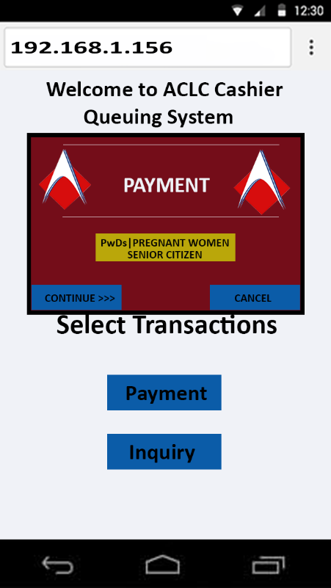

The Modal appears and the user will select continue if they are not PWD and they will be given with their priority number.

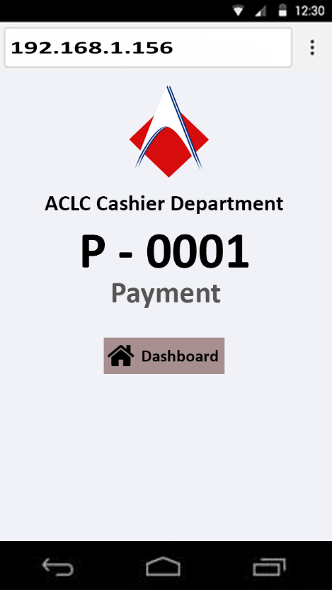

The user will require to go to the dashboard so that they will know the status of their queuing transactions.

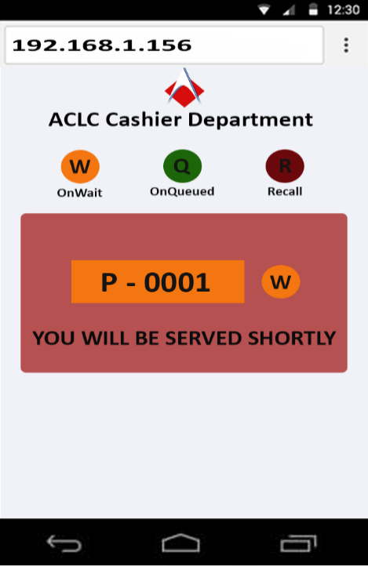

In the dashboard, if the user will see color orange their queuing number it is on wait.

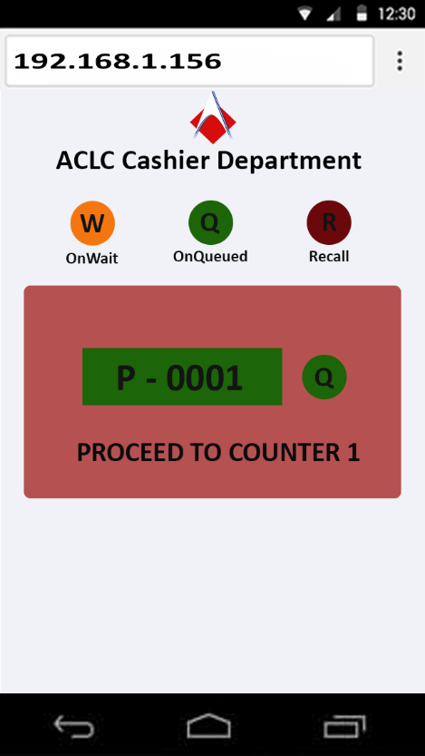

In the dashboard, if the user will see color green their queuing number it is on queued.

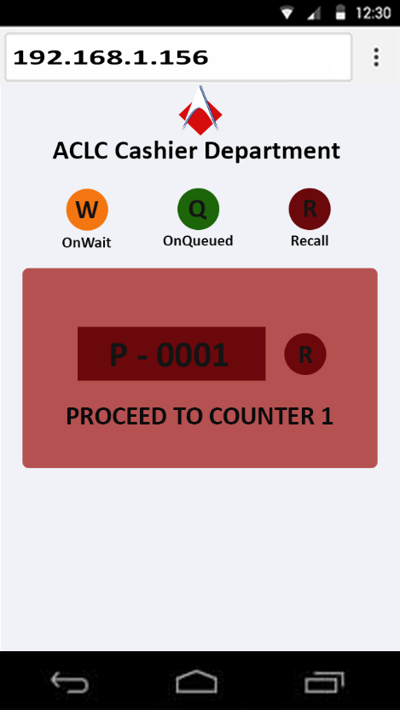

In the dashboard, if the user will see color red their queuing number it is on recall.

**User/PWD User Interface**

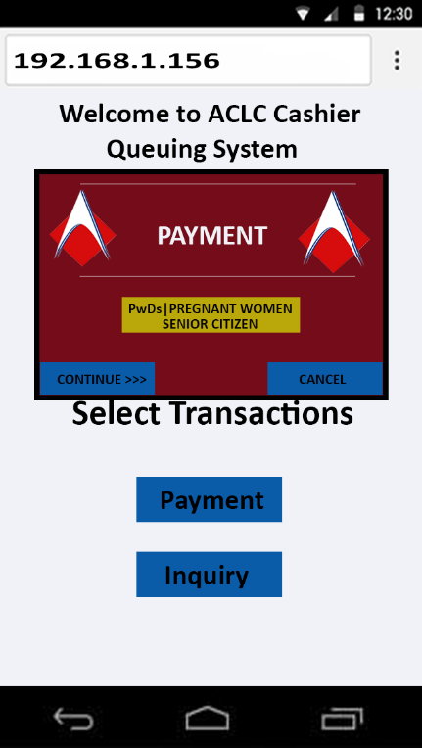

The Modal appears and the user will select continue if they are not PWD and they will be given with their priority number. If they are PWD they will click the PWD button and they will be given with their priority number.

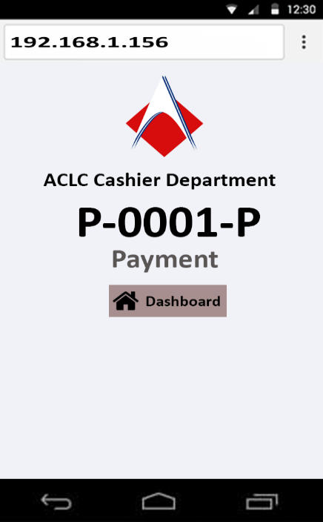

The user will require to go to the dashboard so that they will know the status of

their queuing transactions.

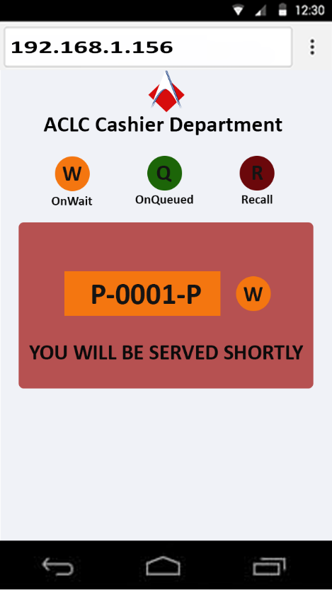

In the dashboard, if the user will see color orange their queuing number it is on wait.

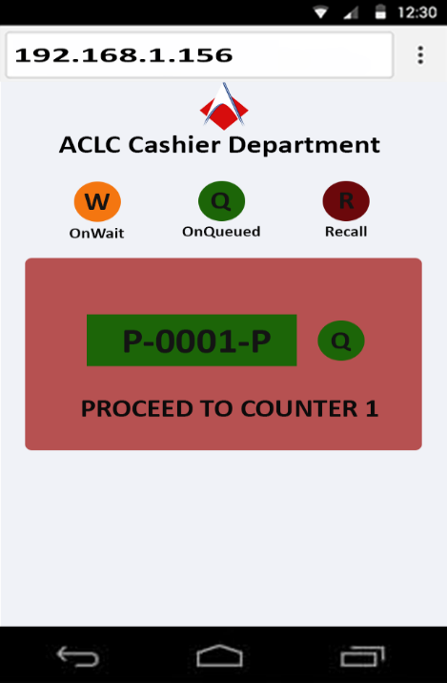

In the dashboard, if the user will see color green their queuing number it is on queued.

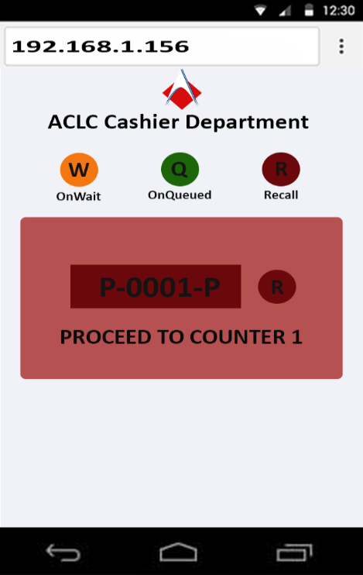

In the dashboard, if the user will see color red their queuing number it is on recall.**Admin/Cashier User Interface**

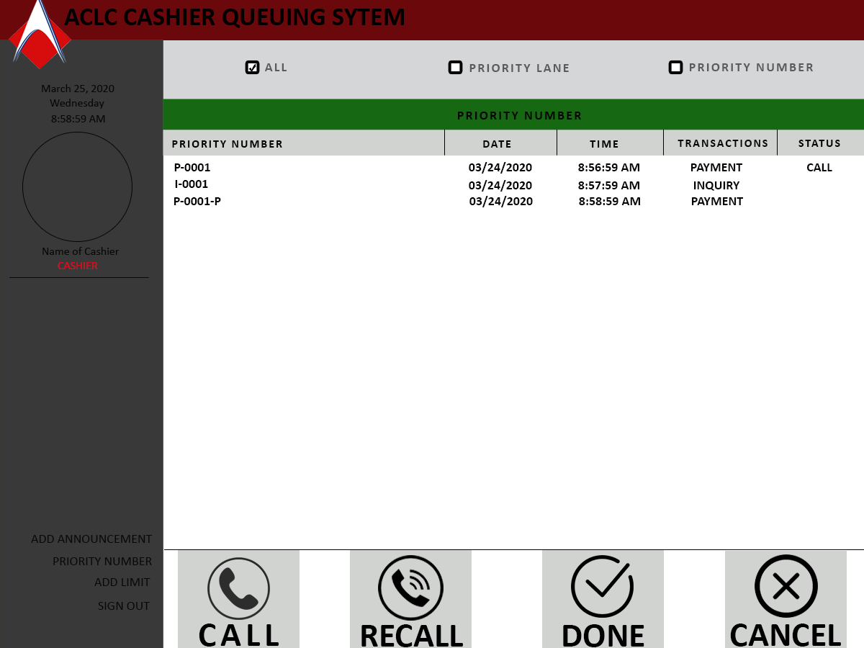

**ADVANTAGES**

* Organize way of queue process
* Avoiding ambush of the lines
* Observe proper selection of transactions
* Maintain and sustain proper alignment for queuing
* Proper manage of time is observe
* Flexibility and faster transaction

**DISADVANTAGES**

* Only smartphone user can use

**System Flowchart**

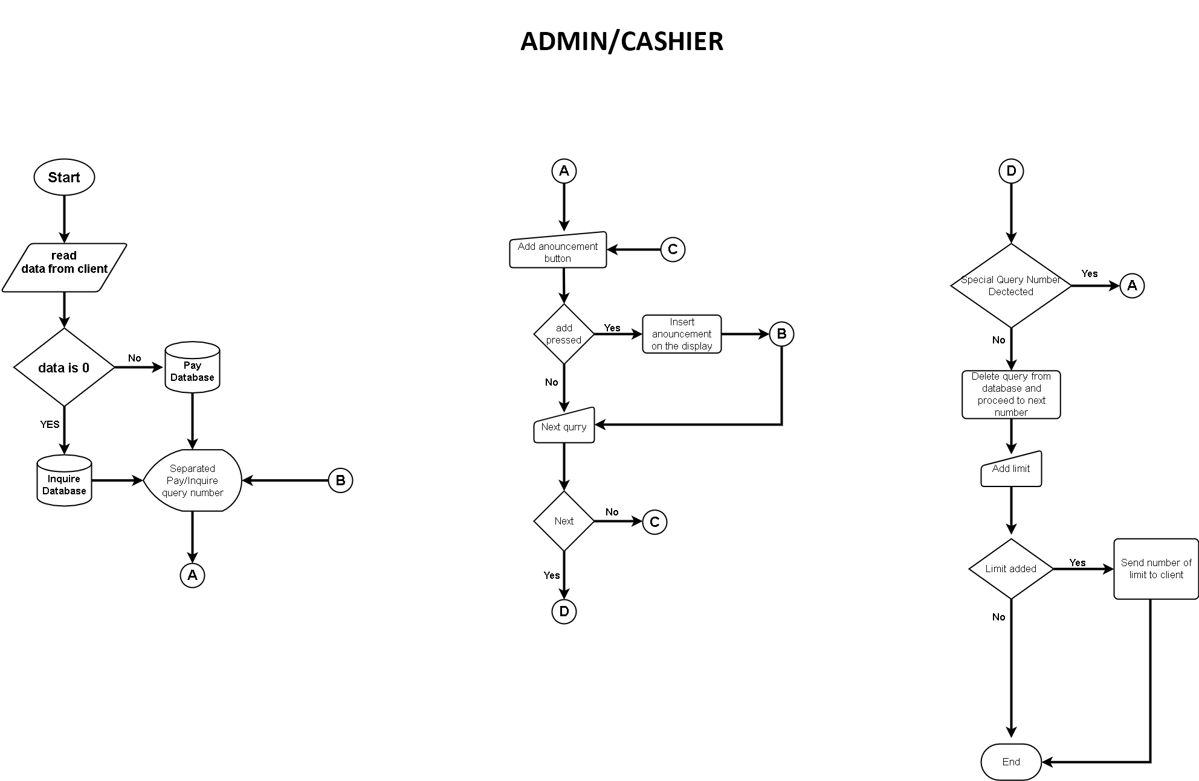

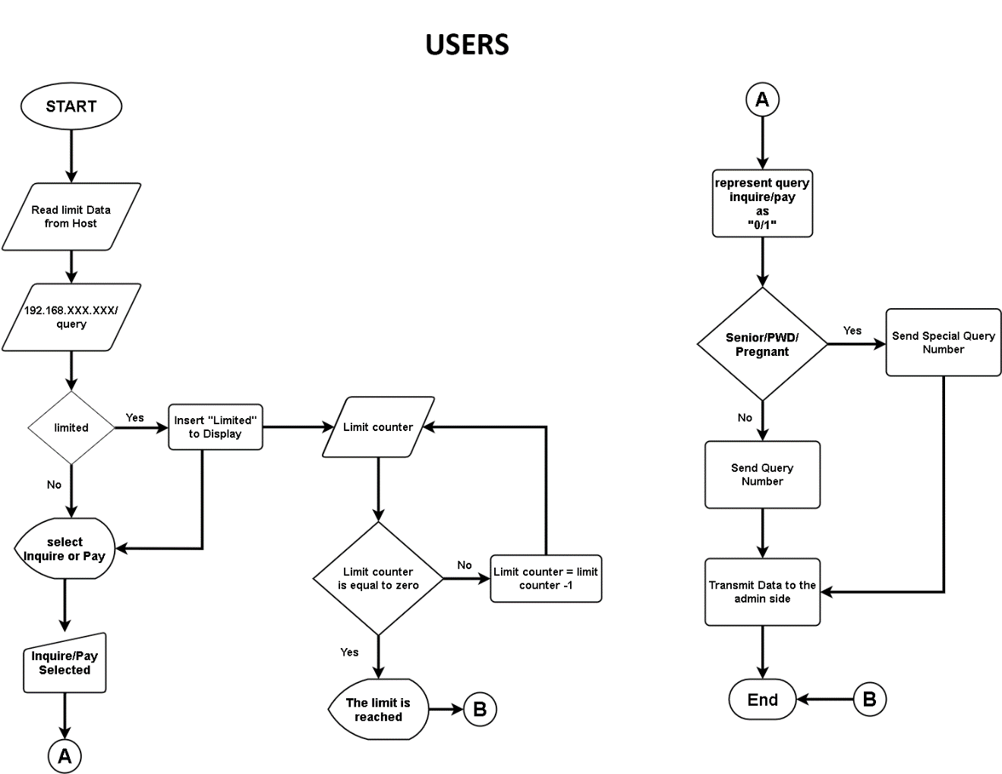

**Super Admin**



**Schematic Diagram**

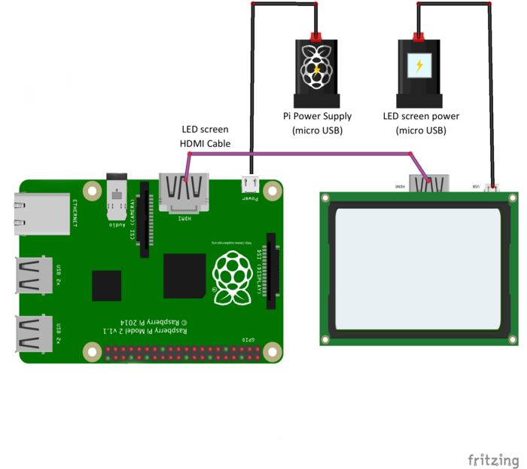

**Raspberry PI Board**

**TV/Monitor**

**Hardware Specification and Budget Cost**

**For Cashier:**

|  |  |
| --- | --- |
| **Components Name** | **Price** |
| Raspberry Pi Board | **P 2999.00** |
| Tv / Monitor | **P 5616.00** |
| LED Screen HDMI Cable | **P 399.00** |
| Pi Power Supply (Micro USB) | **P 1020.00** |
| LED Screen Power (Micro USB) | **P 999.00** |
| 1 TX Port | **P 1650.00** |
| **Total** | ₱ **12,683.00** |

**Deployment Cost**

|  |  |
| --- | --- |
| **Description** | **Price** |
| Queue Kit | **P 10,000.00** |
| **Total** | ₱ **10,000.00** |

**Software Specifications**

|  |  |
| --- | --- |
| **Description** | **Price** |
| Arduino IDE 1.8.5 | **Free** |
| MC Programming Language:  Embedded C | **Free** |
| **Total** | ₱ **0.00** |

**Development Cost**

|  |  |
| --- | --- |
| **Description** | **Price** |
| Lenovo Touchscreen | **35,000** |
| **Total** | ₱ **35,000.00** |

**For Administration:**

|  |  |
| --- | --- |
| **Components Name** | **Price** |
| Raspberry Pi Board | **P 2999.00** |
| Tv / Monitor | **P 5616.00** |
| LED Screen HDMI Cable | **P 399.00** |
| Pi Power Supply (Micro USB) | **P 1020.00** |
| LED Screen Power (Micro USB) | **P 999.00** |
| Cable connector | **P 150.00** |
| **Total** | ₱ **11,183.00** |

**Deployment Cost**

|  |  |
| --- | --- |
| **Description** | **Price** |
| Queue Kit B | **P 9,000.00** |
| **Total** | ₱ **9,000.00** |

**Software Specifications**

|  |  |
| --- | --- |
| **Description** | **Price** |
| Arduino IDE 1.8.5 | **Free** |
| MC Programming Language:  Embedded C | **Free** |
| **Total** | ₱ **0.00** |

**Development Cost**

|  |  |
| --- | --- |
| **Description** | **Price** |
| Samsung Tablet | **P 15,000.00** |
| **Total** | ₱ **20,000.00** |

**For Registrar:**

|  |  |
| --- | --- |
| **Components Name** | **Price** |
| Raspberry Pi Board | **P 2999.00** |
| Tv / Monitor | **P 5616.00** |
| LED Screen HDMI Cable | **P 399.00** |
| Pi Power Supply (Micro USB) | **P 1020.00** |
| LED Screen Power (Micro USB) | **P 999.00** |
| Cable Connector | **P 150.00** |
| **Total** | ₱ **11,183.00** |

**Deployment Cost**

|  |  |
| --- | --- |
| **Description** | **Price** |
| Queue Kit B | **P 9,000.00** |
| **Total** | ₱ **9,000.00** |

**Software Specifications**

|  |  |
| --- | --- |
| **Description** | **Price** |
| Arduino IDE 1.8.5 | **Free** |
| MC Programming Language:  Embedded C | **Free** |
| **Total** | ₱ **0.00** |

**Development Cost**

|  |  |
| --- | --- |
| **Description** | **Price** |
| Samsung Tablet | **P 15,000.00** |
| **Total** | ₱ **15,000.00** |

**SIGNATURES**

|  |  |  |
| --- | --- | --- |
| PROPONENTS | | |
| **Name** | **Signature** | **Date Signed** |
| Jhuven Dejito  **Programmer / Coder** |  |  |
| Rejhel Sinangote  **Documentation Specialist** |  |  |
| Lovely Jean Monsanto  **Documentation Specialist** |  |  |
| Ireneo Arcenal Jr.  **Designer / Coder** |  |  |

|  |  |  |
| --- | --- | --- |
| APPROVER | | |
| **Name** | **Signature** | **Date Signed** |
| Mr. Roy L. Imperial, MSIT  **ACLC College Dean** |  |  |

**User’s Guide**

**PQS (Paperless Queuing System) User’s Manual**

**How to queue the process**

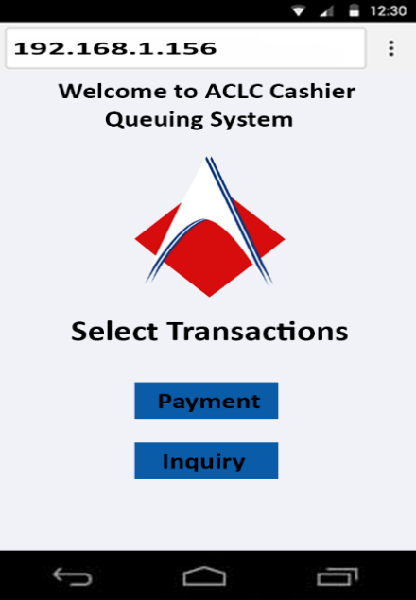

*Figure 22. Generate IP Address to the user*



*Figure 23. Select Queue Transactions*

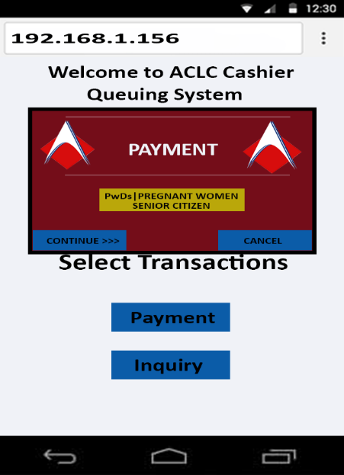

*Figure 24. User’s select continue to queue if not a PWD, Senior Citizen or Pregnant women.*

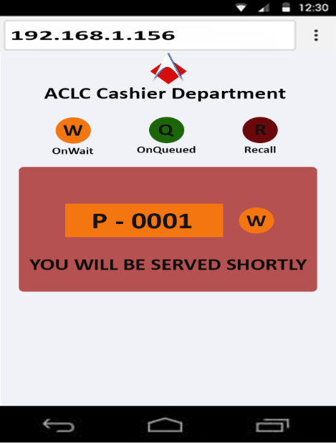

*Figure 25. User’s dashboard to know the queuing transactions.*

*Figure 26. Orange button that represent if the user is on waiting call.*

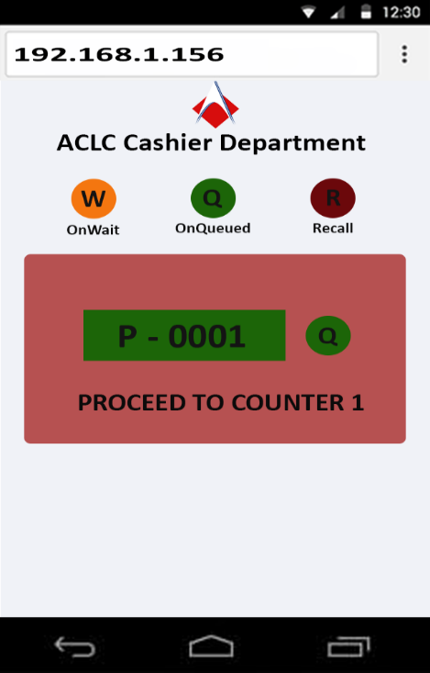

*Figure 27. Green button represents if the user is on queue.*

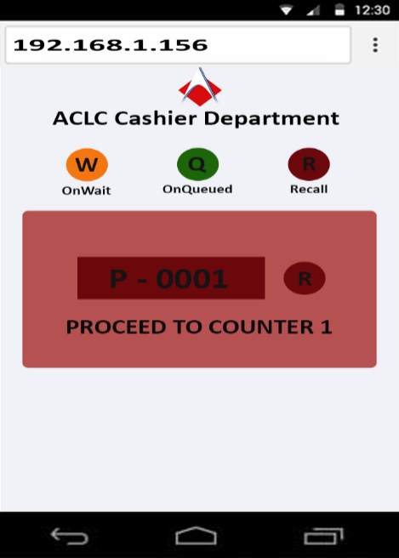



*Figure 28. Red button represent if the user is on the recall*

***PWD/ Pregnant women/ Senior Citizen Guide***

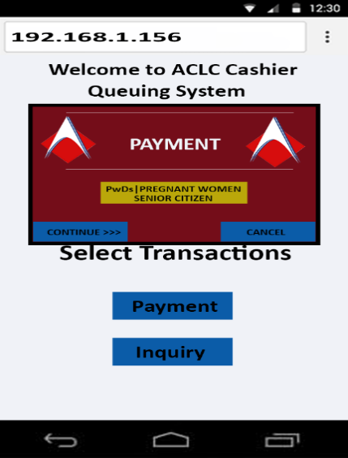

*Figure 29. Click yellow sign button for PWD, Senior Citizen and Pregnant Women.*

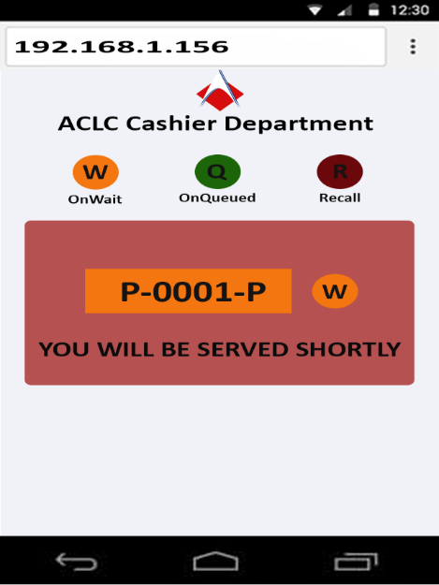

*Figure 30. Dashboard for PWD, Senior Citizen and Pregnant Women. Uppercase P Letter represent for priority lane.*



*Figure 31. Orange button represent if the user is on waiting call for PWD, Senior Citizen and Pregnant Women.*

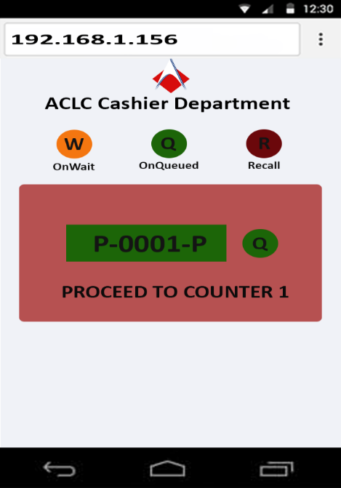

*Figure 32. Green button represents if the user is on queue call for PWD, Senior Citizen and Pregnant Women.*

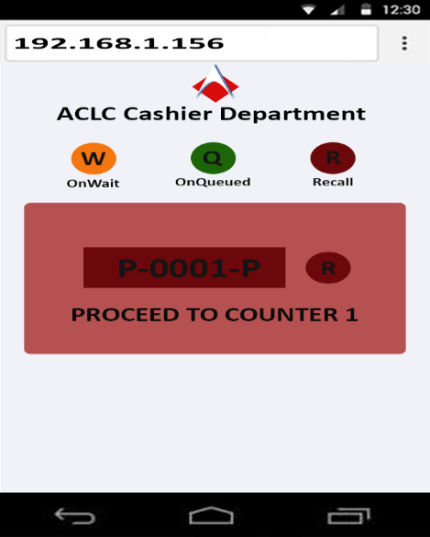

*Figure 33. Red button represents if the user is on recall for PWD, Senior Citizen and Pregnant Women.*

***Cashier Guide***

***How to use Cashier Side***

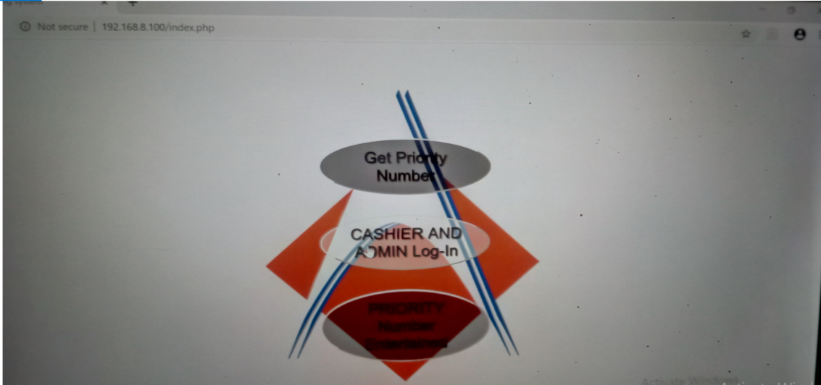

*Figure 34.Click to Log-in.*

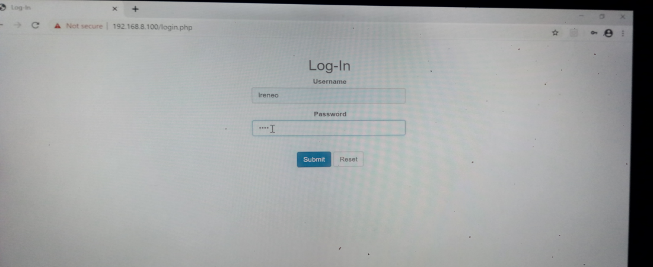

*Figure 35. Cashier Log-in*

***Cashier Homepage***

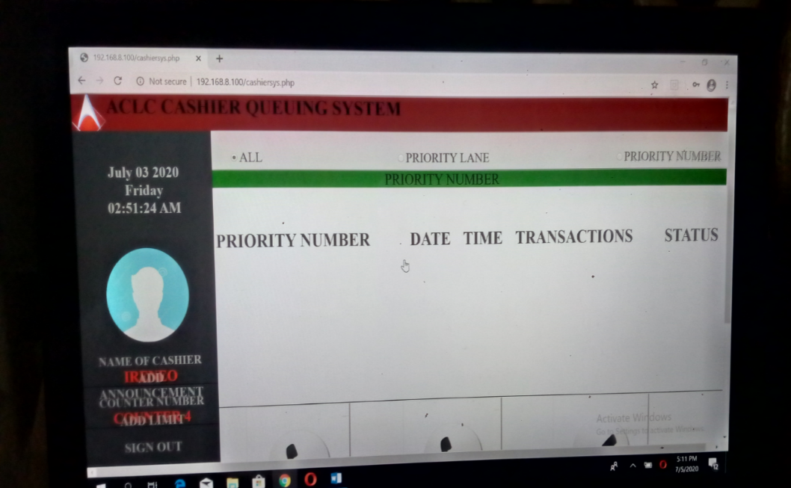

*Figure 36. Cashier Home Page*

**How to call a queue**

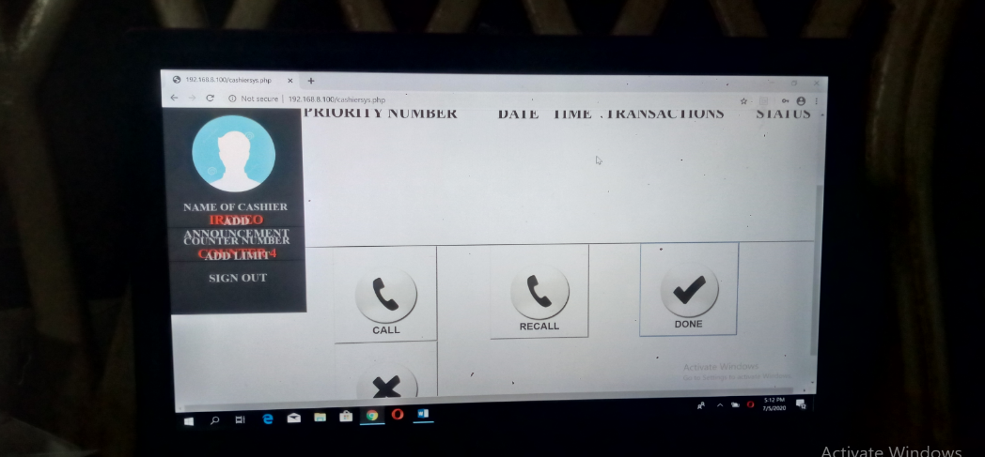

*Figure 37. Cashier Button Calls*

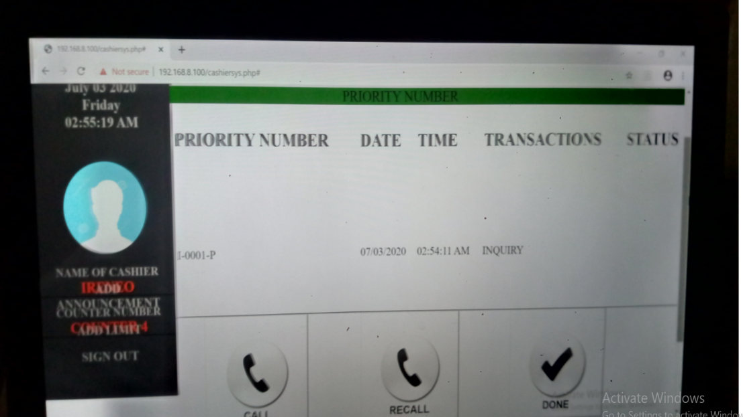

*Figure 38. Cashier Queue Transaction Call*

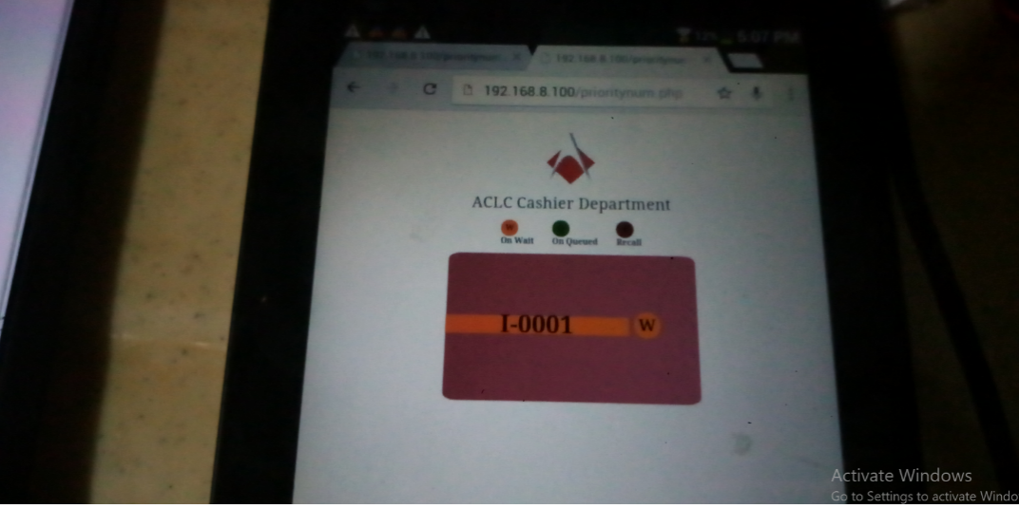

*Figure 39. User call on wait*

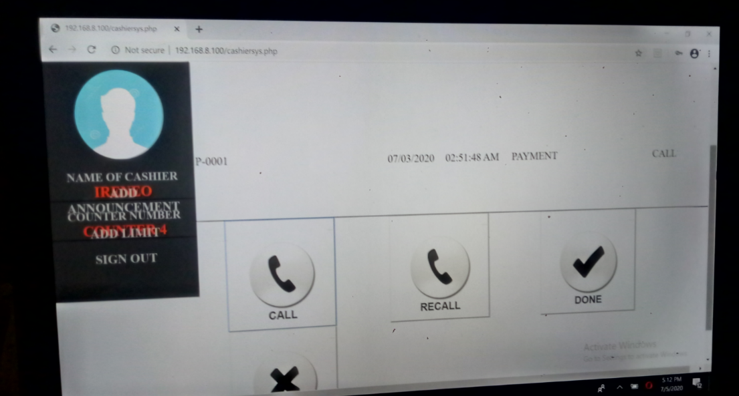

*Figure 40. Cashier is calling a queue to a user.*

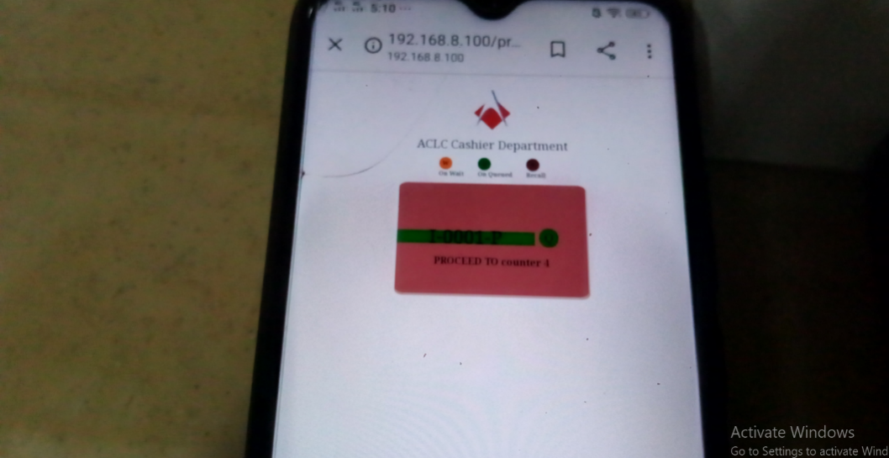

*Figure 41. User is on queue to cashier*

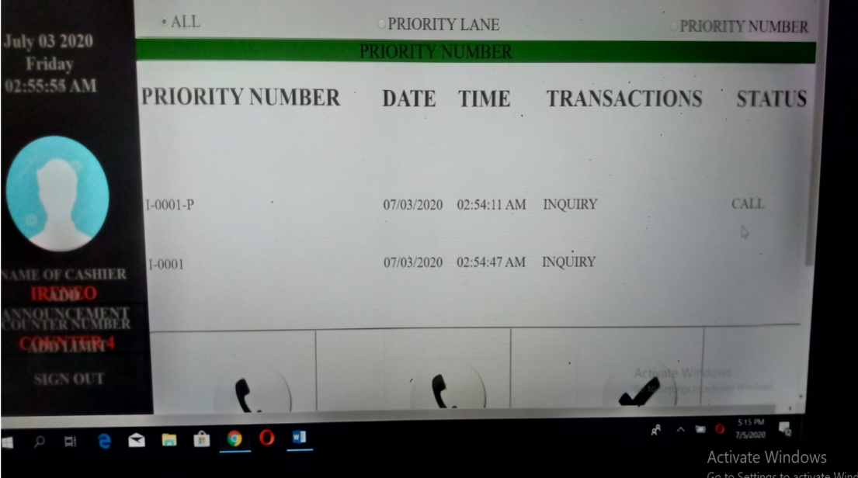

*Figure 42. Cashiers queue on transaction to the users.*

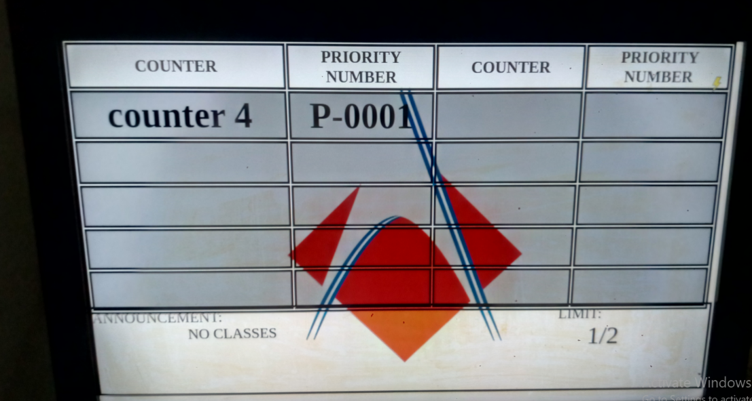

*Figure 43. Cashier queue a user see on the monitor.*

**How to add limit**

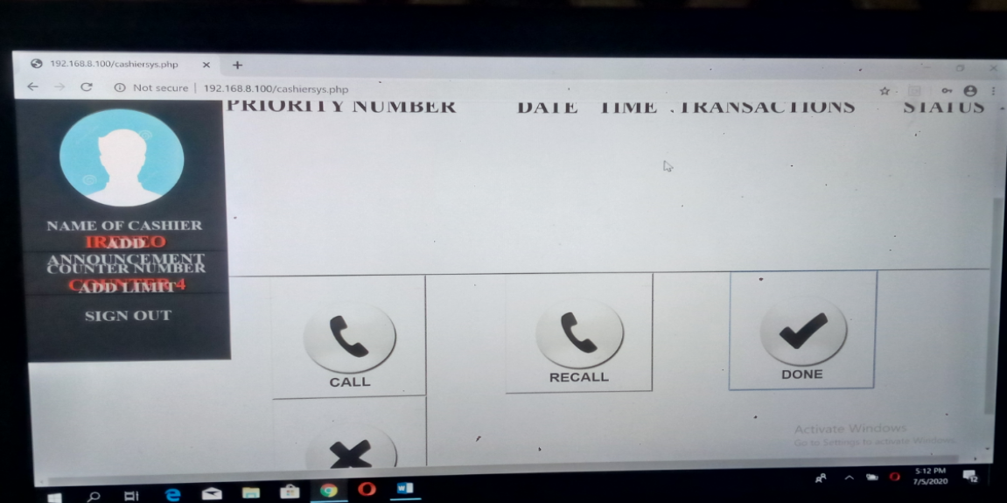

*Figure 44. Cashier add limit to the queue.*

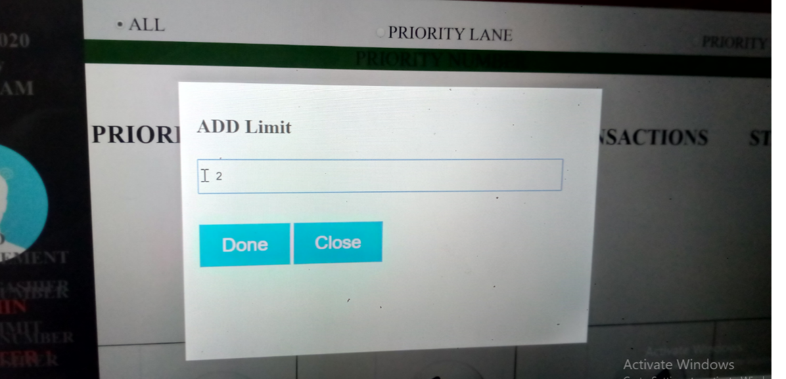

*Figure 45. Limit queue is display.*

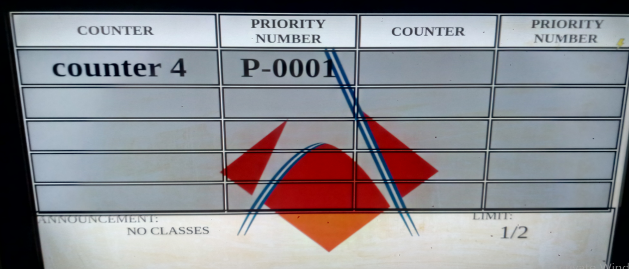

*Figure 46. Limit is display to the monitor.*

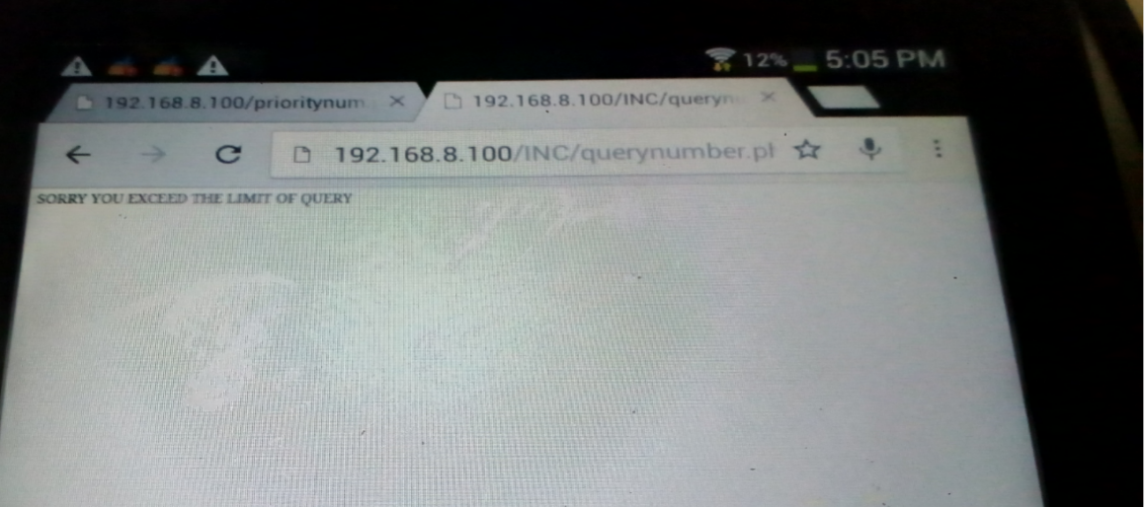

*Figure 47. Queue limit exceed.*

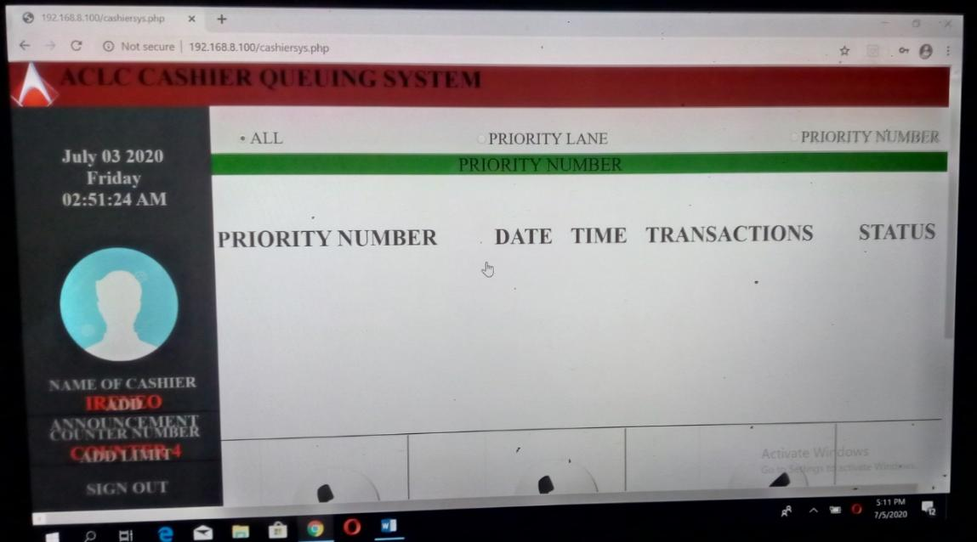

*Figure 48. Add Announcement*

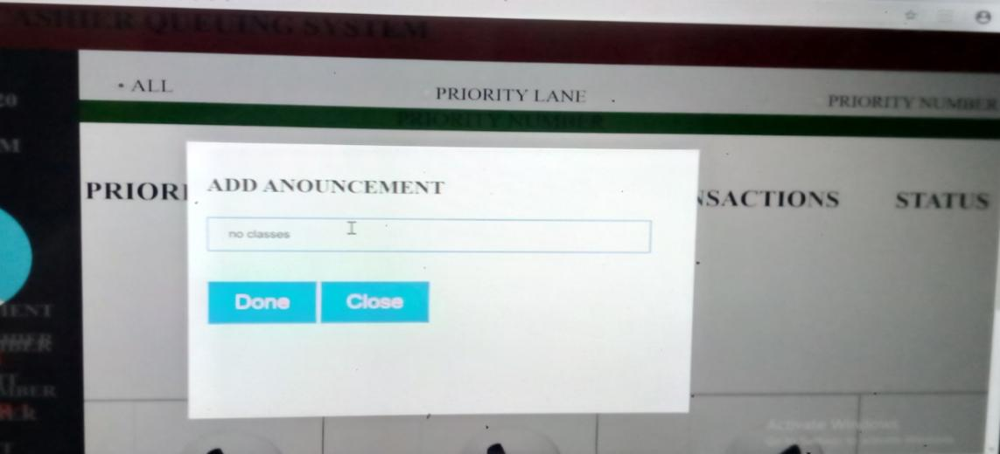

*Figure 49. Add Announcement table is appear.*

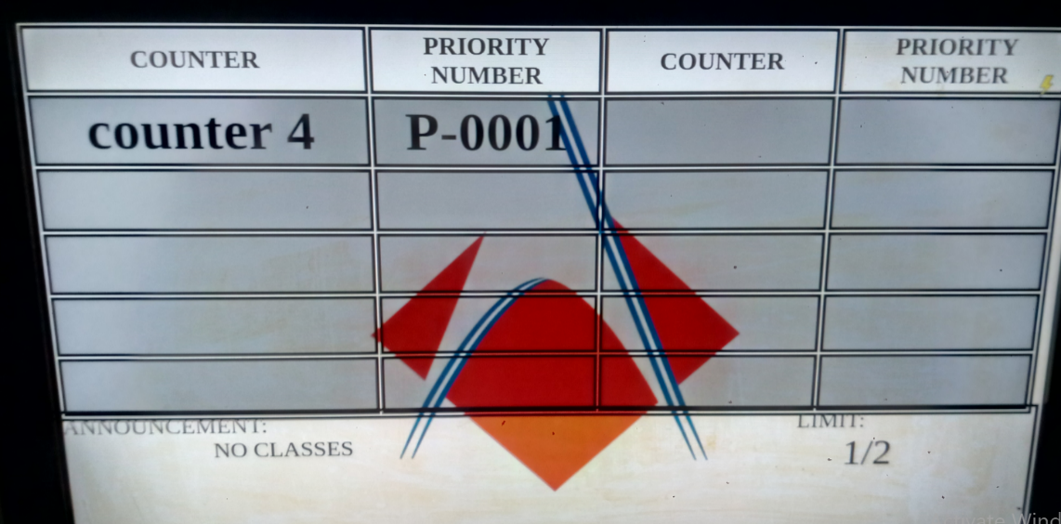

*Figure 50. Display announcement to the monitor.*

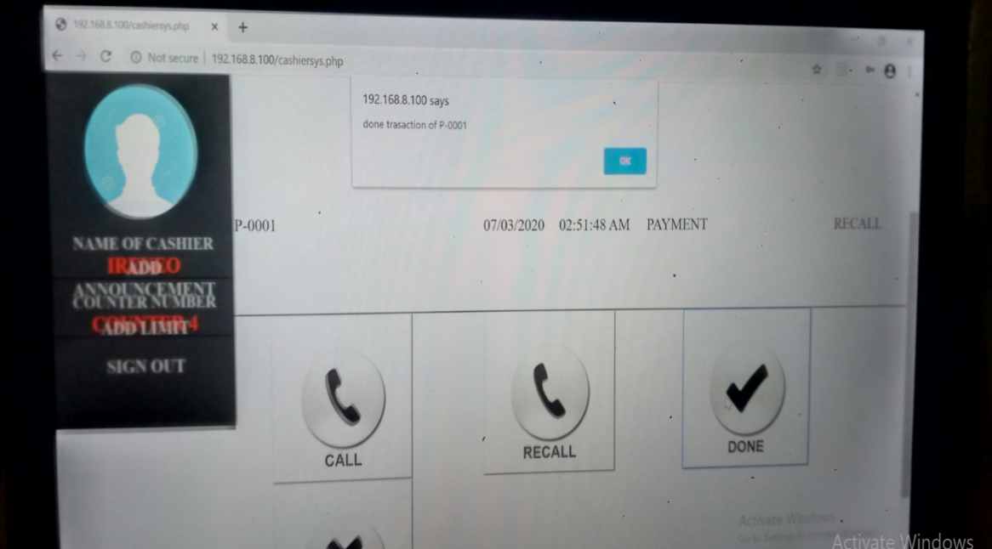

*Figure 51. Recall the queue.*

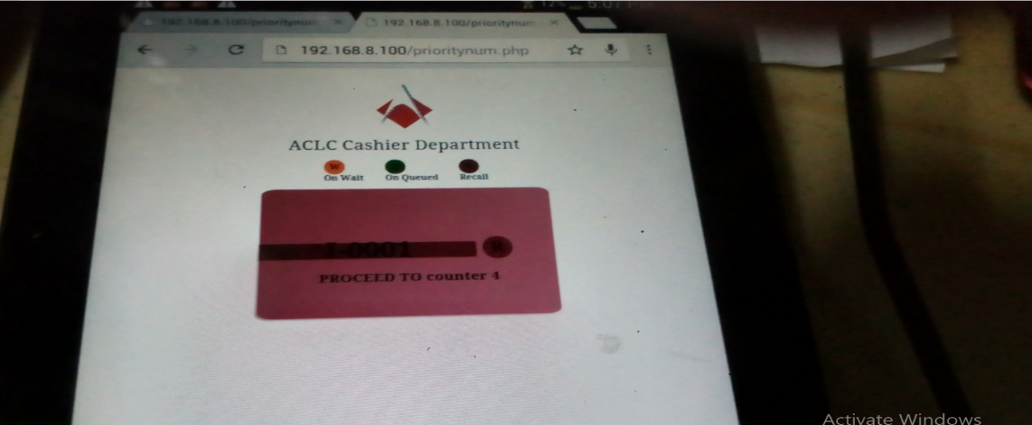

*Figure 52. User queue is recall.*

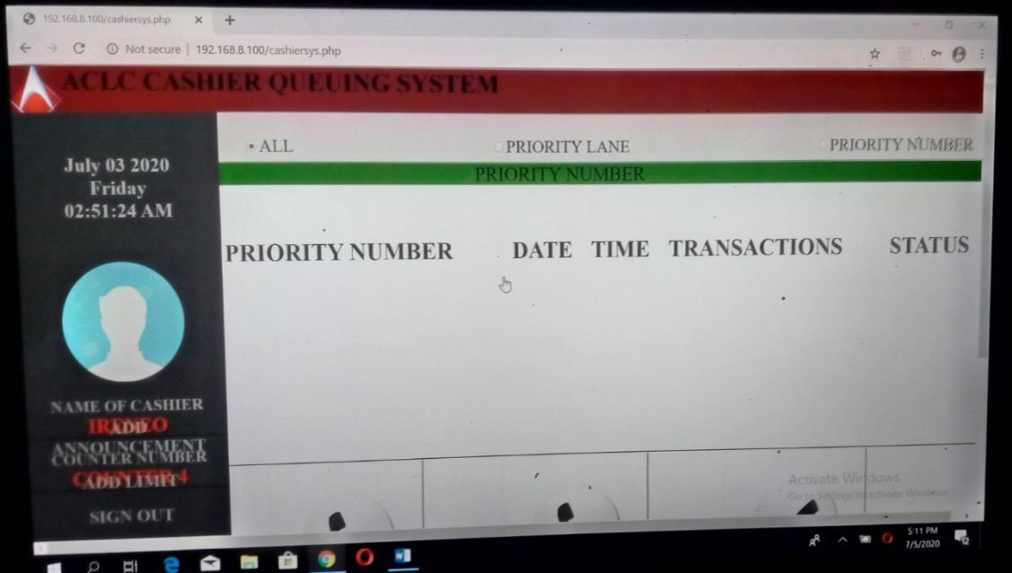

*Figure 53. Cashier Sign out.*

**Admin Guide**

**How to use Admin Side**

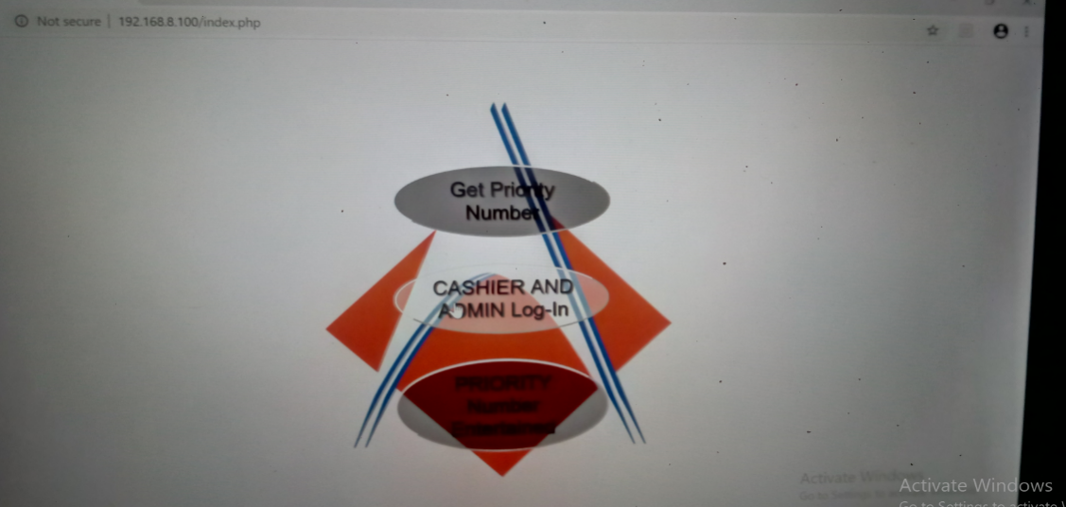

*Figure 54. Click to Log-in.*

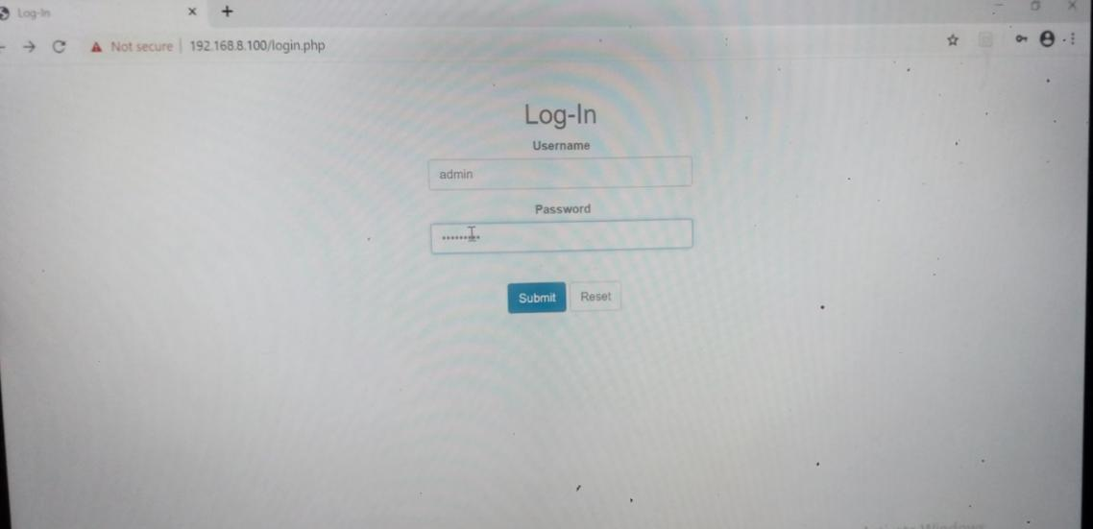

*Figure 55. Admin Log-in.*

**Admin Homepage**

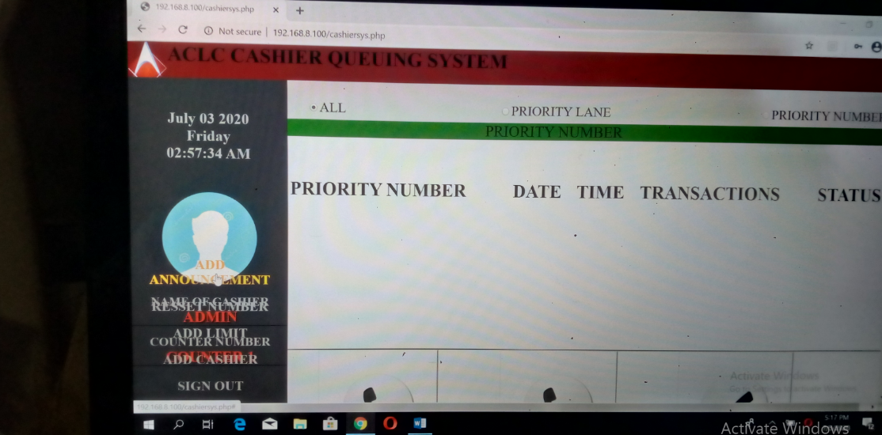

*Figure 56. Homepage.*

**How to add Announcement**



*Figure 57. Announcement Button.*

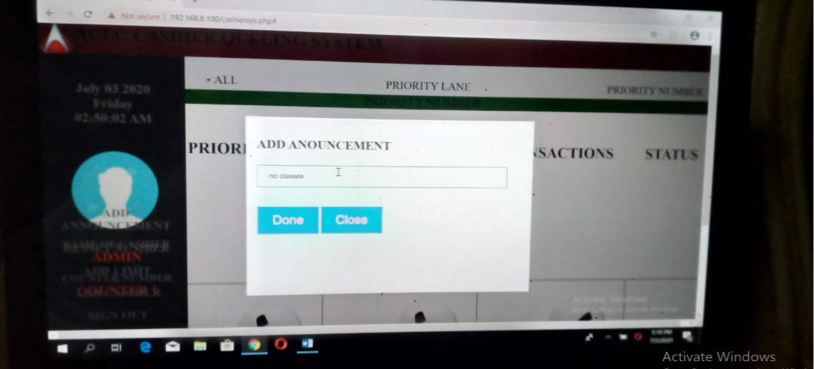

*Figure 58. Add Announcement display.*

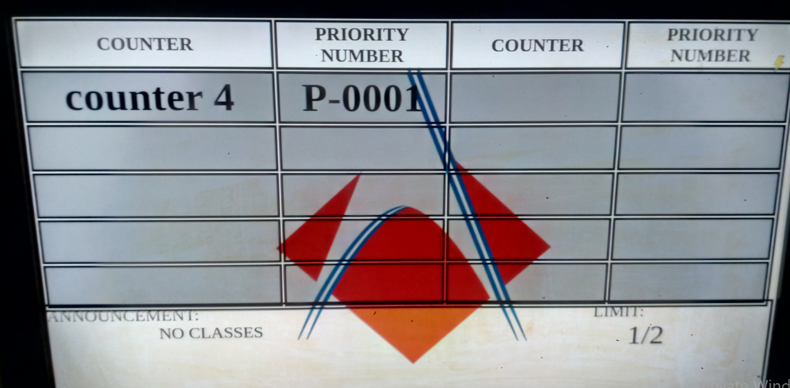

*Figure 59. Add Announcement display on the monitor.*

**How to reset the queue**

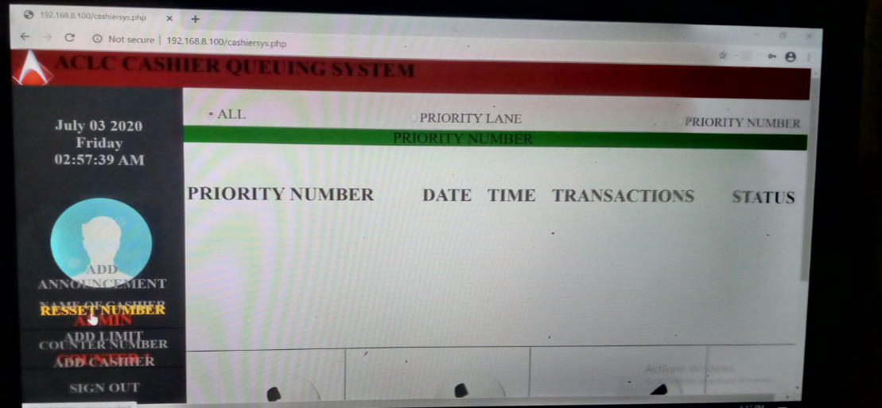

*Figure 60. Reset display button.*

**How to limit the queue**

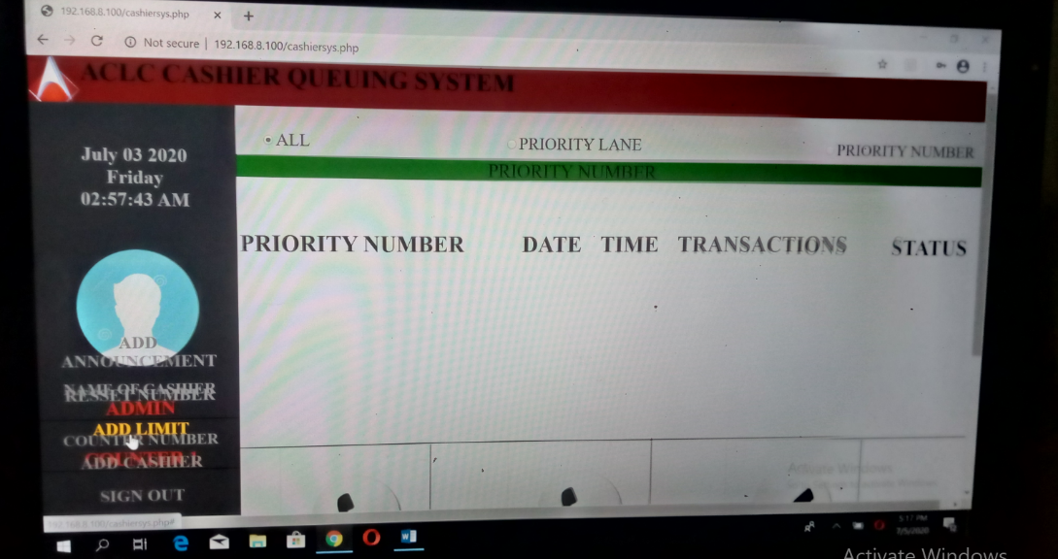

*Figure 61. Add limit display button.*

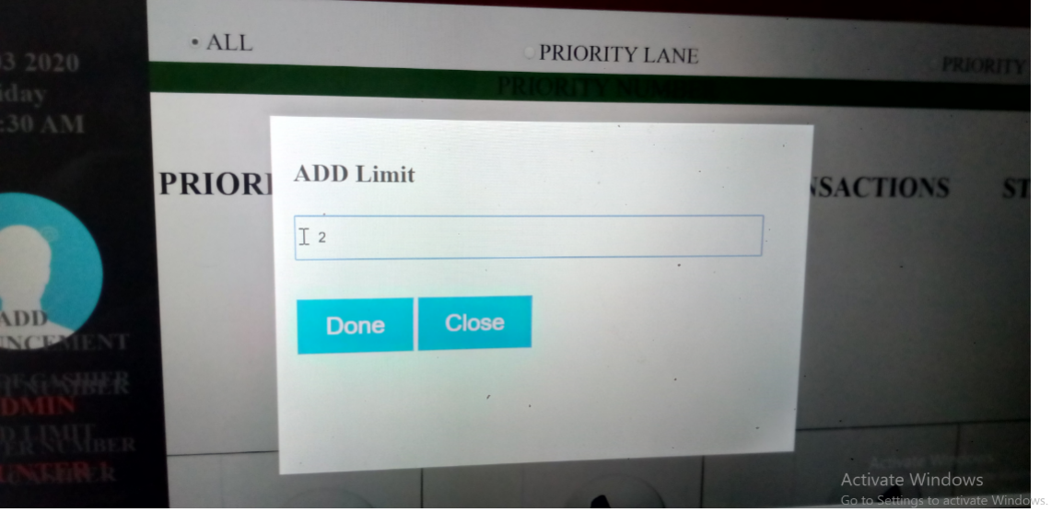

*Figure 62. Add limit is display.*

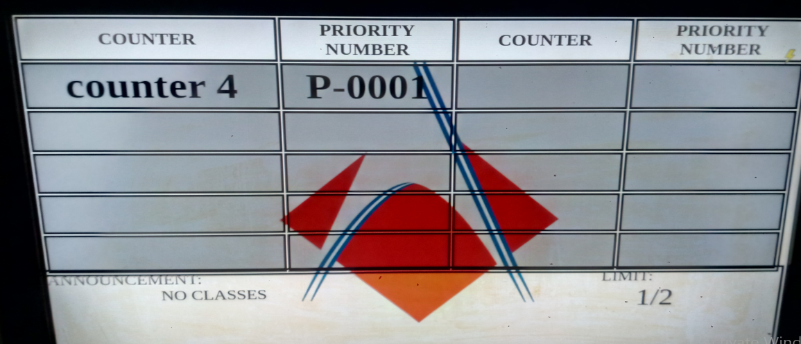

*Figure 63. Add limit is display in the monitor.*

**How to add cashier**

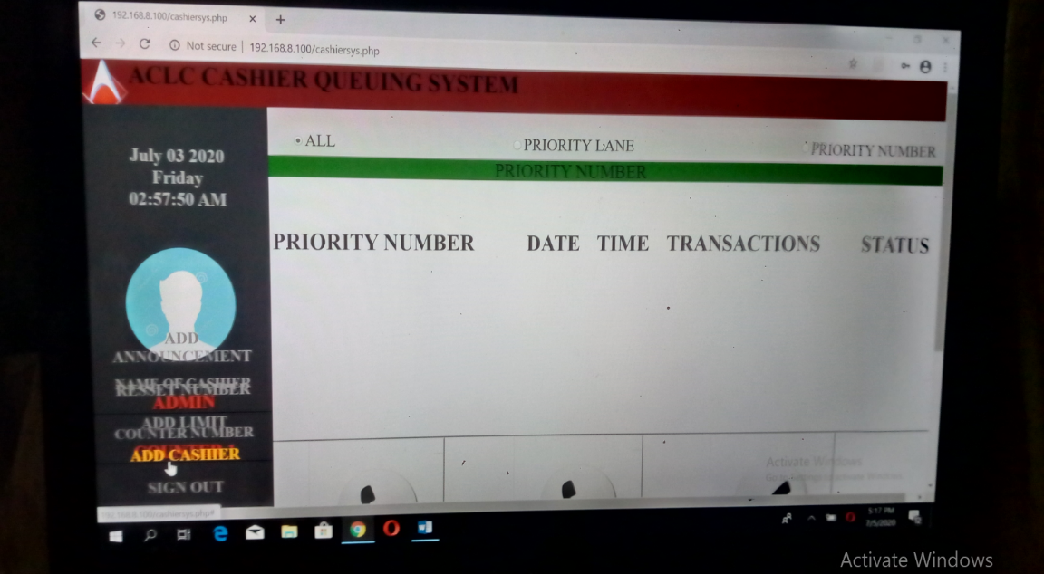

*Figure 64. Add Cashier button.*

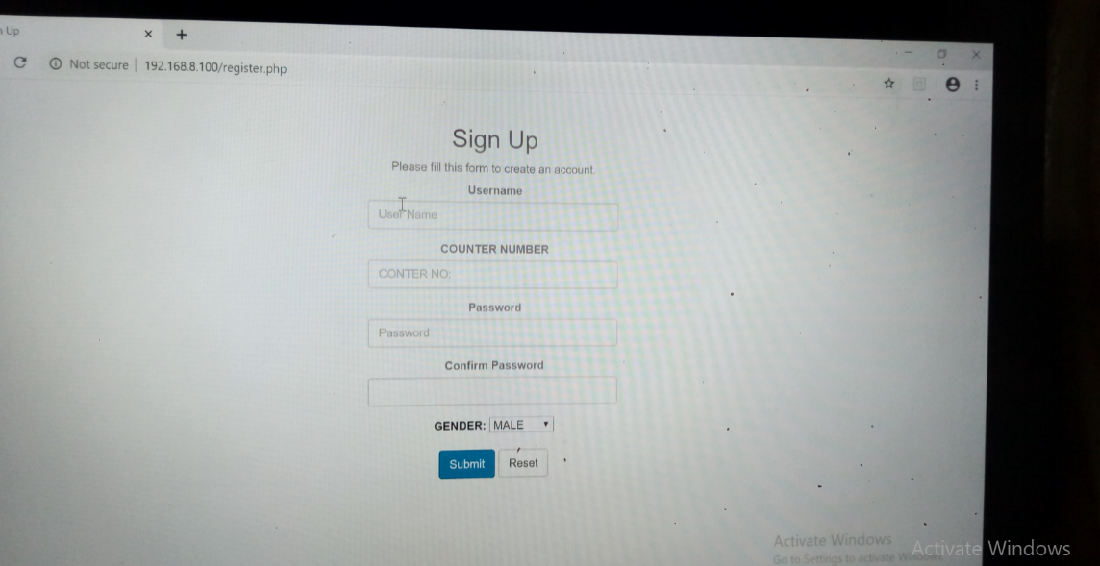

*Figure 65. Add Cashier log-in is display.*

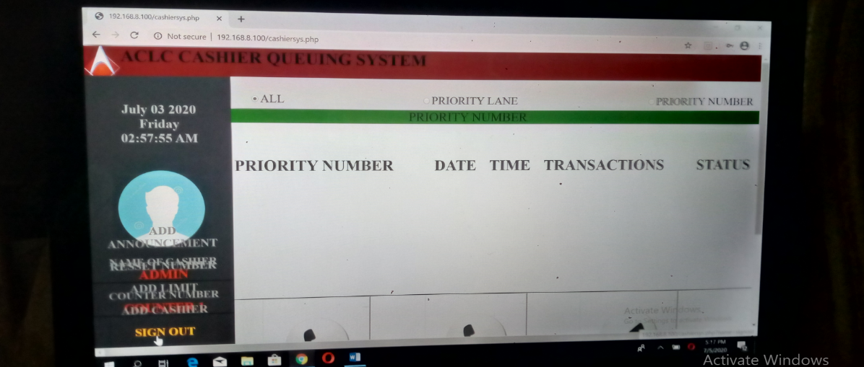

*Figure 66. Admin Sign-out.*

**BIOGRAPHICAL SKETCH**

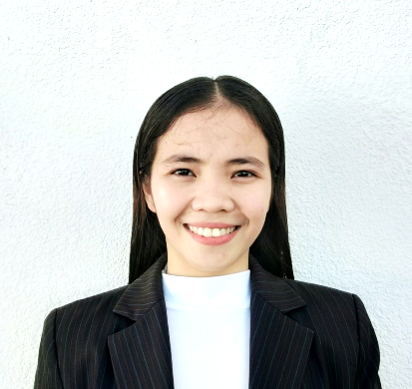

The author Lovely Jean Talingting Monsanto, was born on October 21, 1998 in Borbon, Cebu, Philippines and now currently living in Hermag Basak, Mandaue City, as the third daughter of Dina Talingting Monsanto and Roger Dosdos Monsanto.

She took her primary and secondary education at the Tabunan Borbon, Cebu, where she was a consistent honor student and where she is also a class officers. Lovely Jean is not only academically inclined but she is also good in other fields such as sport. In the four years she spent in high school, she became the class officers and the class vice-president of the TLE major in Information and Communication Technology (ICT) and member of the school dance team, where they are the champion on borbonlympics.

In 2016, she was admitted at the AMA Computer Learning Center, College of Mandaue under the Bachelor of Science in Information Technology. She is a class officers of the (OJT) on-the job training, she is graduated in (NSTP) National Service Training Program and member of the ACLC feet republic.

***LOVELY JEAN TALINGTING MONSANTO***

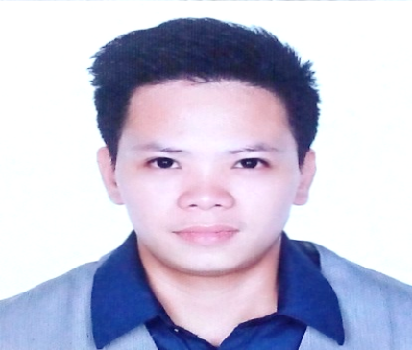

Ireneo Arcenal Jr. was born on March 24, 1992 in Cebu City. He is a college student pursuing to finish his study with the degree of Bachelor of Science Information Technology in ACLC College of Mandaue. He was rewarded as Leadership award in the National Service Training Program given the day March, 2017 at Mandaue City Cebu for his outstanding performance.

His one of the SEEDS Scholar of Jollibee Corp. to support his studies and received several awards like being a crew of the month, Dining Star and GSA wonder. He works as service crew for him to pursue college. His knowledge of being a photo/video editing help him to recognize by others.

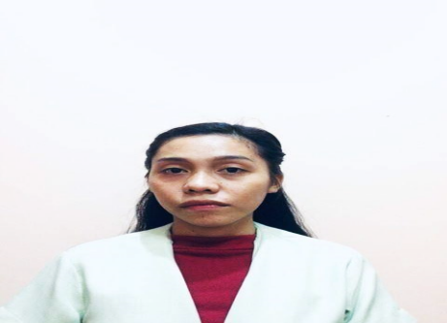

Rejhel Cabahug Sinangote, 22 years of age and was born  
on November 21, 1996 in Kalubi-an, Yati, Lilo-an, Cebu, as the fifth eldest of Alex Lara Sinangote and Emilyn Cabahug Sinangote. She took her primary education at Yati Elementary School and her secondary education at Consolacion National High School, on her secondary level she was a member of Computer Technology Club and was also rewarded as the best outstanding in photo editing, Aside from her editing skills she’s also good at music, poetry and arts where she join for Slogan competition around year 2014. She’s currently a college student pursuing her degree as a Bachelor of Science in Information Technology at ACLC College of Mandaue.   
She graduated in National Service Training Program and completed her On the Job Training (OJT) at Anduiller International Corporation and was awarded by her good performance.

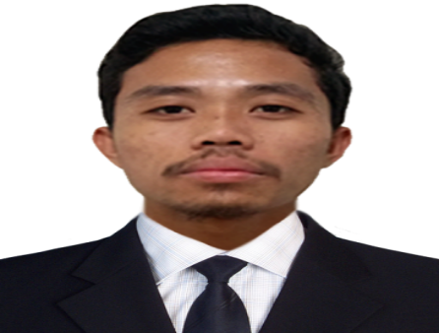

The author Jhuven Sericon Dejito, was born on November 12, 1997 in Maya, Daanbantayan, Cebu, Philippines and now currently residing at L. Jaime St., Marfa Bakilid II, Mandaue City, as the oldest son of Gina Sericon Dejito and Vicente Dela Cruz Dejito.

He took his primary education at the Maya Elementary School and he was a consistent honor student. On his secondary education at Maya National High School, on his secondary level he took TLE major in Information and Communication Technology (ICT) and he was an outstanding student. He received an certificate for photo editing and learned the basic computer maintenance and installations. He was also good in other fields such as sports, he was a member a volleyball team, where they are the champion on the Inter-School Tournament.

In 2016, he was admitted at the AMA Computer Learning Center, College of Mandaue under the Bachelor of Science in Information Technology. He enhanced his skills in photo/editing and learned more knowledge in this school.